**Subject: Embedded Systems**

**Subject code: ETEC-401**

**Semester : Seventh**

**(Notes for B.Tech Students)**



**Department of**

**Electronics & Communication Engineering**

**Maharaja Surajmal Institute of Technology**

**Delhi-110058**

Prepared by: 1. Dr Shaifali M. Arora

2. Ms. Poonam

3. Ms. Sakshi

DISCLAIMER  
COPYRIGHT IS NOT RESERVED BY AUTHORS. AUTHORS ARE NOT  
RESPONSIBLE FOR ANY LEGAL ISSUES ARISING OUT OF ANY COPYRIGHT  
DEMANDS AND/OR REPRINT ISSUES CONTAINED IN THIS MATERIALS. THIS IS NOT MEANT FOR ANY COMMERCIAL PURPOSE & ONLY MEANT FOR PERSONAL USE OF STUDENTS. READERS ARE REQUESTED TO SEND ANY TYPING ERRORS CONTAINED, HEREIN.

**EMBEDDED SYSTEMS**

**Paper Code: ETEC-401 L T/P C**

**Paper: Embedded Systems 3 1 4**

*Objective: The objective of the paper is to enable a student to design an embedded system for specific tasks.*

**UNIT- I**

**Overview of Embedded Systems**: Characteristics of Embedded Systems. Comparison of Embedded Systems

with general purpose processors. General architecture and functioning of micro controllers. 8051 micro

controllers.

**PIC Microcontrollers:** Architecture, Registers, memory interfacing, interrupts, instructions, programming and

peripherals. **[T1][No. of hrs. 12]**

**UNIT- II**

**ARM Processors:** Comparison of ARM architecture with PIC micro controller, ARM 7 Data Path, Registers, Memory Organization, Instruction set, Programming, Exception programming, Interrupt Handling, Thumb mode Architecture.

Bus structure: Time multiplexing, serial, parallel communication bus structure. Bus arbitration, DMA, PCI,

AMBA, I2C and SPI Buses. **[T2][No. of hrs. 12]**

**UNIT- III**

Embedded Software, Concept of Real Time Systems, Software Quality Measurement, Compilers for Embedded

System. **[T3][No. of hrs. 10]**

**UNIT-IV**

**RTOS:** Embedded Operating Systems, Multi Tasking, Multi Threading, Real-time Operating Systems, RTLinux introduction, RTOS kernel, Real-Time Scheduling. **[T3][No. of hrs. 10]**

**Text Book:**

[T1] Design with PIC Microcontrollers, John B. Peatman, Pearson Education Asia, 2002

[T2] ARM System Developer’s Guide: Designing and Optimizing System Software, Andrew N. Sloss,

Dominic Symes, Chris Wright, Morgan Kaufman Publication, 2004.

[T3] Computers as components: Principles of Embedded Computing System Design, Wayne Wolf, Morgan

Kaufman Publication, 2000

**References Books:**

[R1] The Design of Small-Scale embedded systems, Tim Wilmshurst, Palgrave2003

[R2] Embedded System Design , Marwedel ,Peter , Kluwer Publishers , 2004.

**UNIT -I**

**OVERVIEW OF EMBEDDED SYSTEM**

1. **OVERVIEW OF EMBEDDED SYSTEMS**

An embedded system combines mechanical, electrical, and chemical components along with a computer, hidden inside, to perform a single dedicated purpose. There are more computers on this planet than there are people, and most of these computers are single-chip microcontrollers that are the brains of an embedded system. Embedded systems are a ubiquitous component of our everyday lives. We interact with hundreds of tiny computers every day that are embedded into our houses, our cars, our bridges, our toys, and our work. As our world has become more complex, so have the capabilities of the microcontrollers embedded into our devices. Therefore the world needs a trained workforce to develop and manage products based on embedded microcontrollers.

* 1. **CHARACTERISTICS OF EMBEDDED SYSTEMS**
* **Single-functioned** − An embedded system usually performs a specialized operation and does the same repeatedly. For example: A pager always functions as a pager.
* **Tightly constrained** − All computing systems have constraints on design metrics, but those on an embedded system can be especially tight. Design metrics is a measure of an implementation's features such as its cost, size, power, and performance. It must be of a size to fit on a single chip, must perform fast enough to process data in real time and consume minimum power to extend battery life.
* **Reactive and Real time** − Many embedded systems must continually react to changes in the system's environment and must compute certain results in real time without any delay. Consider an example of a car cruise controller; it continually monitors and reacts to speed and brake sensors. It must compute acceleration or de-accelerations repeatedly within a limited time; a delayed computation can result in failure to control of the car.
* **Microprocessors based** − It must be microprocessor or microcontroller based.
* **Memory** − It must have a memory, as its software usually embeds in ROM. It does not need any secondary memories in the computer.
* **Connected** − It must have connected peripherals to connect input and output devices.
* **HW-SW systems** − Software is used for more features and flexibility. Hardware is used for performance and security.

**1.2 COMPARISON OF EMBEDDED SYSTEM WITH GENERAL PURPOSE MICROPROCESSORS**

* **Embedded System,**as it appears from its name, is a part of a bigger system, a computer restricted to one function (or a finite set of functions) that controls, monitors or integrate with larger systems like automotive, robotics, home appliances and military applications.
* They have very tight constraints regarding size, performance, memory, price and durability, also an embedded system is required in most cases to respond in real time, you don’t want your brakes to work after pressing the pedal by a couple of seconds .
* **General purpose processors**is a computer that is built to be customizable in software, like desktop PCs and laptops, you can make it do many thing, sometimes together, with low or no constraints on power, performance or cost, also a general computing system is contained in itself, it’s not a part of a larger system.. It is the system itself.

The primary difference between microprocessors and embedded systems is makeup and integration. Embedded processors, while in a sense "controlling" the system they are a part of, require external resources such as RAM and registers in order to do so. A processor is not a control "system.

**GENERAL PURPOSE MICROPROCESSORS**

As computer miniaturization progressed through the mid to late 1900s, processors became smaller and smaller. All the parts of a processor, including memory and I/O devices, became integrated with the processor as a standard. Finally, when the entire processor apparatus was able to fit on single chips, they became known as "microprocessors." A microprocessor contains everything required to control an external system, and nothing else. This limiting of microprocessor functionality to the basic requirements of a control unit makes implementing microprocessors cheap and easy.

## EMBEDDED SYSTEM

An "embedded" system is simply a computing device placed inside a system it controls. A processor embedded into a system handles all the computation and logical operation of a computer. The embedded processor also handles such tasks as storing and retrieving data from memory, and processing data from any inputs or outputs. Embedded processors often work as part of a computer system, alongside memory and I/O devices.

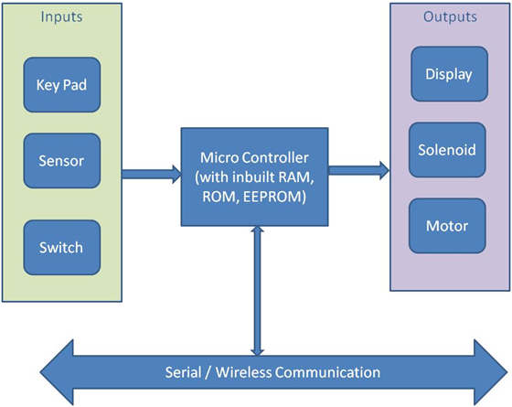

**Figure 1.1 Block diagram of Embedded Systems.**

**Comparison of Embedded System with General Purpose Processors**

Processor is the heart of an embedded system. It is the basic unit that takes inputs and produces an output after processing the data. For an embedded system designer, it is necessary to have the knowledge of both microprocessors and microcontrollers.

**Processors in a System**

A processor has two essential units −

* Program Flow Control Unit (CU)
* Execution Unit (EU)

The CU includes a fetch unit for fetching instructions from the memory. The EU has circuits that implement the instructions pertaining to data transfer operation and data conversion from one form to another.

The EU includes the Arithmetic and Logical Unit (ALU) and also the circuits that execute instructions for a program control task such as interrupt, or jump to another set of instructions.

A processor runs the cycles of fetch and executes the instructions in the same sequence as they are fetched from memory.

**1.3 TYPES OF PROCESSORS**

Processors can be of the following categories −

* **General Purpose Processor (GPP)**
  + Microprocessor
  + Microcontroller
  + Embedded Processor
  + Digital Signal Processor
  + Media Processor
* **Application Specific System Processor (ASSP)**
* **Application Specific Instruction Processors (ASIPs)**
* **GPP core(s) or ASIP core(s) on either an Application Specific Integrated Circuit (ASIC) or a Very Large Scale Integration (VLSI) circuit.**

**Microprocessor**

A microprocessor is a single VLSI chip having a CPU. In addition, it may also have other units such as coaches, floating point processing arithmetic unit, and pipelining units that help in faster processing of instructions.

Earlier generation microprocessors’ fetch-and-execute cycle was guided by a clock frequency of order of ~1 MHz. Processors now operate at a clock frequency of 2GHz

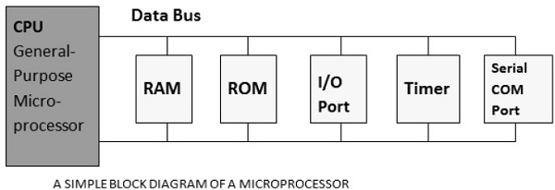

**Figure 1.2 Block diagram of a Microprocessor.**

**Microcontroller**

A microcontroller is a single-chip VLSI unit (also called **microcomputer**) which, although having limited computational capabilities, possesses enhanced input/output capability and a number of on-chip functional units.

Microcontrollers are particularly used in embedded systems for real-time control applications with on-chip program memory and devices.

Microprocessor vs Microcontroller

Let us now take a look at the most notable differences between a microprocessor and a microcontroller.

**Table 1.1 Difference between a Microprocessor and a Microcontroller.**

|  |  |
| --- | --- |
| **Microprocessor** | **Microcontroller (Embedded System)** |
| Microprocessors are multitasking in nature. Can perform multiple tasks at a time. For example, on computer we can play music while writing text in text editor. | Single task oriented. For example, a washing machine is designed for washing clothes only. |
| RAM, ROM, I/O Ports, and Timers can be added externally and can vary in numbers. | RAM, ROM, I/O Ports, and Timers cannot be added externally. These components are to be embedded together on a chip and are fixed in numbers. |
| Designers can decide the number of memory or I/O ports needed. | Fixed number for memory or I/O makes a microcontroller ideal for a limited but specific task. |
| External support of external memory and I/O ports makes a microprocessor-based system heavier and costlier. | Microcontrollers are lightweight and cheaper than a microprocessor. |
| External devices require more space and their power consumption is higher. | A microcontroller-based system consumes less power and takes less space. |

**1.4 MICROCONTROLLER**

A microcontroller (or MCU for microcontroller unit) is a small computer on a single integrated circuit. In modern terminology, it is similar to, but less sophisticated than, a system on a chip or SoC; an SoC may include a microcontroller as one of its components. A microcontroller contains one or more CPUs (processor cores) along with memory and programmable input/output peripherals. Program memory in the form of Ferroelectric RAM, NOR flash or OTP ROM is also often included on chip, as well as a small amount of RAM. Microcontrollers are designed for embedded applications, in contrast to the microprocessors used in personal computers or other general purpose applications consisting of various discrete chips.

Intel 8742, an 8-bit microcontroller that includes a CPU running at 12 MHz, 128 bytes of RAM, 2048 bytes of EPROM, and I/O in the same chip.

Microcontrollers are used in automatically controlled products and devices, such as automobile engine control systems, implantable medical devices, remote controls, office machines, appliances, power tools, toys and other embedded systems. By reducing the size and cost compared to a design that uses a separate microprocessor, memory, and input/output devices, microcontrollers make it economical to digitally control even more devices and processes. Mixed signal microcontrollers are common, integrating analog components needed to control non-digital electronic systems.

Some microcontrollers may use four-bit [words](https://en.wikipedia.org/wiki/Word_(computer_architecture)) and operate at frequencies as low as 4 kHz, for low power consumption (single-digit mill watts or microwatts). They will generally have the ability to retain functionality while waiting for an event such as a button press or other interrupt; power consumption while sleeping (CPU clock and most peripherals off) may be just nanowatts, making many of them well suited for long lasting battery applications. Other microcontrollers may serve performance-critical roles, where they may need to act more like a [digital signal processor](https://en.wikipedia.org/wiki/Digital_signal_processor) (DSP), with higher clock speeds and power consumption.

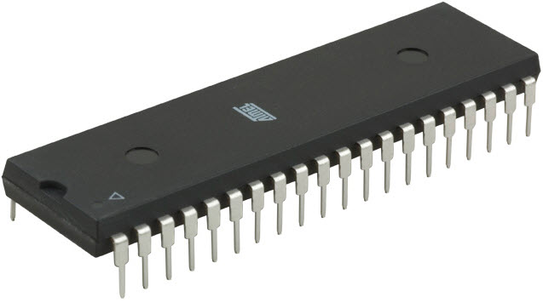

**Figure 1.3 The 8051 IC.**

Nowadays microcontrollers are cheap and readily available for hobbyists, with large online communities around certain processors.

**A MICRO-CONTROLLER IS A SINGLE INTEGRATED CIRCUIT, COMMONLY WITH THE FOLLOWING FEATURES:**

* Central processing unit - ranging from small and simple 4-bit processors to complex 32-bit or 64-bit processors.
* Volatile memory (RAM) for data storage.
* ROM, EPROM, EEPROM or Flash memory for program and operating parameter storage.
* Discrete input and output bits, allowing control or detection of the logic state of an individual package pin.
* Serial input/output such as serial ports (UARTs).
* Other serial communications interfaces like I²C, Serial Peripheral Interface and Controller Area Network for system interconnect.
* Peripherals such as timers, event counters, PWM generators, and watchdog.
* Clock generator - often an oscillator for a quartz timing crystal, resonator or RC circuit.
* Many include analog-to-digital converters, some include digital-to-analog converters.
* In-circuit programming and in-circuit debugging support.

**1.4.1 GENERAL ARCHITECTURE & FUNCTION ING OF A MICROCONTROLLER**

* **CPU**

CPU is the brain of a microcontroller .CPU is responsible for fetching the instruction, decodes it, then finally executed. CPU connects every part of a microcontroller into a single system. The primary function of CPU is fetching and decoding instructions. Instruction fetched from program memory must be decoded by the CPU.

* **Memory**

The function of memory in a microcontroller is same as microprocessor. It is used to store data and program. A microcontroller usually has a certain amount of RAM and ROM (EEPROM, EPROM, etc) or flash memories for storing program source codes.

* **Parallel input/output ports**

Parallel input/output ports are mainly used to drive/interface various devices such as LCD’S, LED’S, printers, memories, etc to a microcontroller.

* **Serial ports**

Serial ports provide various serial interfaces between microcontroller and other peripherals like parallel ports.

* **Timers/counters**

This is the one of the useful function of a microcontroller. A microcontroller may have more than one timer and counters. The timers and counters provide all timing and counting functions inside the microcontroller. The major operations of this

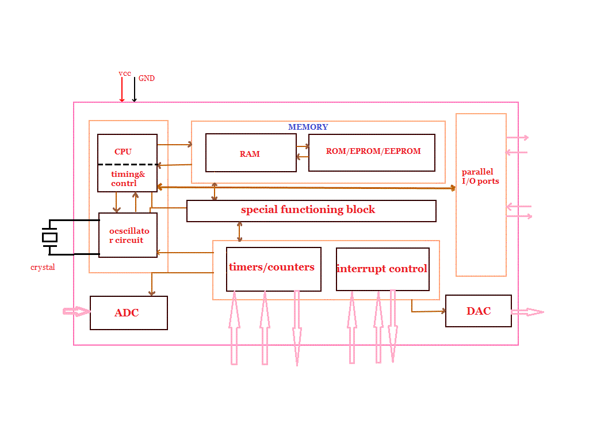

**Figure 1.4 Architecture of 8051 IC.**

section are perform clock functions, modulations, pulse generations, frequency measuring, making oscillations, etc. This also can be used for counting external pulses.

* **Analog to Digital Converter (ADC)**

ADC converters are used for converting the analog signal to digital form. The input signal in this converter should be in analog form (e.g. sensor output) and the output from this unit is in digital form. The digital output can be use for various digital applications (e.g. measurement devices).

* **Digital to Analog Converter (DAC)**

DAC perform reversal operation of ADC conversion.DAC convert the digital signal into analog format. It usually used for controlling analog devices like DC motors, various drives, etc.

* **Interrupt control**

The interrupt control used for providing interrupt (delay) for a working program .The interrupt may be external (activated by using interrupt pin) or internal (by using interrupt instruction during programming).

* **Special functioning block**

Some microcontrollers used only for some special applications (e.g. space systems and robotics) these controllers containing additional ports to perform such special operations. This considered as special functioning block.

**1.4.2 ADVANTAGES OF MICROCONTROLLERS**

The main advantages of microcontrollers are given.

* 1. Microcontrollers act as a microcomputer without any digital parts.
  2. As the higher integration inside microcontroller reduce cost and size of the system.
  3. Usage of microcontroller is simple, easy for troubleshoot and system maintaining.
  4. Most of the pins are programmable by the user for performing different functions.
  5. Easily interface additional RAM, ROM,I/O ports.
  6. Low time required for performing operations.

**1.4.3 APPLICATIONS**

Microcontrollers are widely used in modern electronics equipment. Some basic applications of microcontroller is given below.

* 1. Used in biomedical instruments.
  2. Widely used in communication systems.
  3. Used as peripheral controller in PC.
  4. Used in robotics.
  5. Used in automobile fields.

**2. 8051 MICROCONTROLLER**

The 8051 Microcontroller was designed in 1980’s by Intel. Its foundation was on Harvard Architecture and was developed principally for bringing into play in [Embedded Systems](http://www.edgefxkits.com/embedded-systems-projects/). At first it was created by means of NMOS technology but as NMOS technology needs more power to function therefore Intel re-intended Microcontroller 8051 employing CMOS technology and a new edition came into existence with a letter ‘C’ in the title name, for illustration: 80C51 [1]. These most modern Microcontrollers need fewer amount of power to function in comparison to their forerunners.

There are two buses in 8051 Microcontroller one for program and other for data. As a result, it has two storage rooms for both program and data of 64K by 8 size. The microcontroller comprise of 8 bit accumulator & 8 bit processing unit. It also consists of 8 bit B register as majorly functioning blocks and 8051 microcontroller programming is done with [embedded C language](https://www.elprocus.com/basics-and-structure-of-embedded-c-program-with-examples-for-beginners/) using Keil software. It also has a number of other 8 bit and 16 bit registers.

For internal functioning & processing Microcontroller 8051 comes with integrated built-in RAM. This is prime memory and is employed for storing temporary data. It is unpredictable memory i.e. its data can get be lost when the power supply to the Microcontroller switched OFF.

Architecture

**CPU (Central Processor Unit):**

As you may be familiar that Central Processor Unit or CPU is the mind of any processing machine. It scrutinizes and manages all processes that are carried out in the Microcontroller. User has no power over the functioning of CPU. It interprets program printed in storage space (ROM) and carries out all of them and do the projected duty. CPU manages [different types of registers in 8051 microcontroller](https://www.elprocus.com/know-about-types-of-registers-in-8051-microcontroller/).

**Interrupts:**

As the heading put forward, Interrupt is a sub-routine call that reads the Microcontroller’s key function or job and helps it to perform some other program which is extra important at that point of time. The [characteristic of 8051 Interrupt](https://www.elprocus.com/types-of-interrupts-in-8051-microcontroller-and-interrupt-programming/) is extremely constructive as it aids in emergency cases. Interrupts provides us a method to postpone or delay the current process, carry out a sub-routine task and then all over again restart standard program implementation.

The Micro-controller 8051 can be assembled in such a manner that it momentarily stops or break the core program at the happening of interrupt. When sub-routine task is finished then the implementation of core program initiates automatically as usual. There are 5 interrupt supplies in 8051 Microcontroller, two out of five are peripheral interrupts, two are timer interrupts and one is serial port interrupt.

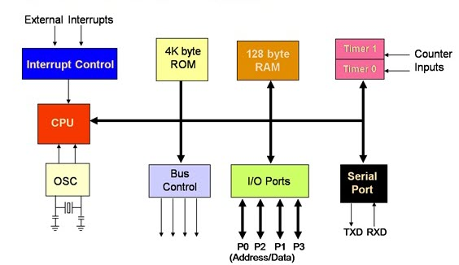

**Figure 1.5Architecture of 8051 IC.**

**Memory:**

Micro-controller needs a program which is a set of commands. This program enlightens Microcontroller to perform precise tasks. These programs need a storage space on which they can be accumulated and interpret by Microcontroller to act upon any specific process. The memory which is brought into play to accumulate the program of Microcontroller is recognized as Program memory or code memory. In common language it’s also known as Read Only Memory or ROM.

Microcontroller also needs a memory to amass data or operands for the short term. The storage space which is employed to momentarily data storage for functioning is acknowledged as Data Memory and we employ Random Access Memory or RAM for this principle reason. Microcontroller 8051 contains code memory or program memory 4K so that is has 4KB Rom and it also comprise of data memory (RAM) of 128 bytes.

**Bus:**

Fundamentally Bus is a group of wires which functions as a communication canal or mean for the transfer Data. These buses comprise of 8, 16 or more cables. As a result, a bus can bear 8 bits, 16 bits all together. There are two types of buses:

1. **Address Bus:** Microcontroller 8051 consists of 16 bit address bus. It is brought into play to address memory positions. It is also utilized to transmit the address from Central Processing Unit to Memory.
2. **Data Bus:** Microcontroller 8051 comprise of 8 bits data bus. It is employed to cart data.

**Oscillator:**

As we all make out that Microcontroller is a digital circuit piece of equipment, thus it needs timer for its function. For this function, Microcontroller 8051 consists of an on-chip oscillator which toils as a time source for CPU (Central Processing Unit). As the productivity thumps of oscillator are steady as a result, it facilitates harmonized employment of all pieces of 8051 Microcontroller. Input/output Port: As we are acquainted with that Microcontroller is employed in embedded systems to manage the functions of devices.

Thus to gather it to other machinery, gadgets or peripherals we need I/O (input/output) interfacing ports in Micro-controller. For this function Micro-controller 8051 consists of 4 input/output ports to unite it to other peripherals.Timers/Counters: Micro-controller [8051 is incorporated with two 16 bit counters & timers](https://www.elprocus.com/8051-microcontroller-8-16-bit-timers-and-counters/). The counters are separated into 8 bit registers. The timers are utilized for measuring the intervals, to find out pulse width etc.

**2.1 Pin Diagram**

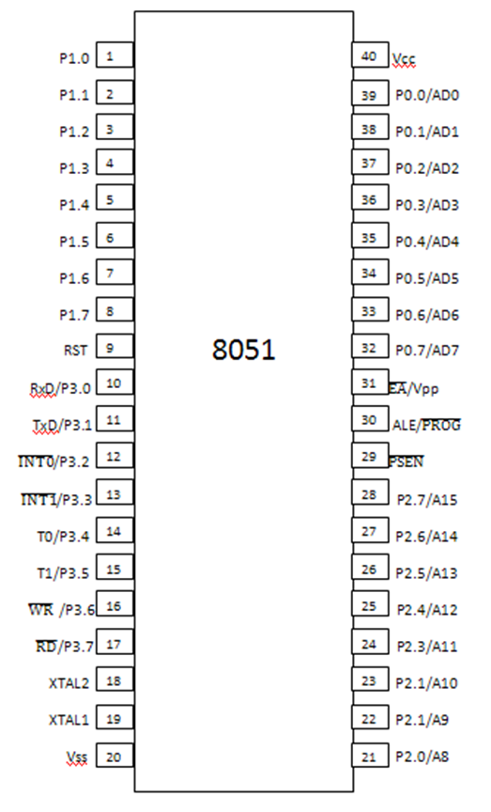

**Figure 1.6Pin Diagram of 8051 IC [2].**

**Pins 1 – 8:-** recognized as Port 1. Different from other ports, this port doesn’t provide any other purpose. Port 1 is a domestically pulled up, quasi bi directional Input/output port.

**Pin 9:-** As made clear previously RESET pin is utilized to set the micro-controller 8051 to its primary values, whereas the micro-controller is functioning or at the early beginning of application. The RESET pin has to be set elevated for two machine rotations.

**Pins 10 – 17:-** recognized as Port 3. This port also supplies a number of other functions such as timer input, interrupts, serial communication indicators TxD & RxD, control indicators for outside memory interfacing WR & RD, etc. This is a domestic pull up port with quasi bi directional port within.

**Pins 18 and 19:-**These are employed for interfacing an outer crystal to give system clock.

**Pin 20:-** Titled as Vss – it symbolizes ground (0 V) association.

**Pins- 21-28:-** recognized as Port 2 (P 2.0 – P 2.7) – other than serving as Input/output port, senior order address bus indicators are multiplexed with this quasi bi directional port.

**Pin- 29:-** Program Store Enable or PSEN is employed to interpret sign from outer program memory.

**Pin-30:-** External Access or EA input is employed to permit or prohibit outer memory interfacing. If there is no outer memory need, this pin is dragged high by linking it to Vcc.

**Pin-31:-** Aka Address Latch Enable or ALE is brought into play to de-multiplex the address data indication of port 0 (for outer memory interfacing). Two ALE throbs are obtainable for every machine rotation.

**Pins 32-39:** recognized as Port 0 (P0.0 to P0.7) – other than serving as Input/output port, low order data & address bus signals are multiplexed with this port (to provide the use of outer memory interfacing). This pin is a bi directional Input/output port (the single one in microcontroller 8051) and outer pull up resistors are necessary to utilize this port as Input/output.

**Pin-40:** termed as Vcc is the chief power supply. By and large it is +5V DC.

### **3. PIC Microcontroller Architecture**

The PIC microcontroller architecture comprises of CPU, I/O ports, memory organization, A/D converter, timers/counters, interrupts, serial communication, oscillator and CCP module which are discussed in detailed below [3].

[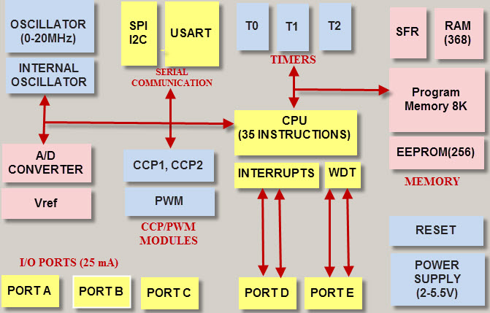](http://www.edgefx.in/wp-content/uploads/2014/08/8-22-2014-5-05-37-PM.jpg)

**Figure 1.7 Architecture of PIC Microcontroller.**

#### CPU (Central Processing Unit)

It is not different from other microcontrollers CPU and the PIC microcontroller CPU consists of the ALU, CU, MU and accumulator, etc. Arithmetic logic unit is mainly used for arithmetic operations and to take logical decisions. Memory is used for storing the instructions after processing. To control the internal and external peripherals, control unit is used which are connected to the CPU and the accumulator is used for storing the results and further process.

#### **3.1 Memory Interfacing**

The memory module in the [PIC microcontroller](http://en.wikipedia.org/wiki/PIC_microcontroller) architecture consists of RAM (Random Access Memory), ROM (Read Only Memory) and STACK.

#### Random Access Memory (RAM)

RAM is an unstable memory which is used to store the data temporarily in its registers. The RAM memory is classified into two banks, and each bank consists of so many registers. The RAM registers are classified into two types: Special Function Registers (SFR) and General Purpose Registers (GPR).

#### General Purpose Registers (GPR)

These registers are used for general purpose only as the name implies. For example, if we want to multiply two numbers by using the PIC microcontroller. Generally, we use registers for multiplying and storing the numbers in other registers. So these registers don’t have any special function,- CPU can easily access the data in the registers.

#### Special Function Registers

These registers are used for special purposes only as the name SFR implies. These registers will perform according to the functions assigned to them , and they  cannot be used as normal registers. For example, if you cannot use the STATUS register for storing the data, these registers are used for showing the operation or status of the program. So, user cannot change the function of the SFR; the function is given by the retailer at the time of manufacturing.

[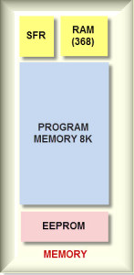](http://www.edgefx.in/wp-content/uploads/2014/08/8-25-2014-4-01-24-PM.jpg)

**Figure 1.8 Memory Organization.**

Memory Organization

#### Read Only Memory (ROM)

Read only memory is a stable memory which is used to store the data permanently. In PIC microcontroller architecture, the architecture ROM stores the instructions or program, according to the program the microcontroller acts. The ROM is also called as program memory, wherein the user will write the program for microcontroller and saves it permanently, and finally the program is executed by the CPU. The microcontroller’s performance depends on the instruction, which is executed by the CPU.

#### Electrically Erasable Programmable Read Only Memory (EEPROM)

In the normal ROM, we can write the program for only once we cannot use again the microcontroller for multiple times. But, in the EEPROM, we can program the ROM multiple times.

#### Flash Memory

Flash memory is also programmable read only memory (PROM) in which we can read, write and erase the program thousands of times. Generally, the PIC microcontroller uses this type of ROM.

#### Stack

When an interrupt occurs, first the PIC microcontroller has to execute the interrupt and the existing process address. Then that is being executed is stored in the stack. After completing the execution of the interrupt, the microcontroller calls the process with the help of address, which is stored in the stack and get executes the process.

#### I/O Ports

* The series of PIC16 consists of five ports such as Port A, Port B, Port C, Port D & Port E.
* Port A is an 16-bit port that can be used as input or output port based on the status of the TRISA (Tradoc Intelligence Support Activity) register.
* Port B is an 8- bit port that can be used as both input and output port.
* Port C is an 8-bit and the input of output operation is decided by the status of the TRISC register.
* Port D is an 8-bit port acts as a slave port for connection to the microprocessor BUS.
* Port E is a 3-bit port which serves the additional function of the control signals to the analog to digital converter.

#### BUS

BUS is used to transfer and receive the data from one peripheral to another. It is classified into two types such as data bus and address.

**Data Bus:**It is used for only transfer or receive the data.

**Address Bus:** Address bus is used to transmit the memory address from the peripherals to the CPU. I/O pins are used to interface the external peripherals; UART and USART both are serial communication protocols which are used for interfacing serial devices like GSM, GPS, Bluetooth, IR etc.

[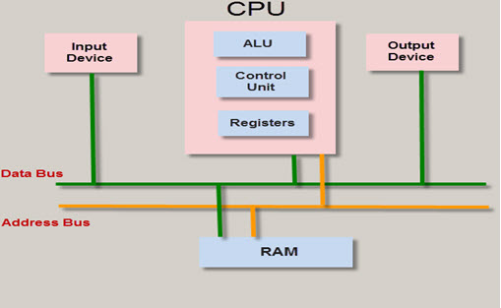](http://www.edgefx.in/wp-content/uploads/2014/08/8-25-2014-4-19-00-PM.jpg)

**Figure 1.9Bus Architecture of PIC.**

BUS

#### A/D converters

The main intention of this analog to digital converter is to convert analog voltage values to digital voltage values. A/D module of PIC microcontroller consists of 5 inputs for 28 pin devices and 8 inputs for 40 pin devices. The operation of the analog to digital converter is controlled by ADCON0 and ADCON1 special registers. The upper bits of the converter are stored in register ADRESH and lower bits of the converter are stored in register ADRESL. For this operation, it requires 5V of an analog reference voltage.

[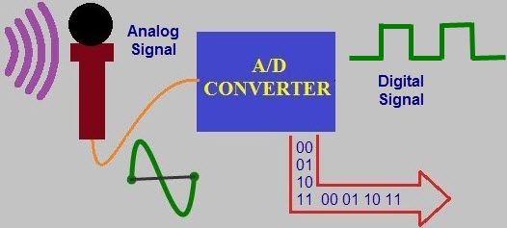](http://www.edgefx.in/wp-content/uploads/2014/08/A-TO-D-CONVERTER.jpg)

**Figure 1.10A/D Conversion process.**

A/D CONVERTER

#### Timers/ Counters

PIC microcontroller has four timer/counters wherein the one 8-bit timer and the remaining timers have the choice to select 8 or 16-bit mode. Timers are used for generating accuracy actions, for example, creating specific time delays between two operations.

#### Interrupts

PIC microcontroller consists of 20 internal interrupts and three external interrupt sources which are associated with different peripherals like ADC, USART, Timers, and so on.

#### Serial Communication

Serial communication is the method of transferring data one bit at a time sequentially over a [communication channel](http://www.edgefx.in/latest-zigbee-communication-based-projects-for-patients-monitoring/).

* **USART:** The name USART stands for Universal synchronous and Asynchronous Receiver and Transmitter which is a serial communication for two protocols. It is used for transmitting and receiving the data bit by bit over a single wire with respect to clock pulses. The PIC microcontroller has two pins TXD and RXD. These pins are used for transmitting and receiving the data serially.
* **SPI Protocol:** The term SPI stands for Serial Peripheral Interface. This protocol is used to send data between PIC microcontroller and other peripherals such as SD cards, [sensors](http://www.edgefx.in/mems-sensors-based-hands-gesture-controlled-robot/) and shift registers. PIC microcontroller support three wire SPI communications between two devices on a common clock source. The data rate of SPI protocol is more than that of the USART.
* **I2C Protocol:** The term I2C stands for Inter Integrated Circuit , and it is a serial protocol which is used to connect low speed devices such as EEPROMS, microcontrollers, A/D converters, etc. PIC microcontroller support two wire Interface or I2C communication between two devices which can work as both Master and Slave device.

[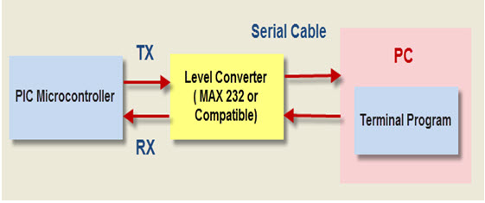](http://www.edgefx.in/wp-content/uploads/2014/08/8-25-2014-4-19-49-PM.jpg)

**Figure 1.10Serial Communication in PIC.**

Serial Communication

#### Oscillators

Oscillators are used for timing generation. Pic microcontroller consist of external oscillators like RC oscillators or crystal oscillators. Where the crystal oscillator is connected between the two oscillator pins. The value of the capacitor is connected to every pin that decides the mode of the operation of the oscillator. The modes are crystal mode, high-speed mode and the low-power mode. In case of RC oscillators, the value of the resistor & capacitor determine the clock frequency and the range of clock frequency is 30KHz to 4MHz.

#### CCP module

The name  CCP module  stands for capture/compare/PWM where it works in three modes such as  capture mode, compare mode and PWM mode.

* **Capture Mode:** Capture mode captures the time of arrival of a signal, or in other words, when the CCP pin goes high, it captures the value of the Timer1.
* **Compare Mode:** Compare mode  acts as an analog comparator. When the timer1 value reaches a certain reference value, then it generates an output.
* **PWM Mode:** PWM mode provides pulse width modulated output with a 10-bit resolution and programmable duty cycle.

#### Advantages of PIC Microcontroller:

* PIC microcontrollers are consistent and faulty of PIC percentage is very less. The performance of the PIC microcontroller is very fast because of using RISC architecture.
* When comparing to other microcontrollers, power consumption is very less and programming is also very easy.
* Interfacing of an analog device is easy without any extra circuitry

#### Disadvantages of PIC Microcontroller:

* The length of the program is high due to using RISC architecture (35 instructions)
* One single accumulator is present and program memory is not accessible

Thus, this is all about PIC microcontroller tutorial which includes PIC microcontroller architecture, advantages, disadvantage and applications. Apart from this, for any help regarding any electronic and electrical projects, you can contact us by commenting in the comment section below.

**3.2 Registers of PIC MCU**

A register is a place inside the PIC that can be written to, read from or both. Think of a register as a piece of paper where you can look at and write information on.

The data memory is partitioned into multiple banks which contain the General Purpose Registers and the Special Function Registers. Number of banks may vary depending on the microcontroller; for example, micro PIC16F84 has only two banks.

Each bank extends up to 7Fh (128 bytes). The lower locations of each bank are reserved for the Special Function Registers. Above the Special Function Registers are General Purpose Registers, implemented as static RAM. While program is being executed, it is working with the particular bank. The default bank is **BANK0.**

**STATUS register**

In most cases, this register is used to switch between the banks (Register Bank Select), but also has other capabilities.

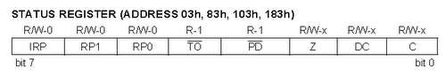

**PIC STATUS register**

With the help of three left bits (IRP, RP1, and RP0) one can control the transition between the banks:

* **IRP - Register Bank Select bit**, used for indirect addressing method.
* **RP1:RP0: - Register Bank Select bits**, used for direct addressing method.

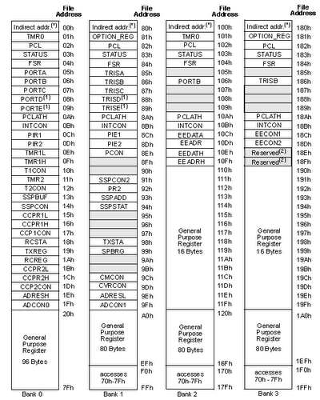

**Figure 1.11Registers in PIC Microcontroller.**

To distinguish between the two methods, at this point, the will use the definition of fundamental concepts. Later on, the two methods will be studied in detail.   
When the IRP Equal to 0, the program will work with banks 0, 1.  
When the IRP Equal to 1, the program will work with banks 2, 3.

The following table demonstrates, which of the Banks the program is working with, based on the selection of the RP0 and RP1 bits:

**Table 1.2 Register banks**

|  |  |
| --- | --- |
| RP1:RP0 | BANK |
| 00 | 0 |
| 01 | 1 |
| 10 | 2 |
| 11 | 3 |

An example of using STATUS register and Register Bank Select bit:

1. bsf STATUS, 5 ; Change to Bank 1
2. clrf TRISB ; Set PORTB as output
3. bcf STATUS, 5 ; Change to Bank 0

In the first line, we are in changing/setting the 5th bit, RP0, in the STATUS register to 1, and thus, base on the table we are switching/selecting Bank 1. After PortB was set as output in the second line, we switched back to Bank 0 by in changing/setting the 5th bit, RP0, in the STATUS register to 0, in the third line.

**C: Carry/borrow bit (ADDWF, ADDLW,SUBLW,SUBWF instructions)**   
1 = A carry-out from the Most Significant bit of the result occurred  
0 = No carry-out from the Most Significant bit of the result occurred

An example of using STATUS register and Carry/borrow bit:

1. Movlw 200
2. Addwf 100, 0

In this example, we are assigning value of 200 to the W (working) register. Then, we are adding the value of 100 and the W register together. The result is stored in W register and should be 300 (200+100).   
However, the maximum value is 256, resulting in carry out. The C (bit 0) of the STATUS register becomes 1 (C = 1). Register W will contain the reminder: 44.

**DC: Digit carry/borrow bit (ADDWF, ADDLW,SUBLW,SUBWF instructions)** (for borrow, the polarity is reversed)  
1 = A carry-out from the 4th low order bit of the result occurred  
0 = No carry-out from the 4th low order bit of the result

**Z: Zero bit**   
1 = The result of an arithmetic or logic operation is zero  
0 = The result of an arithmetic or logic operation is not zero

The bits 3 and 4 are used with WDT - Watchdog Timer.

**PD: Power-down bit**   
1 = After power-up or by the CLRWDT instruction  
0 = By execution of the SLEEP instruction

**TO: Time-out bit**   
1 = After power-up, CLRWDT instruction or SLEEP instruction  
0 = A WDT time-out occurred

**PORT register**

The role of the PORT register is to receive the information from an external source (e.g. sensor) or to send information to the external elements (e.g. LCD). The 28-pin devices have 3 I/O ports, while the 40/44-pin devices, like PIC16F877, have 5 I/O ports located in the BANK 0.

1. PORTA is a 6-bit wide, bidirectional port. The corresponding data direction register is TRISA.  
   Setting a TRISA bit (= 1) will make the corresponding PORTA pin an input. Clearing a TRISA bit (= 0) will make the corresponding PORTA pin an output.
2. PORTB is an 8-bit wide, bidirectional port. The corresponding data direction register is TRISB.  
   Setting a TRISB bit (= 1) will make the corresponding PORTB pin an input. Clearing a TRISB bit (= 0) will make the corresponding PORTB pin an output.
3. PORTC is an 8-bit wide, bidirectional port. The corresponding data direction register is TRISC.   
   Setting a TRISC bit (= 1) will make the corresponding PORTC pin an input. Clearing a TRISC bit (= 0) will make the corresponding PORTC pin an output.
4. PORTD is an 8-bit port with Schmitt Trigger input buffers. Each pin is individually configurable as an input or output.
5. PORTE has three pins (RE0/RD/AN5, RE1/WR/AN6 and RE2/CS/AN7) which are individually configurable as inputs or outputs. These pins have Schmitt Trigger input buffers.

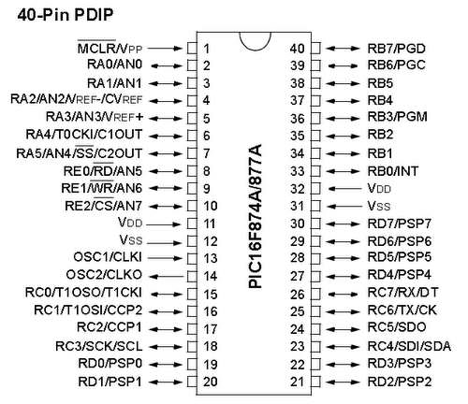  
**Figure 1.12 Pin diagram of PIC16F877A**.

We can control each port by using an assigned address of specific port, but there is much easier way to control the port. We are allowed to use the names of the ports without considering their addresses.

For example:   
# define SWITCH PORTA, 0

We define a variable named SWITCH, which received a value of bit number 0 of the PORTA. Usually we define the ports at the beginning of the program, and then we use only the given names.

**TRIS register**

The TRIS register is data direction register which defines if the specific bit or whole port will be an input or an output. Each PORT has its own TRIS register. Here's a map of the locations:

**Table 1.3 TRIS Register**

|  |  |
| --- | --- |
| **BANK0** | **BANK1** |
| PORTA | TRISA |
| PORTB | TRISB |
| PORTC | TRISC |
| PORTD | TRISD |
| PORTE | TRISE |

The default mode of each TRIS is input. If you want to set a specific port as exit you must change the state of the TRIS to 0.

*Keep in mind:* to change a specific port to an output, one should first move to the BANK1, make the change, and then return to BANK0. The default state of the banks is BANK0.

The running program is working only with one bank at all time. If not set otherwise, then as stated, the default bank is BANK0. Part of the registers located inside BANK0, and some are not. When we need to access a register that is not located inside BANK0, we are required to switch between the banks.

For example, the access to PORT registers is done inside BANK0. However, to change port from an input to an output and vice versa, we need to access TRIS register that is located inside BANK1. From the moment we moved to the BANK1, the program will always work with BANK1; at this time, to access registers inside BANK0, we will have to return to the situation in which our program will work with BANK0.

**Interfacing EEPROM with PIC Microcontroller**

What is an EEPROM ?

EEPROM is an abbreviation for Electrically Erasable Programmable Read Only Memory and it is a Non-Volatile memory. It is used in computers and other electronic devices to store data that must be saved during no power supply. EEPROM is a class of ROM (Read Only Memory) which can be electrically erased in bit by bit and able to store new data. A small amount of EEPROM (usually 128/256 bytes) is available internally with PIC Microcontrollers.

But if the amount of data that we required to store in EEPROM is large, say in the order of Kilobytes then we have to interface external EEPROM with PIC Microcontroller.

Pin Description of 24C64 EEPROM

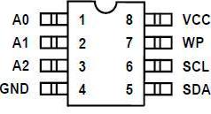

**Figure 1.13 Pin Description of 24C64 EEPROM**

* **A0, A1, A2** – Chip Address Inputs : These inputs are used for multiple device operations.
* **WP – Write Protect** : When this pin is kept LOW (grounded) normal read and write operations are possible but when it is HIGH (Vcc) write operations will be inhibited.
* **Vcc and Vss** : Vcc is the positive DC supply pin. The device is able to work with in 1.8 to 5.5V range. Vss is the ground pin (0v).
* **SDA – Serial Data** : This is bidirectional pin used to transfer data and address to and from the device.
* **SCL – Serial Clock** : This pin is used to synchronize data transfer through SDA.

Basic Read/write operations in PIC

1. **Byte write** : In this mode one byte is written at a time. After giving the START signal, the master send control byte, the control code (four bits), the chip select (three bits), and the R/W bit (which is a logic low) via I2C bus.

Code for Byte write operation :

void write_EEPROM(unsigned int address, unsigned int dat)

{

unsigned int temp;

I2C1_Start(); // issue I2C start signal

I2C1_Wr(0xA0); // send byte via I2C (device address + W)

temp = address >> 8; //saving higher order address to temp

I2C1_Wr(temp); //sending higher order address

I2C1_Wr(address); //sending lower order address

I2C1_Wr(dat); // send data (data to be written)

I2C1_Stop(); // issue I2C stop signal

Delay_ms(20);

}

2. **Random read** : Random read operation allows master to access any memory location in random manner. To perform this type of operation, we want to set the address in internal address counter to the required value. This is achieved by sending address to 24XX64 EEPROM as the part of write operation. After the acknowledge of this process, the master issues a START signal and control byte for read operation. Thus the required random memory location can be easily accessed.

Code for random read operation :

unsigned int read_EEPROM(unsigned int address)

{

unsigned int temp;

I2C1_Start(); // issue I2C start signal

I2C1_Wr(0xA0); // send byte via I2C (device address + W)

temp = address >> 8; //saving higher order address to temp

I2C1_Wr(temp); //sending higher order address

I2C1_Wr(address); //sending lower order address

I2C1_Repeated_Start(); // issue I2C signal repeated start

I2C1_Wr(0xA1); // send byte (device address + R)

temp = I2C1_Rd(0u); // Read the data (NO acknowledge)

I2C1_Stop();

return temp;

}

In this example we write 00000001 to the first memory location, 00000010 to second, 000000100 to third etc sequentially up to 10000000. Then it is read sequentially and output through PORTB.

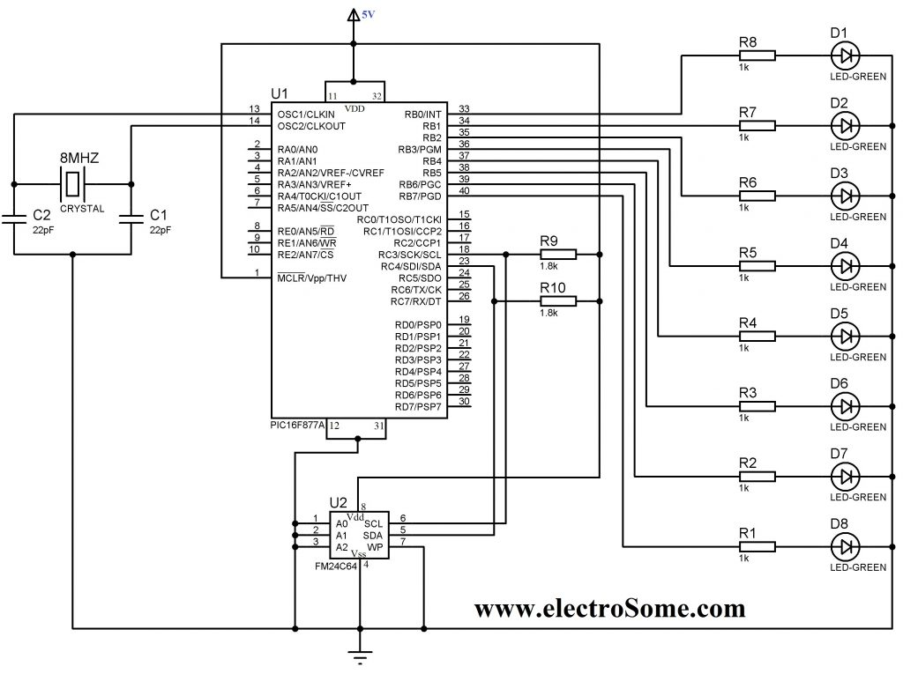

**Figure 1.14Circuit Diagram showing the interfacing between PIC and EEPROM**

**3.3 Interrupts in PIC Microcontroller**

PIC MCUs can have many sources of interrupt. These sources generally include one interrupt source for each peripheral module, though some modules may generate multiple interrupts (such as the USART module). The current interrupts are: • INT Pin Interrupt (external interrupt)

* + TMR0 Overflow Interrupt
  + PORTB Change Interrupt (pins RB7:RB4)
  + Comparator Change Interrupt
  + Parallel Slave Port Interrupt
  + USART Interrupts
  + Receive Interrupt
  + Transmit Interrupt
  + A/D Conversion Complete Interrupt
  + LCD Interrupt.
  + Data EEPROM Write Complete Interrupt
  + Timer1 Overflow Interrupt
  + Timer2 Overflow Interrupt
  + CCP Interrupt
  + SSP Interrupt There is a minimum of one register used in the control and status of the interrupts. This register is:
  + INTCON Additionally, if the device has peripheral interrupts, then it will have registers to enable the peripheral interrupts and registers to hold the interrupt flag bits. Depending on the device, the registers are:
  + PIE1
  + PIR1
  + PIE2
  + PIR2

We will generically refer to these registers as PIR and PIE. If future devices provide more interrupt sources, they will be supported by additional register pairs, such as PIR3 and PIE3. The Interrupt Control Register, INTCON, records individual flag bits for core interrupt requests. It also has various individual enable bits and the global interrupt enable bit.

**Control Registers**

Generally devices have a minimum of three registers associated with interrupts. The INTCON register which contains Global Interrupt Enable bit, GIE, as well as the Peripheral Interrupt Enable bit, PEIE, and the PIE / PIR register pair which enable the peripheral interrupts and display the interrupt flag status.

**INTCON Register**

The INTCON Register is a readable and writable register which contains various enable and flag bits. 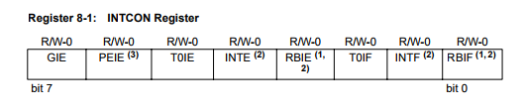

**bit 7 GIE**:

Global Interrupt Enable bit

1 = Enables all un-masked interrupts

0 = Disables all interrupts

**bit 6 PEIE**:

Peripheral Interrupt Enable bit

1 = Enables all un-masked peripheral interrupts

0 = Disables all peripheral interrupts

**bit 5 T0IE**:

TMR0 Overflow Interrupt Enable bit

1 = Enables the TMR0 overflow interrupt

0 = Disables the TMR0 overflow interrupt

**bit 4 INTE**:

INT External Interrupt Enable bit

1 = Enables the INT external interrupt

0 = Disables the INT external interrupt

**bit 3 RBIE (1)**:

RB Port Change Interrupt Enable bit

1 = Enables the RB port change interrupt

0 = Disables the RB port change interrupt

**bit 2 T0IF**:

TMR0 Overflow Interrupt Flag bit

1 = TMR0 register has overflowed (must be cleared in software)

0 = TMR0 register did not overflow

**bit 1 INTF**:

INT External Interrupt Flag bit

1 = The INT external interrupt occurred (must be cleared in software)

0 = The INT external interrupt did not occur

**bit 0 RBIF (1)**:

RB Port Change Interrupt Flag bit

1 = At least one of the RB7:RB4 pins changed state (must be cleared in software)

0 = None of the RB7:RB4 pins have changed state Legend R = Readable bit W = Writable bit U = Unimplemented bit, read as ‘0’ - n = Value at POR reset

**PIE Register(s)**

Depending on the number of peripheral interrupt sources, there may be multiple Peripheral Inter-rupt Enable registers (PIE1, PIE2). These registers contain the individual enable bits for the Peripheral interrupts. These registers will be generically referred to as PIE. If the device has a PIE register, The PEIE bit must be set to enable any of these peripheral interrupts.

**Note:**Bit PEIE (INTCON<6>) must be set to enable any of the peripheral interrupts.

Although, the PIE register bits have a general bit location with each register, future devices may not have consistent placement. Bit location inconsistencies will not be a problem if you use the supplied Microchip Include files for the symbolic use of these bits. This will allow the Assem-bler/Compiler to automatically take care of the placement of these bits by specifying the correct register and bit name.

|  |  |  |  |  |  |  |
| --- | --- | --- | --- | --- | --- | --- |
| **PIE Register** | | | |  |  |  |
|  |  | |  | R/W-0 |  |  |
|  |  | |  | (Note 1) | | |
|  | bit 7 | | |  | bit 0 | |
| bit | **TMR1IE**: TMR1 Overflow Interrupt Enable bit | | | |  |  |
|  |  | | 1= Enables the TMR1 overflow interrupt | |  |  |
|  |  | | 0= Disables the TMR1 overflow interrupt | |  |  |
| bit | **TMR2IE**: TMR2 to PR2 Match Interrupt Enable bit | | | |  |  |
|  |  | | 1= Enables the TMR2 to PR2 match interrupt | |  |  |
|  |  | | 0= Disables the TMR2 to PR2 match interrupt | |  |  |
|  |  | | 1= Enables the CCP1 interrupt | |  |  |
|  |  | | 0= Disables the CCP1 interrupt | |  |  |
| bit | **CCP2IE**: CCP2 Interrupt Enable bit | | | |  |  |
|  |  | | 1= Enables the CCP2 interrupt | |  |  |
|  |  | | 0= Disables the CCP2 interrupt | |  |  |
| bit | **SSPIE**: Synchronous Serial Port Interrupt Enable bit | | | | | |
|  |  | | 1= Enables the SSP interrupt | |  |  |
|  |  | | 0= Disables the SSP interrupt | |  |  |
| bit | **RCIE**: USART Receive Interrupt Enable bit | | | |  |  |
|  |  | | 1= Enables the USART receive interrupt | |  |  |
|  |  | | 0= Disables the USART receive interrupt | |  |  |
| bit | **TXIE**: USART Transmit Interrupt Enable bit | | | |  |  |
|  |  | | 1= Enables the USART transmit interrupt | |  |  |
|  |  | | 0= Disables the USARTtransmit interrupt | |  |  |
| bit | **ADIE**: A/D Converter Interrupt Enable bit | | | |  |  |
|  |  | | 1= Enables the A/D interrupt | |  |  |
|  |  | | 0= Disables the A/D interrupt | |  |  |
| bit | **ADCIE**: Slope A/D Converter comparator Trip Interrupt Enable bit | | | | | |
|  |  | | 1= Enables the Slope A/D interrupt | |  |  |
|  |  | | 0= Disables the Slope A/D interrupt | |  |  |
| bit | **OVFIE**: Slope A/D TMR Overflow Interrupt Enable bit | | | | | |
|  |  | | 1= Enables the Slope A/D TMR overflow interrupt | | | |
|  |  | | 0= Disables the Slope A/D TMR overflow interrupt | | | |
| bit | **PSPIE:** Parallel Slave Port Read/Write Interrupt Enable bit | | | | | |
|  |  | | 1= Enables the PSP read/write interrupt | |  |  |
|  |  | | 0= Disables the PSP read/write interrupt | |  |  |
| bit | **EEIE**: EE Write Complete Interrupt Enable bit | | | |  |  |
|  |  | | 1= Enables the EE write complete interrupt | |  |  |
|  |  | | 0= Disables the EE write complete interrupt | |  |  |
| bit | **LCDIE**: LCD Interrupt Enable bit | | | |  |  |
|  |  | | 1= Enables the LCD interrupt | |  |  |
|  |  | | 0= Disables the LCD interrupt | |  |  |
| bit | **CMIE**: Comparator Interrupt Enable bit | | | |  |  |
|  |  | 1= Enables the Comparator interrupt | | |  |  |
|  |  | 0= Disables the Comparator interrupt | | |  |  |

**PIR Register(s)**

Depending on the number of peripheral interrupt sources, there may be multiple Peripheral Inter-rupt Flag registers (PIR1, PIR2). These registers contain the individual flag bits for the peripheral interrupts. These registers will be generically referred to as PIR.

Although, the PIR bits have a general bit location within each register, future devices may not be able to be consistent with that. It is recommended that you use the supplied Microchip Include files for the symbolic use of these bits. This will allow the Assembler/Compiler to automatically take care of the placement of these bits within the specified register.

**PIR Register**

bit**ADCIF**: Slope A/D Converter Comparator Trip Interrupt Flag bit1 = An A/D conversion completed (must be cleared in software) 0 = The A/D conversion is not complete

bit**OVFIF**: Slope A/D TMR Overflow Interrupt Flag bit

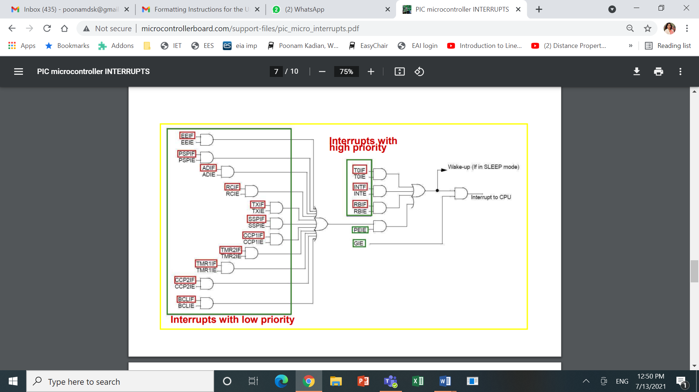

**Figure 1.15 PIC16F877 Interrupts**

1 = Slope A/D TMR overflowed (must be cleared in software)

0 = Slope A/D TMR did not overflow

Bit**PSPIF:** Parallel Slave Port Read/Write Interrupt Flag bit

1 = A read or a write operation has taken place (must be cleared in software)

0 = No read or write has occurred

Bit**EEIF**: EE Write Complete Interrupt Flag bit

1 = The data EEPROM write operation is complete (must be cleared in software)

0 = The data EEPROM write operation is not complete

Bit**LCDIF**: LCD Interrupt Flag bit

1 = LCD interrupt has occurred (must be cleared in software)

0 = LCD interrupt has not occurred

Bit**CMIF**: Comparator Interrupt Flag bit

1 = Comparator input has changed (must be cleared in software)

0 = Comparator input has not changed

**3.3 PIC INSTRUCTION**

The [PIC](https://en.wikipedia.org/wiki/PIC_microcontroller) [instruction set](https://en.wikipedia.org/wiki/Instruction_set) refers to the set of instructions that a [Microchip Technology](https://en.wikipedia.org/wiki/Microchip_Technology) PIC or dsPIC [microcontroller](https://en.wikipedia.org/wiki/Microcontroller) supports. The instructions are usually programmed into the [Flash memory](https://en.wikipedia.org/wiki/Flash_memory) of the processor, and automatically executed by the microcontroller on startup.

PICmicro chips have a [Harvard architecture](https://en.wikipedia.org/wiki/Harvard_architecture), and instruction words are unusual sizes. Originally, 12-bit instructions included 5 address bits to specify the memory operand, and 9-bit branch destinations. Later revisions added opcode bits, allowing additional address bits.

In the instruction set tables that follow, register numbers are referred to as "f", while constants are referred to as "k". Bit numbers (0–7) are selected by "b". The "d" bit selects the destination: 0 indicates W, while 1 indicates that the result is written back to source register f. The C and Z status flags may be set based on the result; otherwise they are unmodified. Add and subtract (but not rotate) instructions that set C also set the DC (digit carry) flag, the carry from bit 3 to bit 4, which is useful for [BCD](https://en.wikipedia.org/wiki/Binary-coded_decimal) arithmetic.

**Architecture**

Memory operands are also referred to as "registers". Most are simply general-purpose storage (RAM), while some locations are reserved for *special function registers*. Except for a single accumulator (called W), almost all other registers are memory-mapped, even registers like the [program counter](https://en.wikipedia.org/wiki/Program_counter) and ALU [status register](https://en.wikipedia.org/wiki/Status_register). (The other exceptions, which are not memory-mapped, are the return address stack, and the [tri-state](https://en.wikipedia.org/wiki/Three-state_logic) registers used to configure the [GPIO](https://en.wikipedia.org/wiki/GPIO) pins.)

The instruction set does not contain conditional branch instructions. Instead, it contains conditional skip instructions which cause the following instruction to be ignored. A conditional skip followed by an unconditional branch performs a conditional branch. The skip instructions test any bit of any register. The ALU status register is one possibility.

Memory operands are specified by [absolute address](https://en.wikipedia.org/wiki/Addressing_mode#Absolute_or_direct); the location is fixed at [compile time](https://en.wikipedia.org/wiki/Compile_time). To provide indirect addressing, a pair of special function registers are provided:

* The *file select register* (FSR) is written with the address of the desired memory operand, after which
* The *indirect file* register (INDF) becomes an [alias](https://en.wikipedia.org/wiki/Aliasing_(computing)) for the operand [pointed to](https://en.wikipedia.org/wiki/Pointer_(computer_programming)) by the FSR.

This mechanism also allows up to 256 bytes of memory to be addressed, even when the instruction set only allows 5- or 7-bit memory operands. Models with more registers (special function registers plus RAM) than fit into the instruction provide multiple banks of memory, and use one of two mechanisms for accessing them:

1. Most baseline core devices, and some mid-range core devices, use the high-order bits of the file select register to select the current register bank.
2. More recent models have a separate *bank select register*, and a MOVLB instruction to set it.

|  |
| --- |
| **Instruction set:**  **Table 1.4 Instruction Set** |
| |  |  | | --- | --- | | **Mnemonics** | **Description** | | bcf f, b | Clear bit b of register f | | bsf f, b | Set bit b of register f | | clrw | Clear working register W | | clrf f | Clear f | | movlw k | Move literal 'k' to W | | movwf f | Move W to f | | movf f, F(W) | Move f to F or W | | swapf f, F(W) | Swap nibbles of f, putting result in F or W | | andlw k | And literal value into W | | andwf f, F(W) | And W with F and put the result in W or F | | andwf f, F(W) | And W with F and put the result in W or F | | iorlw k | inclusive-OR literal value into W | | iorwf f, F(W) | inclusive-OR W with f and put the result in F or W | | xorlw k | Exclusive-OR literal value into W | | xorwf f, F(W) | Exclusive-OR W with f and put the result in F or W | | addlw k | Add the literal value to W and store the result in W | | addwf f, F(W) | Add W to f and store the result in F or W | | sublw k | Subtract the literal value from W and store the result in W | | subwf f, F(W) | Subtract f from W and store the result in F or W | | rlf f, F(W) | Copy f into F or W; rotate F or W left through the carry bit | |

**3.4 PROGRAMMING AND PERIPHERALS OF PIC**

Programming of PIC microcontroller:

The recent trends in the advanced technology are helpful in developing most advanced electronic gadgets. Most of these electronic devices are developed using microcontrollers. The microcontroller is an electronic component, which is programmed to perform various control operations. There are various kinds of microcontrollers available, such as [8051, AVR, ARM, and PIC microcontrollers](https://www.elprocus.com/microcontrollers-types-and-applications/), etc., which are programmed by using the integrated development tools.

The [PIC microcontroller is programmed by the embedded C language](https://www.elprocus.com/introduction-to-pic-microcontrollers-and-its-architecture/) or assembly language by using appropriate dedicated software. Before going to build a PIC microcontroller project, we must become aware of developing a basic microcontroller (like 8051) based project. Once you get the idea, this controller based project building becomes easy, so let us look at the [basic steps to build a PIC microcontroller based project](https://www.elprocus.com/how-to-program-the-microcontroller/).

Before going to program the PIC microcontroller, first we have to select the right project that you are going program the microcontroller. As of now, consider the LEDs flash light system.

The LEDs flashlight uses a set of light emitting diodes, and these are advanced to the [traditional incandescent lights which consume more energy](https://www.elprocus.com/top-3-ways-get-energy-efficient-lighting/) and have very less life time. The LED lights on the other hand, consume less energy and have longer life. The microcontroller generates the output logic pulses so that the LED light is switched ON and OFF at certain intervals. It is a [40 pin microcontroller](https://www.elprocus.com/8051-microcontroller-architecture-and-applications/). The Crystal interfaced to the input pins of the microcontroller provide accurate clock signals at the crystal frequency.

The PIC microcontroller programming is performed through ‘MP-Lab’ software. First instal the MP-Lab software, then select and install the compiler like CCS, GCC compiler, etc. Here ‘CCS C compiler’ is used for building the program.

* First open the MPLAB software. This shows the menu bar with file, edit, view, project and tools option.
* Select the project option and select the ‘project wired option’ from the drop-down menu. This will show the project wired window.
* [Select a microcontroller for your project](https://www.elprocus.com/ways-to-select-microcontroller-for-microcontroller-based-projects/). Here ‘PIC16f877A’ microcontroller is selected.
* Select the compiler and path location for your project. Here  ‘CCS C compiler’ is selected for the PIC microcontroller, then select the ‘browse’ option from the project wired window to select the ‘ccsloader’ in the PICC  folder from the program files.  A folder with the name ‘source group’ is created in the ‘target’ folder.
* Give a name to the project and click on ‘NEXT’ button to save the project. A folder with the name ‘source group’ is created in the ‘target’ folder.. Click on the ‘file’ menu on the menu bar. Select ‘new file’ from the drop- down menu.

**Load the Code to PIC Microcontroller**

* The code loading process of microcontroller is called dumping. The microcontrollers understand only the machine level language, which contains ‘0 or 1s’. So we need to load the hex code into the microcontroller. There are many software available in the market for loading the code to the microcontroller. Here we have used ‘PICFLSH’ programmer software to dump the code to the PIC microcontroller. The programmer kit comes with the hardware kit along with the software.
* This software needs to be installed into the computer. The microcontroller placed in the hardware kit, which comes with the socket. Here are the steps to load the code onto the microcontroller.

### Simulating the Circuit

The simulation is a decision analysis and support tool, which is used to know the performance of the circuit. The hardware is the cost-effective equipment, so the proposed action cannot be directly observed by the hardware. The simulation software allows you to know the circuit performance and find & rectify the errors of the program. There are different types of simulating softwares available in the market for checking the circuit performance.  Here Proteous software is used to check the circuit performance.

* Open the project in the **Proteus** software.
* Click on the ‘**Debug**’ menu.
* Select the ‘**start debugging**’ option. The LED starts blinking, which indicates the circuit is running.
* After some time, select the ‘**stop debugging**’ option. The LED will now stop blinking.

Peripherals of PIC:

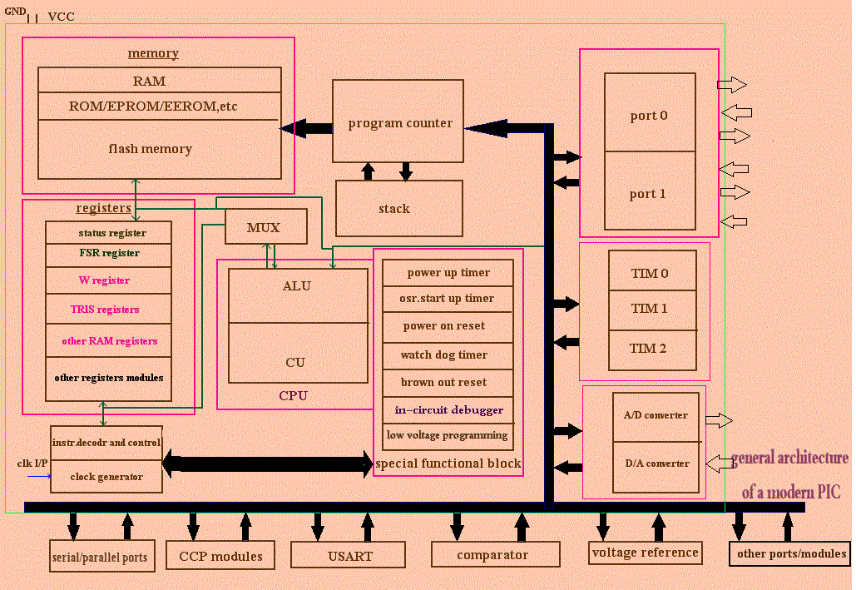

**Figure 1.15 Peripheral of PIC Microcontroller.**

Peripheral Interface Controllers (PIC) is one of the advanced microcontrollers developed by microchip technologies. These microcontrollers are widely used in modern electronics applications.  A PIC controller integrates all type of advanced interfacing ports and memory modules. These controllers are more advanced than normal microcontroller like INTEL 8051. The first PIC chip was announced in 1975 (PIC1650). As like normal microcontroller, the   PIC   chip also combines a microprocessor unit called CPU and is integrated with various types of memory modules (RAM, ROM, EEPROM ,etc), I/O ports, timers/counters, communication ports, etc. All PIC microcontroller family uses Harvard architecture. This architecture has the program and data accessed from separate memories so the device has a program memory bus and a data memory bus (more than 8 lines in a normal bus). This improves the bandwidth (data throughput) over traditional von Neumann architecture where program and data are fetched from the same memory (accesses over the same bus). Separating program and data memory further allows instructions to be sized differently than the 8-bit wide data word.

### CPU

The function of CPU in PIC is same as a normal microcontroller CPU. A PIC CPU consists of several sub units such as instruction decoder, ALU, accumulator, control unit, etc. The CPU in PIC normally supports Reduced Instruction Set Computer (RISC) architecture (Reduced Instruction Set Computer (RISC), a type of microprocessor that focuses on rapid and efficient processing of a relatively small set of instructions. RISC design is based on the premise that most of the instructions a computer decodes and executes are simple. As a result, RISC architecture limits the number of instructions that are built into the microcontroller but optimizes each so it can be carried out very rapidly (usually within a single clock cycle.) . These RISC structure gives the following advantages.  
•     The RISC structure only has 35 simple instructions as compared to others  
•    The execution time is same for most of the instructions (except very few numbers).  
•    The execution time required is very less (5 million instructions/second (approximately).

### Memory

The memory in a PIC chip used to store the data and programs temporary or permanently. As like normal microcontrollers, the PIC chip also has certain amount of RAM, ROM, EEPROM, other flash memory, etc.  
ROM memory is used for permanent storage. The ROM memory also called as n program memory. A PI chip has certain amount of ROM memory.  
EEPROM memory is another category of ROM memory. The contents in the EEPROM changes during run time and at that time it acts like a RAM memory. But the difference is   after the power goes off   , the data remains in this ROM chip. This is the one of the special advantages of EEPROM. In the PIC chip   the function of EPROM is to store the values created during the runtime.  
RAM memory is the one of the complex memory module in a PIC chip. This memory associated with various type of registers (special function registers and general purpose registers) and memory BANK modules (BANK 0, BANK 1, etc.). Once the power goes off, the contents in the RAM will be cleared. As like normal microcontrollers, the RAM memory is used to store temporary data and provide immediate results.

### Flash memory

This is a special type of memory where READ, WRITE, and ERASE operations can be done many times. This type of memory was invented by INTEL corporation in 1980. A PIC Chip normally contains a certain amount of flash memory.

### Registers

Information is stored in a CPU memory location called a register. Registers can be thought of as the CPU’s tiny scratchpad, temporarily storing instructions or data. Registers basically classified into the following.

**1)**GeneralPurposeRegister(GPR)  
A general purpose register (or processor register) is a small storage area available on a CPU whose contents can be accessed more quickly than other storage that available on PIC. A general purpose register can store both data addresses simultaneously.

**2)SpecialFunctionregisters(SFR)**  
These are also a part of RAM memory locations. As compared to GPR, their purpose is predetermined during the manufacturing time and cannot be changed by the user. It is only for special dedicated functions.

### Interrupts

Interrupt is the temporary delay in a running program. These delays stop the current execution for a particular interval. This interval/delay is usually called as interrupt. When an interrupt request arrives into a current execution program, then it stops its regular execution. Interrupt can be performed by externally (hardware interrupt) or internally (by using software).

### Bus

BUS is the communication or data transmission/reception path in a microcontroller unit. In a normal microcontroller chip, two types of  buses are normally available.

**1)  Data bus**

Data bus is used for memory addressing. The function of data bus is interfacing all the circuitry components inside the PIC chip.

2)Addressbus  
Address bus mostly used for memory addressing. The function of address bus is to transmit the address from the CPU to memory locations.

### **USART or UART**

These ports are used for the transmission (TX) and reception (RX) of data. These transmissions possible with help of various digital data transceiver modules like RF, IR, Bluetooth, etc. This is the one of the simplest way to communicate the PIC chip with other devices.

### Oscillators

Oscillator unit basically an oscillation/clock generating circuit which is used for providing proper clock pulses to the PIC chip. This clock pulses also helps the timing and counting applications. A PIC chip normally use various types of clock generators. According to the application and the type of PIC used, the oscillators and its frequencies may vary. RC (Resistor-Capacitor), LC (Inductor-Capacitor), RLC (Resistor-Inductor-capacitor), crystal oscillators, etc are the normal oscillators used with A PIC chip.

### **STACK**

The entire PIC chip has an area for storing the return addresses. This area or unit called Stack is used in some Peripheral interface controllers. The hardware stack is not accessible by software. But  for most of the controllers, it can be easily accessible.

### Input/output ports

These ports are used for the interfacing various input/output devices and memories. According to the type of PIC, the number of ports may change.

### Advanced functioning blocks

These sections include various advanced features of a PIC chip. According to the type of PIC, these features may change. Various advanced features in a peripheral interface controller are power up timer, oscillator start up timer, power on reset, watch dog timer, brown out reset, in circuit debugger, low voltage programming, voltage comparator, CCP modules etc.

### Limitations of PIC Architecture

•    Peripheral Interface Controller has only one accumulator.  
•    Small instruction set.  
•    Register banking switch required to access RAM of other devices.  
•Operations and registers are not orthogonal.  
•    Program memory is not accessible.

### Advantages of PIC Controlled System

**Reliability**  
The PIC controlled system often resides machines that are expected to run continuously for many years without any error and in some cases recover by themselves if an error occurs(with help of supporting firmware).

**Performance**  
Many of the PIC based embedded system use a simple pipelined RISC processor for computation and most of them provide on-chip SRAM for data storage to improve the performance.

**Power consumption**  
A PIC controlled system operates with minimal power consumption without sacrificing performance. Power consumption can be reduced by independently and dynamically controlling multiple power platforms.

**Memory**  
Most of the PIC based systems are memory expandable and will help in easily adding more and more memory according to the usage and type of application. In small applications the inbuilt memory can be used.

**1.5 8051 Microcontroller programs**

* 1. **Write a program to show the addition of two numbers.**

MOV A,#10H

MOV B,#20H

ADD A,B

MOV P3,A

**OUTPUT**= 30H

* 1. **Write a program to subtract two numbers.**

MOV A,#20H

MOV B,#10H

SUBB A,B

MOV P3,A

**OUTPUT**= 10H

* 1. **Write a program to divide two numbers.**

MOV A,#95H

MOV B,#10H

DIV AB

MOV P3,A

**OUTPUT**

A= 09 H (QUOTIENT)

B= 05 H (REMAINDER)

* 1. **Write a program to multiply two numbers**

MOV A,#25H

MOV B,#65H

MUL AB

MOV P3,A

SOURCE FILE NAME : NNN.ASM

0000 7495 MOV A,#95H

0002 75F010 MOV B,#10H

0005 A4 MUL AB

0006 F5B0 MOV P3,A

No errors detected.

**OUTPUT**

E99

B=0E H A=99 H

* 1. **Write a program to perform multiplication without using MUL Instruction**

MOV A,#00h

MOV B,#04h

MOV R0,#02h

L1: ADD A,R0

DJNZ B,L1

MOV P1,A

# Output:-

00001000

* 1. **Write a program to perform division without using DIV Instruction.**

L2:MOV A,#09H

MOV R0,#02H

MOV R1,#00H

SUBB A,R0

JC L1

INC R1

SJMP L2

L1: CPL A

INC A

MOV R2,A

**OUTPUT**

R1=04H

R2= 01H

* 1. **Write a program to add first ten natural numbers**

MOV A,#00H

MOV R2,#10

MOV R0,#00H

L1:INC R0

ADD A,R0

DJNZ R2,L1

MOV P3,A

SOURCE FILE NAME : ASM

0000 7400 MOV A,#00H

0002 7A0A MOV R2,#10

0004 7800 MOV R0,#00H

0006 08 L1:INC R0

0007 28 ADD A,R0

0008 DAFC DJNZ R2,L1

000A F5B0 MOV P3,A

SYMBOL TABLE :

L1 0006

No errors detected.

**OUTPUT=37H**

* 1. **Write a program to show alternate LED on/off**

MAIN:MOV A, #55H

MOV P0,A

ACALL DELAY

MOV A, #AAH

MOV P0,A

SJMP MAIN

DELAY: MOV R0,#255

L2: MOV R1,#13

L1: DJNZ R1,L1

DJNZ R2,L2

RET

* 1. **Write a program to generate a pulse of width of 5ms.**

L3: MOV P3,#00H

LCALL DELAY

MOV P3,#0FFH

LCALL DELAY

SJMP L3

DELAY:MOV R0,#255

L2: MOV R1,#13

L1: DJNZ R1,L1

DJNZ R2,L2

RET

* 1. **Write a program to toggle all the bits of p0, p1, p2 every ¼ of a second.**

BACK:MOV A,#55H

MOV P0,A

MOV P1,A

MOV P2,A

LCALL DELAY

MOV A,#0AAH

MOV P0,A

MOV P1,A

MOV P2,A

LCALL DELAY

SJMP BACK

DELAY:

MOV R1,#255

L3:MOV R2,#255

L2:MOV R3,#05

L1:DJNZ R3,L1

DJNZ R2,L2

DJNZ R1,L3

RET

* 1. **Write a program to display data 0-9 on seven segment display.**

START:MOV P0,#0C0H

ACALL DELAY

MOV P0,#F9H

ACALL DELAY

MOV P0,#0A4H

ACALL DELAY

MOV P0,#B0H

ACALL DELAY

MOV P0,#99H

ACALL DELAY

MOV P0,#92H

ACALL DELAY

MOV P0,#82H

ACALL DELAY

MOV P0,#0F8H

ACALL DELAY

MOV P0,#80H

ACALL DELAY

MOV P0,#98H

ACALL DELAY

SJMP START

DELAY:

MOV R7,#10

L3:MOV R5,#255

L2:MOV R6,#255

L1:DJNZ R6,L1

DJNZ R5,L2

DJNZ R7,L3

RET

* 1. **Write a program to display data 0-99 on seven segment display.**

ORG 0100H

MOV A,00H

MOV P1,A

L4: CLR A

MOV R0,#10

MOV DPTR,#1000H

L3: MOV R1,#10

L2: MOV R2,#255

L1: CLR P1.1

SETB P1.0

MOV A,R1

MOVC A,@A+DPTR

MOV P0,A

ACALL DELAY

CLR P1.0

SETB P1.1

MOV A,R0

MOVC A,@A+DPTR

MOV P0,A

ACALL DELAY

DJNZ R2,L1

DJNZ R1,L2

DJNZ R0,L3

SJMP L4

DELAY: MOV R3,#255

HERE: NOP

DJNZ R3,HERE

RET

ORG 1001H

db 098H,080H,0F8H,082H,092H,099H,0B0H,0A4H,0F9H,0C0H

**1.6 PIC Microcontroller programs**

**1. Write a program to Interfacing of LED Bar Graph with PIC Microcontroller**

#include <PIC.H>

//__CONFIG(WDTDIS & LVPDIS & PWRTEN & XT);

__CONFIG(FOSC_HS & PWRTE_ON & WDTE_OFF & CP_OFF & LVP_OFF);

/* LED Bar Graph data and clock pin define at port C */

#define ROW_data RC0

#define ROW_Clock RC1

#define COL_data RC2

#define COL_Clock RC3

#define Enable RC4

/********************* Function Prototype****************************************/

void row_Clock();

void col_Clock();

void out_enable();

void N_data();

void DelayMs(unsigned int count);

/*********************************Main Program*****************************/

void main()

{

unsigned int k;

TRISC = 0x00;

PORTC = 0x00;

Enable = 0;

while(1) // Loop will work for Infinite times

{

N_data();

}

}

/************************** SUBROUTINES******************************/

/**************************N character display***************************/

void N_data()

{

// first Column

COL_data = 1; col_Clock(); COL_data = 1; col_Clock();COL_data = 1;

col_Clock();COL_data = 1;col_Clock();COL_data = 0; col_Clock();

ROW_data = 0;row_Clock();ROW_data = 1;row_Clock();

ROW_data = 1;row_Clock();ROW_data = 1;row_Clock();

ROW_data = 1;row_Clock();ROW_data = 1;row_Clock();

ROW_data = 0;row_Clock();

out_enable();

// second column

COL_data = 1;col_Clock();COL_data = 1;col_Clock();COL_data = 1;col_Clock();

COL_data = 0;col_Clock();COL_data = 1;col_Clock();

ROW_data = 0;row_Clock();ROW_data = 0;row_Clock();

ROW_data = 0;row_Clock();ROW_data = 0;row_Clock();

ROW_data = 1;row_Clock();ROW_data = 0;row_Clock();ROW_data = 0;row_Clock();

out_enable();

// third column

COL_data = 1;col_Clock();COL_data = 1;col_Clock();COL_data = 0;

col_Clock();COL_data = 1;col_Clock();COL_data = 1;col_Clock();

ROW_data = 0;row_Clock();ROW_data = 0;row_Clock();

ROW_data = 0;row_Clock();ROW_data = 1;row_Clock();

ROW_data = 0;row_Clock();ROW_data = 0;row_Clock();ROW_data = 0;row_Clock();

out_enable();

// forth column

COL_data = 1;col_Clock(); COL_data = 0;col_Clock();

COL_data = 1;col_Clock();COL_data = 1;col_Clock();COL_data = 1;col_Clock();

ROW_data = 0;row_Clock();ROW_data = 0;row_Clock();

ROW_data = 1;row_Clock();ROW_data = 0;row_Clock();

ROW_data = 0;row_Clock();ROW_data = 0;row_Clock();ROW_data = 0;row_Clock();

out_enable();

//fifth column

COL_data = 0;col_Clock();COL_data = 1;col_Clock();COL_data = 1;col_Clock();

COL_data = 1;col_Clock();COL_data = 1;col_Clock();

ROW_data = 0;row_Clock();ROW_data = 1;row_Clock();ROW_data = 1;row_Clock();

ROW_data = 1;row_Clock();ROW_data = 1;row_Clock();ROW_data = 1;row_Clock();

ROW_data = 0;row_Clock();

out_enable();

}

/****** Row clock *****/

void row_Clock()

{

ROW_Clock = 0;

ROW_Clock = 1;

}

/**** Column clock ****/

void col_Clock()

{

COL_Clock = 0;

COL_Clock = 1;

}

/**** Enable pin *****/

void out_enable()

{

Enable = 0;

DelayMs(1);

Enable = 1;

DelayMs(35);

}

/************This function generates delay for (count X 1milisecond)**************/

void DelayMs(unsigned int count)

{

unsigned int Del;

while(count)

{

for(Del=0;Del<=5;Del++);

count--;

}

}

/****************************END*******************************************/

Result Analysis:

Step 1:-

Switch ON Nvis 5002

Burn Program LED Bar Graph Interface.hex file in PIC16F877A Microcontroller using Nvis 5002.

Step 2:- Connections:

Connect FRC cable Nvis 5002 port C to LED Bar Graph Interface Block socket (MC04).

Step 3:-

Place Microcontroller on ZIF Socket

Switch on the Power supply

Press Reset Switch

Step 4:-

**Output:**

"N" will display on LED Bar Graph.

1. **Write a program to Interfacing of 16x2 LCD with PIC Microcontroller**

**Program:**

#include<pic.h>

__CONFIG(FOSC_HS & PWRTE_ON & WDTE_OFF & CP_OFF & LVP_OFF);

#define LCD_Port PORTD /* LCD data pin(D0-D7) to port D*/

#define LCD_rs RB5 /* LCD RS (Register select) pin RB5 */

#define LCD_rw RB6 /* LCD R/W (Read/ Write)pin RB6 */

#define LCD_en RB7 /* LCD Enable pin RB7 */

/**********************Function Prototypes**********************/

void LCD_Init();

void LCD_Cmd(unsigned char);

void LCD_Data(unsigned char ASCII);

void LCD_Disp(unsigned char Loc,unsigned char *String);

/******************************* Company Name******************************/

void Display_CompanyName()

{

LCD_Disp(0x80," Nvis");

LCD_Disp(0xC0," Technologies ");

}

/*******************************Delay*********************************/

void Delay(unsigned int rTime)

{

unsigned int x,y;

for(x=0;x<=rTime;x++)

for(y=0;y<=500;y++);

}

/************************** Main Function*********************************/

void main()

{

TRISB = 0x00; /* Port B initialized as output port */

TRISD = 0x00; /* Port D initialized as output port */

LCD_Init(); /* LCD Control Command Initialized */

LCD_Cmd(0x01); /* Clear Display */

Display_CompanyName(); /* Display Company Name */

while(1);

}

/********************** Subroutines*************************************/

/********** Initialize LCD Routine *****************/

void LCD_Init()

{

LCD_Cmd(0x38); /* Function Set 8bit : 2 Line 5x7 Dots */

Delay(2);

LCD_Cmd(0x0E); /* Display On curser Off */

Delay(2);

LCD_Cmd(0x01); /* Clear Display */

Delay(2);

LCD_Cmd(0x06); /* Entry Mode */

Delay(2);

}

/**************** LCD Cmds Routine **************/

void LCD_Cmd(unsigned char Cmd)

{

LCD_Port = Cmd; /* Write Command to LCD */

LCD_rs = 0; /* Clear bit P3.5 */

LCD_rw = 0; /* Clear bit P3.6 */

LCD_en = 1;

Delay(5); /* Set bit P3.7 */

LCD_en = 0;

}

/*************** Write Charactor to LCD ***************/

void LCD_Data(unsigned char ASCII)

{

LCD_Port = ASCII; /* Write data to LCD in ascii value*/

LCD_rs = 1;

LCD_rw = 0;

LCD_en = 1;

Delay(5);

LCD_en = 0;

}

/*************** Write String to LCD *****************/

void LCD_Disp(unsigned char Loc,unsigned char *String)

{

LCD_Cmd(Loc);

while(*String)

{

LCD_Data(*String++); /* write data to LCD */

}

}

/************************** END ***************************/

Result Analysis:

Step 1:-

Swith ON NV5002

Burn Program LCD Interface.hex file in PIC16F877A Microcontroller using Nvis5002

Step 2:-

Connections:

Connect FRC cable Nvis 5002 port RD to LCD_Data (MC04).

Connect FRC cable Nvis 5002 port RB to LCD_Control (MC04).

Step 3:-

Place MicroController on ZIF Socket

Switch on the Power supply

Press Reset Switch

Step 4:-

Output:

A message "Nvis Technologies" will display on LCD screen.

1. **Write a program to Interfacing of seven segment display with PIC Microcontroller**

#include<pic.h>

__CONFIG(FOSC_HS & PWRTE_ON & WDTE_OFF & LVP_OFF & CP_OFF);

#define Seg_Data PORTC /* Seven Segment data pins initialized at port C */

#define Segment_A_cntrl RD0 /* Seven Segment control pins initialized at port D */

#define Segment_B_cntrl RD1

#define Segment_C_cntrl RD2

#define Segment_D_cntrl RD3

/************************Delay Function********************************/

void Delay(unsigned int rTime)

{

unsigned int x,y;

for(x=0;x<=rTime;x++)

for(y=0;y<=500;y++);

}

/****Segment_Disp* Description : This function generates digit 0 to 9*************/

void Segment_Disp()

{

Seg_Data=0x3F; /* '0' */

Delay(100);

Seg_Data=0x06; /* '1' */

Delay(100);

Seg_Data=0x5B; /* '2' */

Delay(100);

Seg_Data=0x4F; /* '3' */

Delay(100);

Seg_Data=0x66; /* '4' */

Delay(100);

Seg_Data=0x6D; /* '5' */

Delay(100);

Seg_Data=0x7D; /* '6' */

Delay(100);

Seg_Data=0x07; /* '7' */

Delay(100);

Seg_Data=0x7F; /* '8' */

Delay(100);

Seg_Data=0x6F; /* '9' */

Delay(100);

}

/****************************Main Function*******************************/

void main()

{

TRISD = 0X00; /* Port D initialized as output port */

TRISC = 0X00; /* Port C initialized as output port */

Segment_A_cntrl = 0; /* Clear All Control Pins for Seven segment */

Segment_B_cntrl = 0;

Segment_C_cntrl = 0;

Segment_D_cntrl = 0;

while(1) /* Forever loop */

{

Segment_A_cntrl=1; /* High All Control Pins for all Seven segment */

Segment_B_cntrl=1;

Segment_C_cntrl=1;

Segment_D_cntrl=1;

Segment_Disp(); /* Display digits from 0 to 9 */

}

}

/*****************************End************************************/.

Output Analysis:

Step 1:-

Swith ON Nvis 5002

Burn Program Seven Segment Interface.hex file in PIC16F877A Microcontroller using Nvis 5002

Step 2:- Connection:

Connect an FRC cable from Nvis 5002 Port RC to the data pins of segment(7-Seg_Data) (MC04)

Connect an FRC cable fromNvis 5002 Port RD to the transistor input of the segments (7-Seg_Control) (MC04)

Step 3:-

Place MicroController on ZIF Socket

Switch on the Power supply

Press Reset Switch

Step 4:-

**Output:**

All 4 segments will display 0 to 9 digits simultaneously.

1. **Write a program to Interfacing of hex keypad with PIC Microcontroller and output display on LCD.**

#include<pic.h>

__CONFIG(FOSC_HS & PWRTE_ON & WDTE_OFF & BOREN_OFF & LVP_OFF & CP_OFF);

#define _XTAL_FREQ 4000000

/*********************Global function and Variable Declearation********************/

unsigned char KeyVal;

/* Defined LCD Data Pin on PORT D */

#define LCD_Port PORTD /* LCD data pin(D0-D7) to port P0 */

/* Defined LCD Control Pin on Port C */

#define LCD_rs RC5 /* LCD RS (Register select) pin */

#define LCD_rw RC6 /* LCD R/W (Read/ Write)pin */

#define LCD_en RC7 /* LCD Enable pin */

#define Buzzer RC0

#define Led RC1

/* Defined Keypad Pin on Port B */

#define COL0 RB0

#define COL1 RB1

#define COL2 RB2

#define COL3 RB3

#define ROW3 RB4

#define ROW2 RB5

#define ROW1 RB6

#define ROW0 RB7

/********************* Function Prototypes*******************************/

void LCD_Init(void);

void LCD_Cmd(unsigned char Cmd);

void LCD_Data(unsigned char ASCII);

void Delay(unsigned int rTime);

void LCD_Disp(unsigned char Loc,unsigned char *String);

void Display_CompanyName(void);

/****** Delay Subroutine ******/

void Delay(unsigned int rTime)

{

unsigned int x,y;

for(x=0;x<rTime;x++)

for(y=0;y<500;y++);

}

/********** Initialize LCD Routine *****************/

void LCD_Init()

{

LCD_Cmd(0x38); /* Function Set 8bit : 2 Line 5x7 Dots */

Delay(5);

LCD_Cmd(0x0C); /* Display On curser Off */

Delay(5);

LCD_Cmd(0x01); /* Clear Display */

Delay(5);

LCD_Cmd(0x06); /* Entry Mode */

Delay(5);

}

/**************** LCD Commands Routine **************/

void LCD_Cmd(unsigned char Cmd)

{

LCD_Port = Cmd; /* Write Command to LCD */

LCD_rs = 0; /* Clear bit P3.5 */

LCD_rw = 0; /* Clear bit P3.6 */

LCD_en = 1; /* Set bit P3.7 */

Delay(2);

LCD_en = 0;

}

/*************** Write Srting to LCD ***************/

void LCD_Disp(unsigned char Loc,unsigned char *String)

{

LCD_Cmd(Loc);

Delay(2);

while(*String)

{

LCD_Data(*String++); /* write data to LCD */

Delay(1);

}

}

/*************** Write Charactor to LCD ***************/

void LCD_Data(unsigned char ASCII)

{

LCD_Port=ASCII; /* Write data to LCD in ascii value*/

LCD_rs=1; /* Set bit P3.5 */

LCD_rw=0; /* Clear bit P3.6 */

LCD_en=1; /* Set bit P3.7 */

Delay(2);

LCD_en=0;

}

/********************Company Name***********************************/

void Display_CompanyName()

{

LCD_Disp(0x80," Nvis");

LCD_Disp(0xC2,"Technologies");

}

/************************Keypad subroutine*****************************/

unsigned char Scan_Keypad(void)

{

PORTB = 0xFF;

while(1)

{

// Row0 Scan

ROW0 = 1;

if(COL0 != 1)

{

KeyVal='1';

return KeyVal;

}

if(COL1 != 1)

{

KeyVal='2';

return KeyVal;

}

if(COL2 != 1)

{

KeyVal='3';

return KeyVal;

}

if(COL3 != 1)

{

KeyVal='F';

return KeyVal;

}

ROW0 = 0;

// Row1 Scan

ROW1 = 1;

if(COL0 != 1)

{

KeyVal='0';

return KeyVal;

}

if(COL1 != 1)

{

KeyVal='A';

return KeyVal;

}

if(COL2 != 1)

{

KeyVal='B';

return KeyVal;

}

if(COL3 != 1)

{

KeyVal='C';

return KeyVal;

}

ROW1 = 0;

// Row2 Scan

ROW2 = 1;

if(COL0 != 1)

{

KeyVal='7';

return KeyVal;

}

if(COL1 != 1)

{

KeyVal='8';

return KeyVal;

}

if(COL2 != 1)

{

KeyVal='9';

return KeyVal;

}

if(COL3 != 1)

{

KeyVal='D';

return KeyVal;

}

ROW2 = 0;

// Row3 Scan

ROW3 = 1;

if(COL0 != 1)

{

KeyVal='4';

return KeyVal;

}

if(COL1 != 1)

{

KeyVal='5';

return KeyVal;

}

if(COL2 != 1)

{

KeyVal='6';

return KeyVal;

}

if(COL3 != 1)

{

KeyVal='E';

return KeyVal;

}

ROW3 = 0;

}

return KeyVal;

}

void main()

{

OPTION_REG = 0X00;

TRISC = 0x00;

TRISB = 0x0F; //

TRISD = 0x00; //

ADCON1 = 0x06;

Buzzer = 0;

Led = 0;

LCD_Init(); /* Initialize LCD */

Delay(20);

LCD_Cmd(0x01); /* Clear Display */

Delay(20);

Display_CompanyName(); /* Display Company Name*/

Delay(50);

LCD_Cmd(0x01);

LCD_Disp(0x83,"Key Pressed");

while(1)

{

Scan_Keypad(); /* Keypad Sence */

LCD_Cmd(0xC8); /* if key is pressed select LCD Location */

LCD_Data(KeyVal); /* Display the Key value */

}

}

/*****************************End************************************/

Output Analysis:

Swith ON Nvis 5002

Burn Program Keypad Interface.hex file in PIC16F877A Microcontroller using Nvis 5002

Connections:

Connect 20 Pin FRC cable in following manner:

Nvis 5002 Port RD with "LCD_Data" Connector of MC10.

Nvis 5002 Port RB with "Keypad" Connector of MC10.

Nvis 5002 Port RC with "LCD_Control" Connector of MC10

**Output:**

Initially on LCD "Nvis Technologies" will display then after some delay "Key Pressed" is showing. Now whenever you will press any key

the same character will display on LCD second row.

**1.7 MULTIPLE CHOICE QUESTIONS**

1.The 8051 microcontroller is of ___pin package as a ______ processor.

a) 30, 1byte

b) 20, 1 byte

c) 40, 8 bit

d) 40, 8 byte

2. The SP is of ___ wide register. And this may be defined anywhere in the ______.

a) 8 byte, on-chip 128 byte RAM.

b) 8 bit, on chip 256 byte RAM.

c) 16 bit, on-chip 128 byte ROM

d) 8 bit, on chip 128 byte RAM.

3. After reset, SP register is initialized to address________.

a) 8H

b) 9H

c) 7H

d) 6H

4. What is the address range of SFR Register bank?

a) 00H-77H

b) 40H-80H

c) 80H-7FH

d) 80H-FFH

5. Which pin of port 3 is has an alternative function as write control signal for external data memory?

a) P3.8

b) P3.3

c) P3.6

d) P3.1

6. What is the Address (SFR) for TCON, SCON, SBUF, PCON and PSW respectively?

a) 88H, 98H, 99H, 87H, 0D0H.

b) 98H, 99H, 87H, 88H, 0D0H

c) 0D0H, 87H, 88H, 99H, 98H

d) 87H, 88H, 0D0H, 98H, 99H

7. Match the following: 1) TCON i) contains status information 2) SBUF ii) timer / counter control register. 3) TMOD iii) idle bit, power down bit 4) PSW iv) serial data buffer for Tx and Rx. 5) PCON v) timer/ counter modes of operation.

a) 1->ii, 2->iv, 3->v, 4->i, 5->iii.

b) 1->i, 2->v, 3->iv, 4->iii, 5->ii.

c) 1->v, 2->iii, 3->ii, 4->iv, 5->i.

d) 1->iii, 2->ii, 3->i, 4->v, 5->iv.

8. Which of the following is of bit operations? i) SP ii) P2 iii) TMOD iv) SBUF v) IP

a) ii, v only

b) ii, iv, v only

c) i, v only

d) iii, ii only

9. Serial port interrupt is generated, if ____ bits are set

a) IE

b) RI, IE

c) IP, TI

d) RI, TI

10. In 8051 which interrupt has highest priority?

a)IE1

b)TF0

c)IE0

d)TF1

11. Intel 8096 is of ___ bit microcontroller family called as ______.

a) 8, MCS51

b) 16, MCS51

c) 8, MCS96

d) 16, MCS96

12. 8096 has following features fill up the following

i) ____ Register file, ii) ____ I/O Ports iii) ____ architecture.

a) 256 byte, five 8bit, register to register

b) 256 byte, four 8bit, register to register

c) 232 byte, five 8bit, register to register

d) 232 byte, six 8 bit, register to register

13. How many synchronous and asynchronous modes are there in serial port of 8096?

a) 2, 2 respectively

b) 3,1 respectively

c) 1, 3 respectively

d) 1, 2 respectively

14. In 8096 we have _____interrupt sources and _______ interrupt vectors.

a) 18, 8

b) 21, 6

c) 21, 8

d) 16, 8

15. 8096 has ___ general purpose I/O ports, Port 2 includes ______ of the following

i) two quasi-bidirectional I/O lines ii) two output lines iii) four input lines iv) open drain outputs

a) 4, i, iv

b) 6, ii, iii

c) 4, i,ii,iii

d) 6, i, ii, iv

16. 8096 write-protected mode, no code can write to memory address between __.

a) 2020 to 3FFFH

b) 8000 to FFFFH

c) 2000 to 3FFFH

d) 2020 to 202FH

17. If the __ pin is ___ , then we have the option of using the ____ ROM or EPROM together with _____ memory and devices.

a) EA, high, internal, external

b) EA, low, internal, external

c) EA, high, external, internal

d) EA, low, external, internal

18. In 8096, CCB bit 3 is ____.

a) write strobe mode select

b) address valid strobe select

c) bus width select

d) Internal read control mode

19. In 8096, mode ____ of serial port are ___ modes commonly used for ____ communications.

a) 1, 8bit, single processor

b) 0, 7bit, multiple microcontroller

c) 2, 9 bit, multiple processors

d) 3, 8 bit, multiple microcontroller

20. What is the function of watchdog timer?

a) The watchdog Timer is an external timer that resets the system if the software fails to operate properly.

b) The watchdog Timer is an internal timer that sets the system if the software fails to operate properly.

c) The watchdog Timer is an internal timer that resets the system if the software fails to operate properly.

d) None of them

21. How many clock pulses are confined by each machine cycle of Peripheral-Interface Controllers?

a. 4  
b. 8  
c. 12  
d. 16

22. Which flags are more likely to get affected in status registers by Arithmetic and Logical Unit (ALU) of PIC 16 CXX on the basis of instructions execution?

a. Carry (C) Flags  
b. Zero (Z) Flags  
c. Digit Carry (DC) Flags  
d. All of the above

23. What is the execution speed of instructions in PIC especially while operating at the maximum value of clock rate?

a. 0.1 μs  
b. 0.2 μs  
c. 0.4 μs  
d. 0.8 μs

24. Which operational feature of PIC allows it to reset especially when the power supply drops the voltage below 4V?

a. Built-in Power-on-reset  
b. Brown-out reset  
c. Both a & b  
d. None of the above

25. Which among the below stated reasons is/are responsible for the selection of PIC implementation/design on the basis of Harvard architecture instead of Von-Newman architecture?

a. Improvement in bandwidth  
b. Instruction fetching becomes possible over a single instruction cycle  
c. Independent bus access provision to data memory even while accessing the program memory  
d. All of the above

26. Which among the below specified major functionalities is/are associated with the programmable timers of PIC?

a. Excogitation of Inputs  
b. Handling of Outputs  
c. Interpretation of internal timing for program execution  
d. Provision of OTP for large and small production runs

a. Only C  
b. C & D  
c. A, B & D  
d. A, B & C

27. Which timer/s possess an ability to prevent an endless loop hanging condition of PIC along with its own on-chip RC oscillator by contributing to its reliable operation?

a. Power-Up Timer (PWRT)  
b. Oscillator Start-Up Timer (OST)  
c. Watchdog Timer (WDT)  
d. All of the above

28. Which register/s is/are mandatory to get loaded at the beginning before loading or transferring the contents to corresponding destination registers?

a. W  
b. INDF  
c. PCL  
d. All of the above

29. How many RPO status bits are required for the selection of two register banks?

a. 1  
b. 2  
c. 8  
d. 16

30. The RPO status register bit has the potential to determine the effective address of______

a. Direct Addressing Mode  
b. Indirect Addressing Mode  
c. Immediate Addressing Mode  
d. Indc. Watchdog Timer (WDT) exed Addressing Mode

**1.8 END TERM QUESTIONS**

1. Discuss how does the witching in 8051 between register banks occur?
2. Differentiate MOV, MOVX, and MOVC.
3. Give the architectural difference between PIC and 8051.
4. Describe the status register of PIC 16C74A.
5. Draw and discuss the format of TMOD and PW register of 8051 Microcontroller.
6. Assume that XTAL=22MHz, WAP to generate a square wave of frequency 1KHZ on P1.2.
7. Explain the following instructions with examples in PIC Microcontroller SWAPF, BCF, INCSFZ, MOVWF.
8. What are the various addressing modes in PIC Microcontroller? What is the role of INDF in Indirect addressing?
9. Explain embedded system, hard RTS, watchdog.
10. Difference between microprocessor and microcontroller with respect to their architecture and instructions.
11. How many ports are placed in 8051 microcontroller?
12. Name the types of 8051 interrupts signals.
13. Explain how stack is implemented in 8051.
14. Explain the different jump instructions in 8051.

**1.9 INTERVIEW QUESTIONS**

**Q1) Intel 8051 follows which architecture?**

Q2) What is the difference between Harvard Architecture and von Neumann Architecture?

Q3) 8051 was developed using which technology?

Q4) Why 8051 is called an 8-bit microcontroller?

Q5) List the features of the 8051 microcontrollers?

Q6) What location code memory space and data memory space begins?

Q7) With 12 MHz clock frequency how many instructions (of 1 machine cycle and 2 machine cycle) can execute per second?

Q8) How much total external data memory that can be interfaced to the 8051?

Q9) What are the types of interrupts in 8051?

Q10)What are the components of an embedded system?

Q11)Which flags are more likely to get affected in status registers by Arithmetic and Logical Unit (ALU) of PIC 16 CXX on the basis of instructions execution?

Q12)What is the execution speed of instructions in PIC especially while operating at the maximum value of clock rate?

Q13)Which timer/s possess an ability to prevent an endless loop hanging condition of PIC along with its own on-chip RC oscillator by contributing to its reliable operation ?

Q14) Which register/s is/are mandatory to get loaded at the beginning before loading or transferring the contents to corresponding destination registers ?

**References:**

1. Muhammad Ali Mazidi, Janice Gillispie Mazidi, Rolin D. MCKinlay “The 8051 Microcontroller and Embedded Systems”, 2nd Edition, Pearson Education 2008.
2. Muhammad Ali Mazidi, “Microprocessors and Microcontrollers”, Pearson, 2006
3. Design with PIC Microcontrollers, John B. Peatman, Pearson Education Asia, 2002

**UNIT 2**

**ARM PROCESSORS**

**2.1 Comparison of ARM architecture with PIC Microcontroller**

A micro-controller can be comparable to a little standalone computer; it is an extremely powerful device, which is able of executing a series of pre-programmed tasks and interacting with extra hardware devices. Being packed in a tiny integrated circuit (IC) whose size and weight is regularly negligible, it is becoming the perfect controller for as robots or any machines required some type of intelligent automation. A single microcontroller can be enough to manage a small mobile robot, an automatic washer machine or a security system. Several microcontrollers contains a memory to store the program to be executed, and a lot of input/output lines that can be a used to act jointly with other devices, like reading the state of a sensor or controlling a motor.

### PIC Microcontroller

Peripheral Interface Controller (PIC) is microcontroller developed by a Microchip, [PIC microcontroller](http://www.elprocus.com/introduction-to-pic-microcontrollers-and-its-architecture/)is fast and simple to implement program when we contrast other microcontrollers like 8051. The ease of programming and simple to interfacing with other peripherals PIC become successful microcontroller.

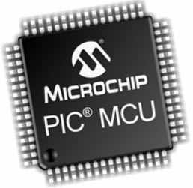

**Fig 2.1 PIC Microcontroller**

We know that microcontroller is an integrated chip which is consists of RAM, ROM, CPU, [TIMER and COUNTERS](http://www.elprocus.com/8051-microcontroller-8-16-bit-timers-and-counters/). The PIC is a microcontroller which as well consists of RAM, ROM, CPU, timer, counter, ADC DAC (digital to analog converter). PIC Microcontroller also support the protocols like CAN, SPI, UART for an interfacing with additional peripherals. PIC mostly used to modify Harvard architecture and also supports [RISC (Reduced Instruction Set Computer)](http://www.elprocus.com/what-is-risc-and-cisc-architecture-and-their-workings/) by the above requirement RISC and Harvard we can simply that PIC is faster than the 8051 based controllers which is prepared up of Von-Newman architecture.

### ARM Processor

An [ARM processor](http://www.elprocus.com/arm-architecture/) is also one of a family of CPUs based on the RISC (reduced instruction set computer) architecture developed by Advanced RISC Machines (ARM).

An ARM makes at 32-bit and 64-bit RISC multi-core processors. RISC processors are designed to perform a smaller number of types of computer instructions so that they can operate at a higher speed, performing extra millions of instructions per second (MIPS). By stripping out unnecessary instructions and optimizing pathways, RISC processors give outstanding performance at a part of the power demand of CISC (complex instruction set computing) procedure.

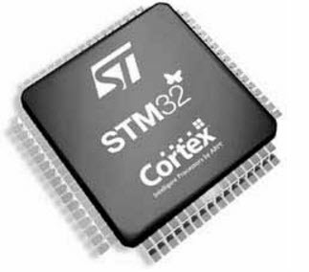

Fig 2.2: ARM Microcontroller

ARM processors are widely used in customer electronic devices such as smart phones, tablets, multimedia players and other mobile devices, such as wear ables. Because of their reduced to instruction set, they need fewer transistors, which enable a smaller die size of the [integrated circuitry](https://www.elprocus.com/different-types-of-integrated-circuits/) (IC). The ARM processors, smaller size reduced difficulty and lower power expenditure makes them suitable for increasingly miniaturized devices.

***Some Important Differences:***

**Table 2.1 Differences between ARM and PIC Microcontroller**

|  |  |
| --- | --- |
| **PIC Microcontroller:** | **ARM Microcontroller:** |
| Bus width: 8/16/32-bit | Bus width: 32-bit mostly also available in 64-bit |
| Communication Protocols: PIC, UART, USART, LIN, CAN, Ethernet, SPI, I2S | Communication Protocols: UART, USART, LIN, I2C, SPI, CAN, USB, Ethernet, I2S, DSP, SAI (serial audio interface), IrDA |
| Speed: 4 Clock/instruction cycle | Speed: 1 clock/ instruction cycle |
| Memory: SRAM, FLASH | Memory: Flash, SDRAM, EEPROM |
| ISA: Some feature of RISC | ISA: RISC |
| Memory Architecture: Harvard architecture | Memory Architecture: Modified Harvard architecture |
| Power Consumption: Low | Power Consumption: Low |
| Families: PIC16, PIC17, PIC18, PIC24, PIC32 | Families: ARMv4,5,6,7 and series |
| Popular Microcontrollers: PIC18fXX8, PIC16f88X, PIC32MXX | Popular Microcontrollers: LPC2148, ARM Cortex-M0 to ARM Cortex-M7, etc. |

**2.2 ARM 7datapath**

**Data Path**

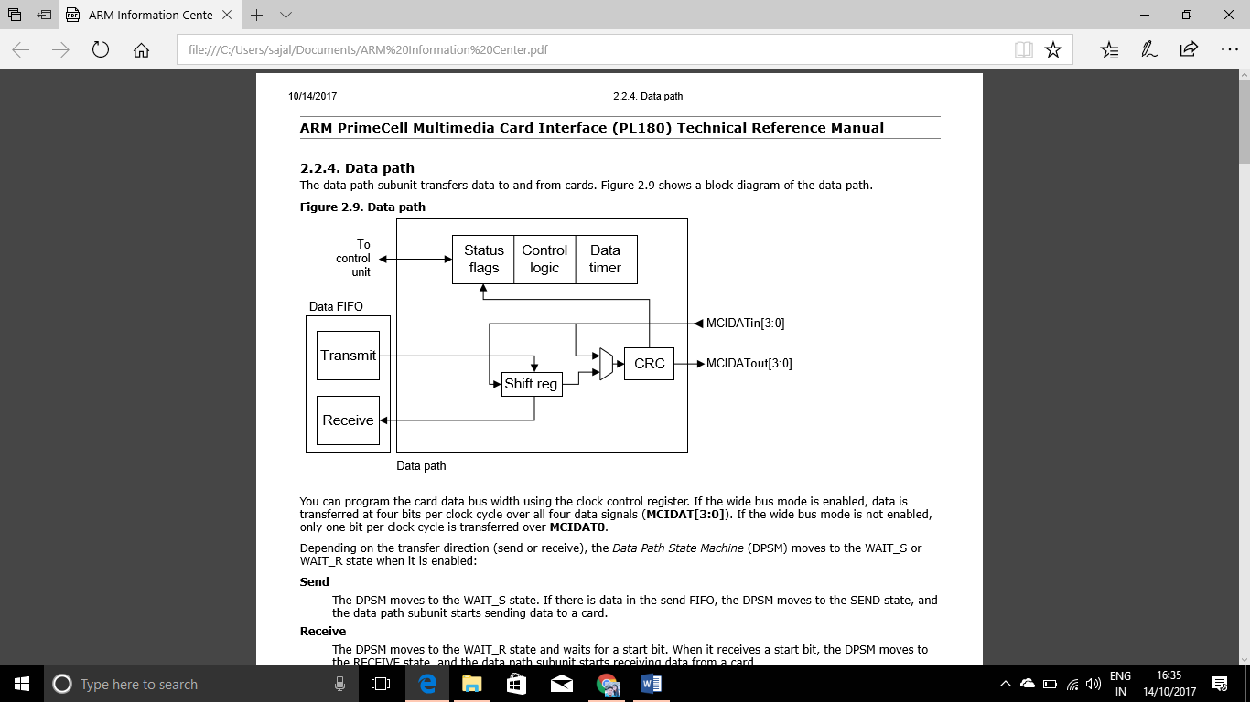

**Fig 2.3 Data path**

You can program the card data bus width using the clock control register. If the wide bus mode is enabled, data is transferred at four bits per clock cycle over all four data signals (MCIDAT[3:0]). If the wide bus mode is not enabled, only one bit per clock cycle is transferred over MCIDAT0. Depending on the transfer direction (send or receive), the **Data Path State Machine (DPSM)** moves to the **WAIT_S** or **WAIT_R** state when it is enabled: Send The DPSM moves to the **WAIT_S** state. If there is data in the send FIFO, the DPSM moves to the **SEND** state, and the data path subunit starts sending data to a card. Receive The DPSM moves to the WAIT_R state and waits for a start bit. When it receives a start bit, the DPSM moves to the **RECEIVE** state, and the data path subunit starts receiving data from a card

Data path state machine The DPSM operates at MCICLK frequency. Data on the card bus signals is synchronous to the rising edge of MCICLK. The DPSM has six states, as shown in figure.

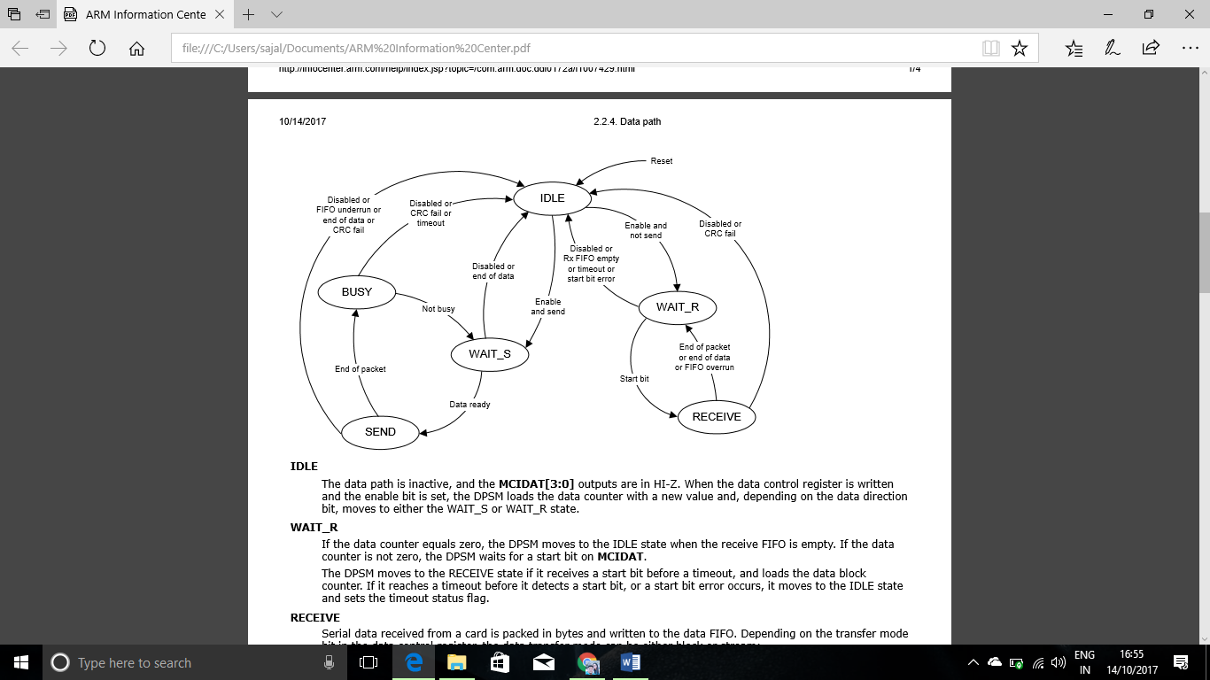

**Fig 2.4 Data path state machine**

**IDLE**

The data path is inactive, and the MCIDAT[3:0] outputs are in HI-Z. When the data control register is written and the enable bit is set, the DPSM loads the data counter with a new value and, depending on the data direction bit, moves to either the WAIT_S or WAIT_R state.

**WAIT_R**

If the data counter equals zero, the DPSM moves to the IDLE state when the receive FIFO is empty. If the data counter is not zero, the DPSM waits for a start bit on **MCIDAT**.

The DPSM moves to the RECEIVE state if it receives a start bit before a timeout, and loads the data block counter. If it reaches a timeout before it detects a start bit, or a start bit error occurs, it moves to the IDLE state and sets the timeout status flag.

**RECEIVE**

Serial data received from a card is packed in bytes and written to the data FIFO. Depending on the transfer mode bit in the data control register, the data transfer mode can be either block or stream:

* *In block mode*, when the data block counter reaches zero, the DPSM waits until it receives the CRC code. If the received code matches the internally generated CRC code, the DPSM moves to the WAIT_R state. If not, the CRC fail status flag is set and the DPSM moves to the IDLE state.
* *In stream mode*, the DPSM receives data while the data counter is not zero. When the counter is zero, the remaining data in the shift register is written to the data FIFO, and the DPSM moves to the WAIT-R state. If a FIFO overrun error occurs, the DPSM sets the FIFO error flag and moves to the WAIT_R state.

**WAIT_S**

The DPSM moves to the IDLE state if the data counter is zero. If not, it waits until the data FIFO empty flag is deasserted, and moves to the SEND state.

Note The DPSM remains in the WAIT_S state for at least two clock periods to meet Nwr timing constraints.

**SEND**

The DPSM starts sending data to a card. Depending on the transfer mode bit in the data control register, the data transfer mode can be either block or stream:

* In **block mode**, when the data block counter reaches zero, the DPSM sends an internally generated CRC code and end bit, and moves to the BUSY state.
* In **stream mode**, the DPSM sends data to a card while the enable bit is HIGH and the data counter is not zero. It then moves to the IDLE state.

If a FIFO underrun error occurs, the DPSM sets the FIFO error flag and moves to the IDLE state.

**BUSY**

The DPSM waits for the CRC status flag:

* If it does not receive a positive CRC status, it moves to the IDLE state and sets the CRC fail status flag.
* If it receives a positive CRC status, it moves to the WAIT_S state if MCIDAT0 is not LOW (the card is not busy).

If a timeout occurs while the DPSM is in the BUSY state, it sets the data timeout flag and moves to the IDLE state.

The data timer is enabled when the DPSM is in the WAIT_R or BUSY state, and generates the data timeout error:

* When transmitting data, the timeout occurs if the DPSM stays in the BUSY state for longer than the programmed timeout period.
* When receiving data, the timeout occurs if the end of the data is not true, and if the DPSM stays in the WAIT_R state for longer than the programmed timeout period.

**Data counter**

The data counter has two functions:

* To stop a data transfer when it reaches zero. This is the end of the data condition.
* To start transferring a pending command (see Figure). This is used to send the stop command for a stream data transfer.

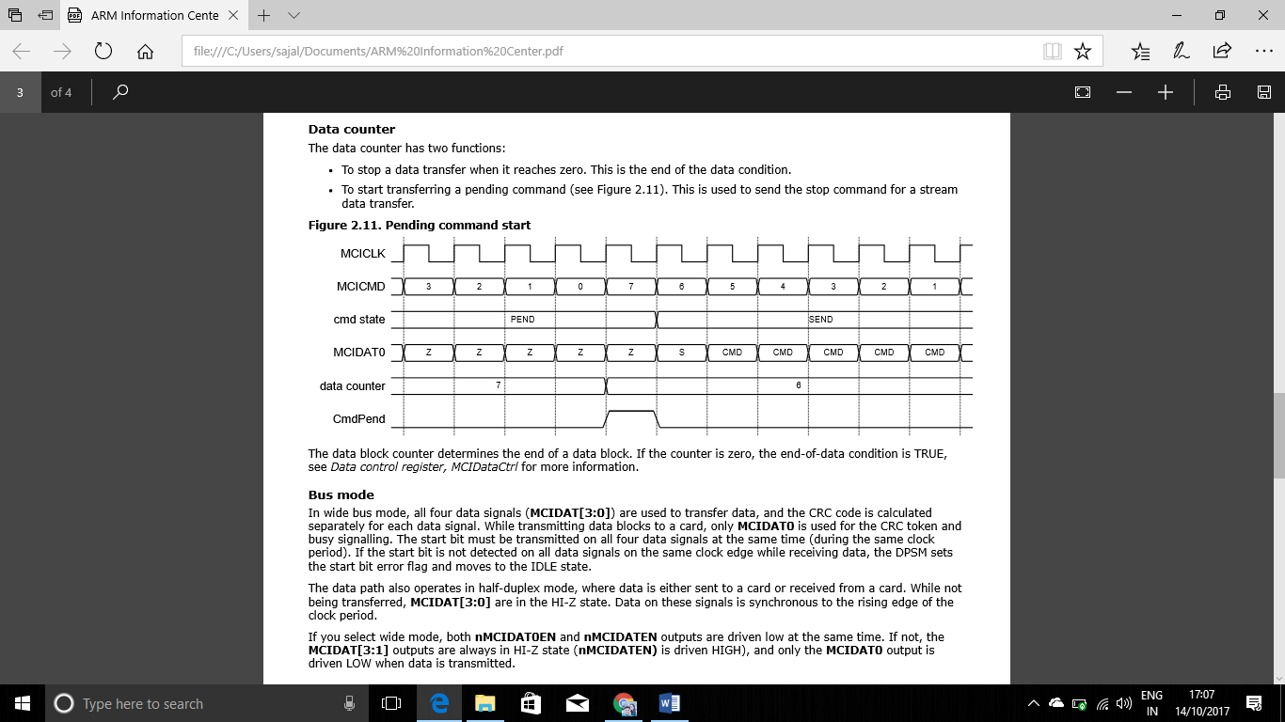

**Fig 2.5 Pending command start**

The data block counter determines the end of a data block. If the counter is zero, the end-of-data condition is TRUE, see Data control register, MCIDataCtrl for more information.

**Bus mode**

In wide bus mode, all four data signals (MCIDAT[3:0]) are used to transfer data, and the CRC code is calculated separately for each data signal. While transmitting data blocks to a card, only MCIDAT0 is used for the CRC token and busy signalling. The start bit must be transmitted on all four data signals at the same time (during the same clock period). If the start bit is not detected on all data signals on the same clock edge while receiving data, the DPSM sets the start bit error flag and moves to the IDLE state.

The data path also operates in half-duplex mode, where data is either sent to a card or received from a card. While not being transferred, MCIDAT[3:0] are in the HI-Z state. Data on these signals is synchronous to the rising edge of the clock period.

If you select wide mode, both nMCIDAT0EN and nMCIDATEN outputs are driven low at the same time. If not, the MCIDAT[3:1] outputs are always in HI-Z state (nMCIDATEN) is driven HIGH), and only the MCIDAT0 output is driven LOW when data is transmitted.

**CRC token status** The CRC token status follows each write data block, and determines whether a card has received the data block correctly. When the token has been received, the card asserts a busy signal by driving MCIDAT0 LOW. Table 2.2 shows the CRC token status values.

**Table 2.2 CRC Token Status**

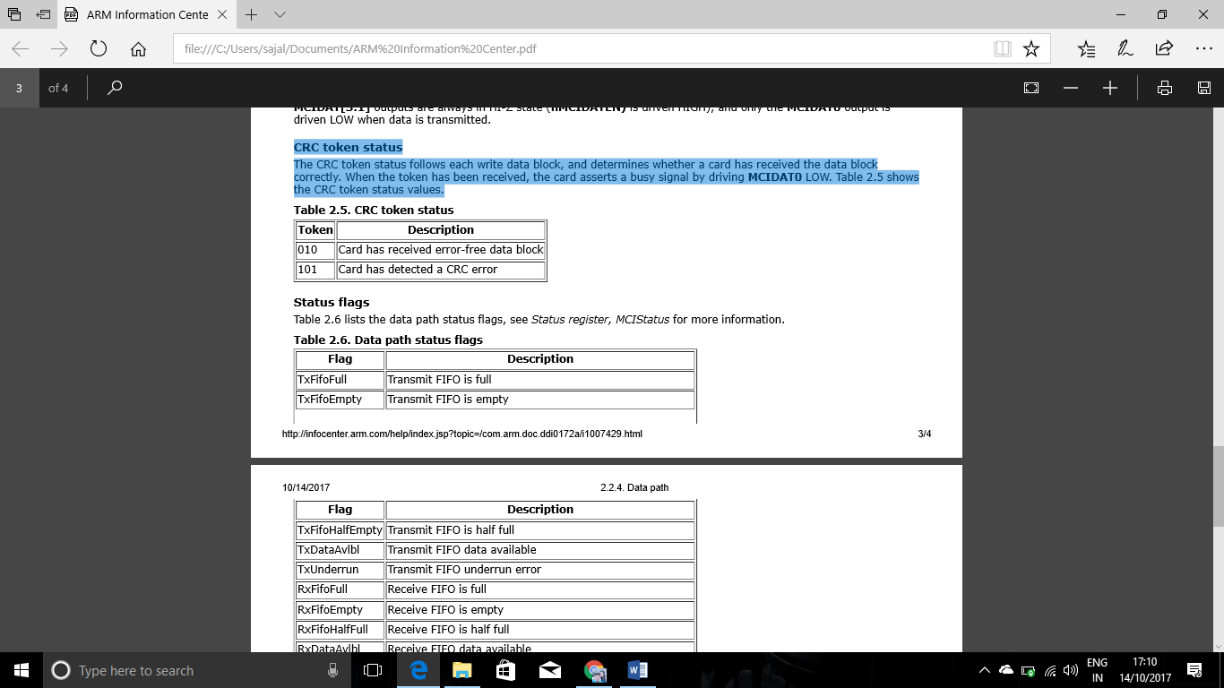

**Status flags**

Table lists the data path status flags:

**Table 2.3 Data path status flags**

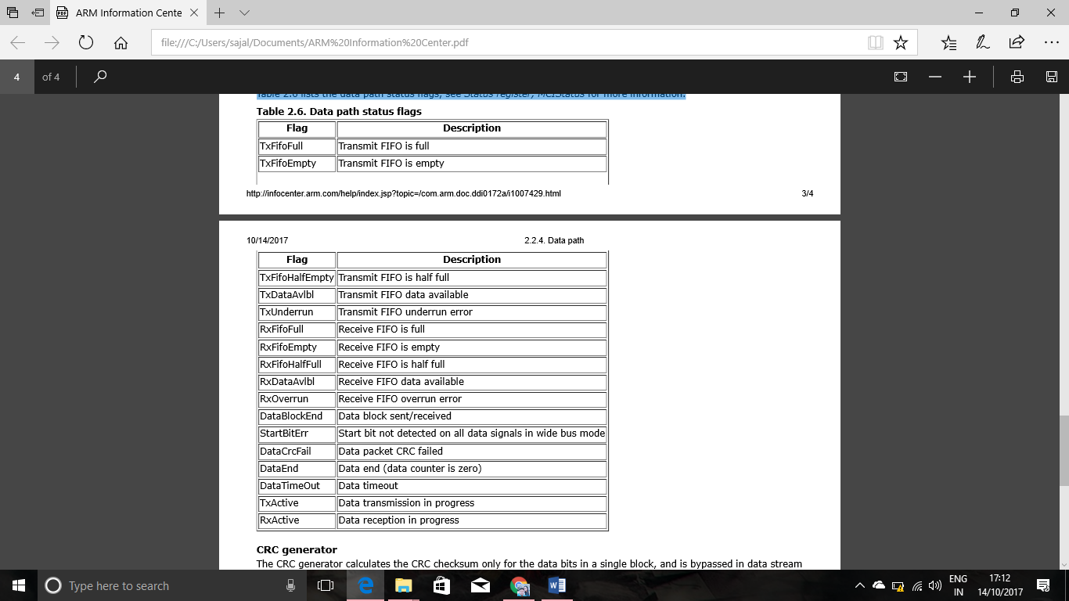



**CRC generator**

The CRC generator calculates the CRC checksum only for the data bits in a single block, and is bypassed in data stream mode. The checksum is a 16-bit value:

CRC[15:0] = Remainder [(M(x) *x15) / G(x)]

G(x) = x16 + x12 + x5 + 1

M(x) - (first data bit) *xn + ... + (last data bit) *x0

**2.3-2.4 Registers and Memory Organization of ARM**

* Two main blocks: datapath and decoder
* Register bank (r0 to r15)

1. Two read ports to A-bus/B-bus
2. One write port from ALU-bus
3. +Additional read/write ports for program counter r15

* Barrel shifter - shift/rotate 2nd operand by any number of bits
* ALU performs arithmetic/logic functions Dedicated PC incrementer
* Address register – either from PC or from ALU
* Data register holds read/write data from/to memory
* Instruction decoder decodes machine code instructions to produce control signals to datapath

Data processing instructions take a single cycle: data values are read on the A-bus & B-bus, the results from ALU is written back into register bank

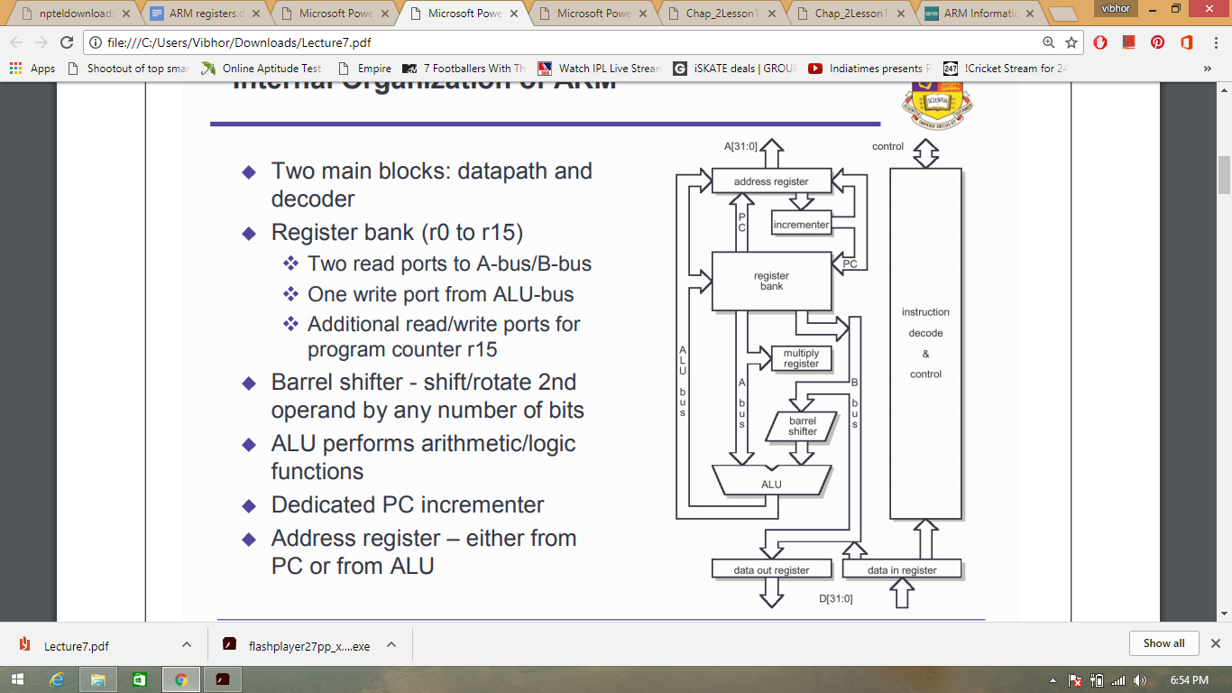

**Fig 2.6 Internal Organisation**

**Pipelining**

* The maximum processing rate is determined by the propagation delay of the computational logic – in abstract: +

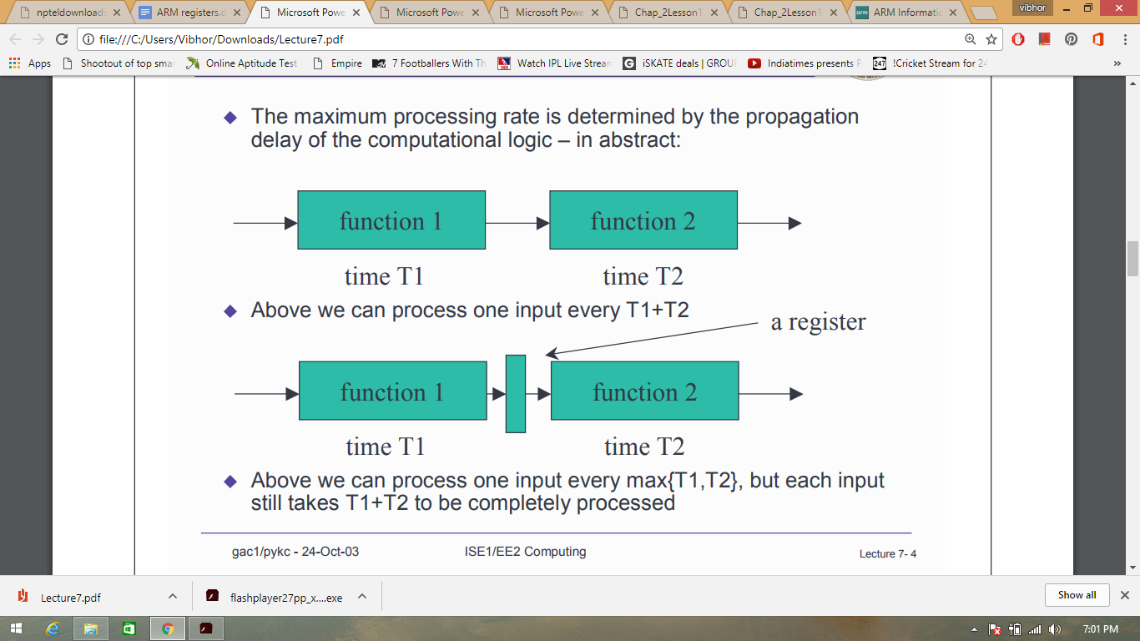

* Above we can process one input every T1+T2



* Above we can process one input every max{T1,T2}, but each input still takes T1+T2 to be completely processed
* ARM uses a 3-stage instruction pipeline Fetch: fetch instruction code from memory into the instruction pipeline Decode: instruction decoded to obtain control signals for the datapath ready for the next stage Execute: instruction “owns” the datapath - register read; shifting; ALU results generated and write-back
* Results for each stage stored in registers.
* The consequence is that the clock period is much shorter than without pipelining.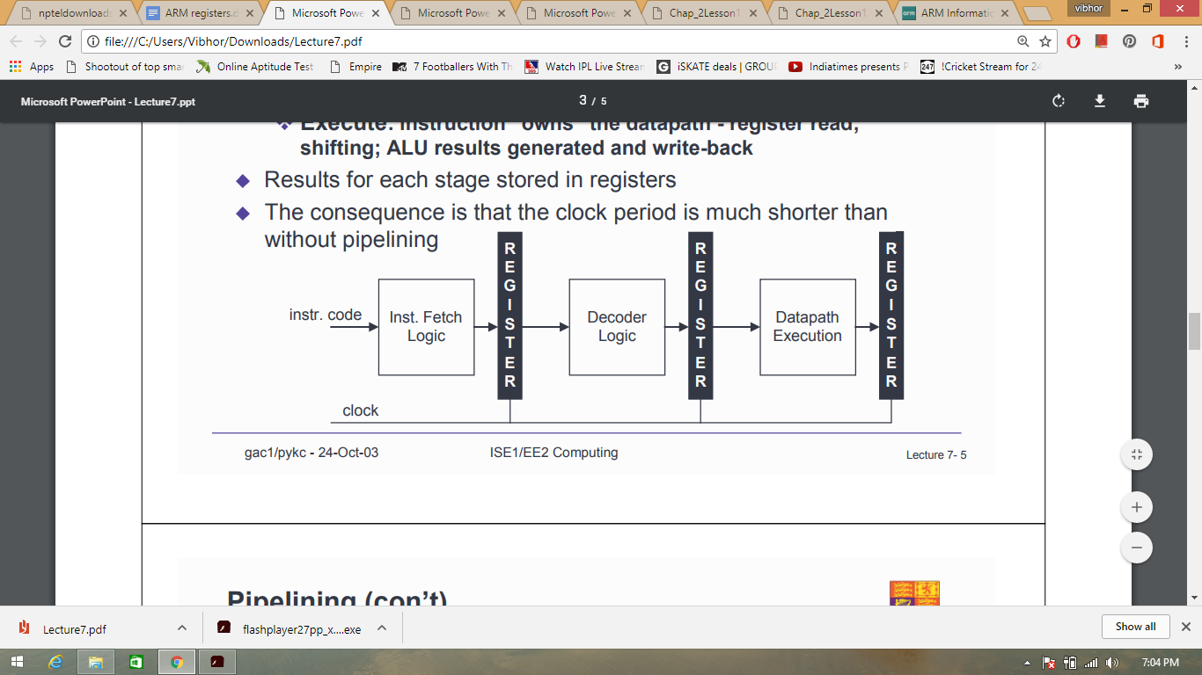

**Fig 2.7 Clock Period without pipelining**

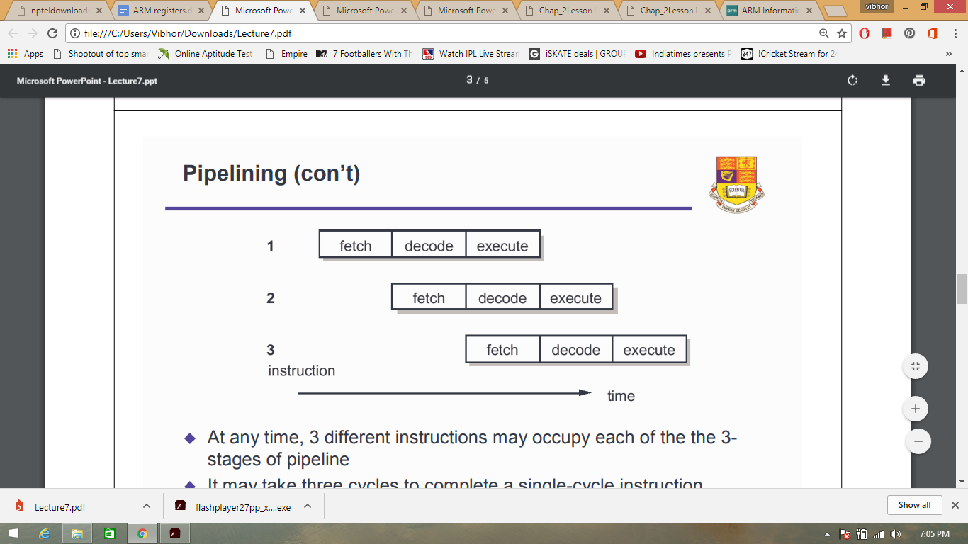

**Fig 2.8 Three stage Pipelining**

* At any time, 3 different instructions may occupy each of the the 3- stages of pipeline
* It may take three cycles to complete a single-cycle instruction. This is said to have a three cycle latency
* Once a pipeline fills, the processor completes a single-cycle instruction every clock cycle. Therefore the throughput is one instruction per cycle.

**Datapath activity during data processing instruction (register – immediate)**

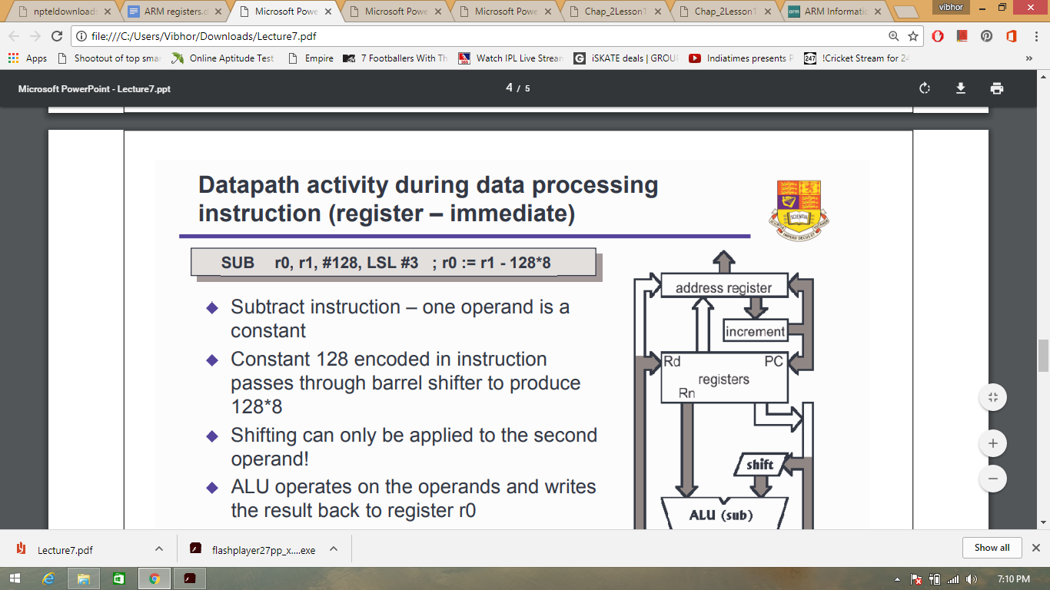

* Subtract instruction – one operand is a constant
* Constant 128 encoded in instruction passes through barrel shifter to produce 128*8
* Shifting can only be applied to the second operand!
* ALU operates on the operands and writes the result back to register r0
* PC value in address register is incremented and coped back to r15 and the address register

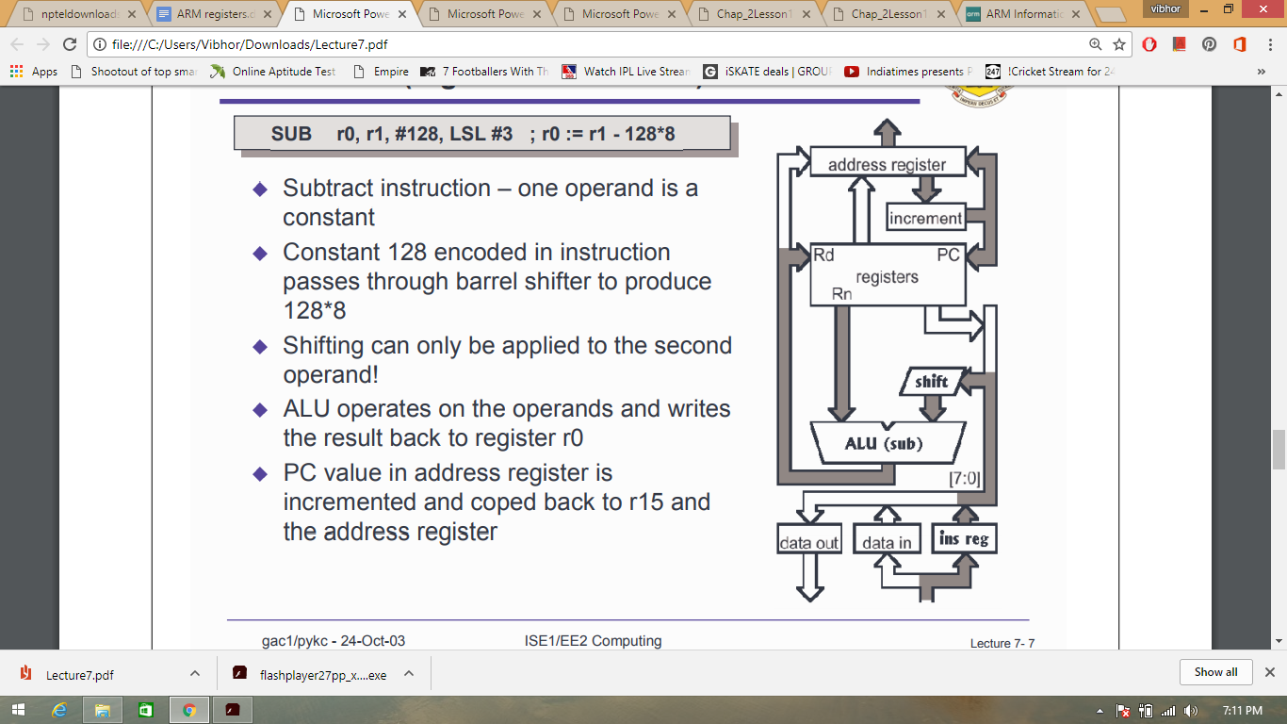

**Fig 2.9 Datapath activity during data processing instruction (register – register)**

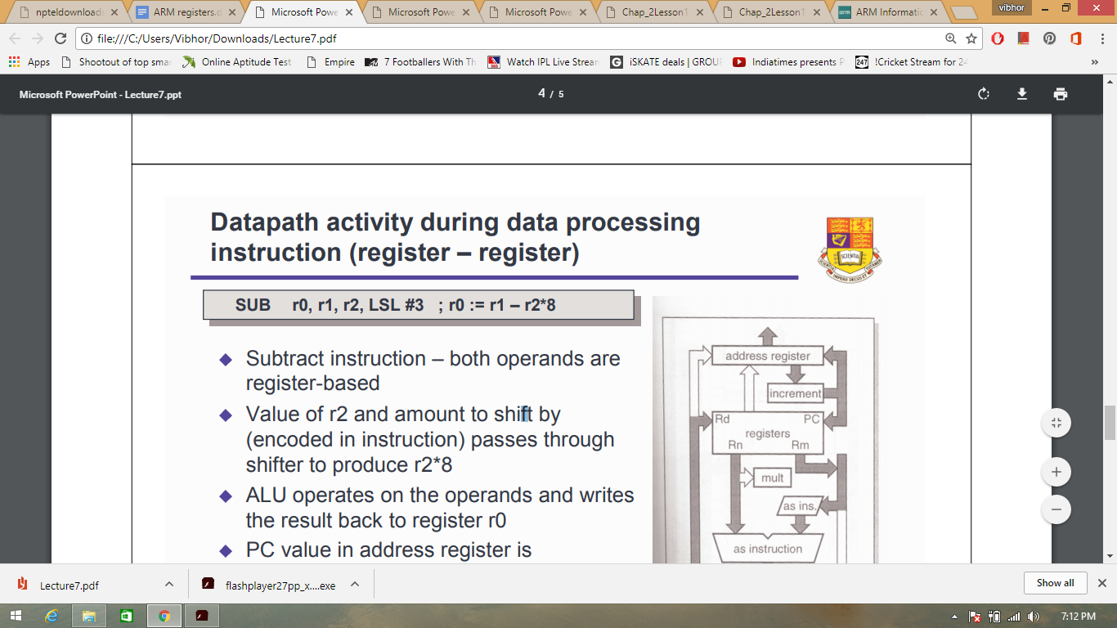

* Subtract instruction – both operands are register-based

* Value of r2 and amount to shift by (encoded in instruction) passes through shifter to produce r2*8

* ALU operates on the operands and writes the result back to register r0

* PC value in address register is incremented and coped back to r15 and the address register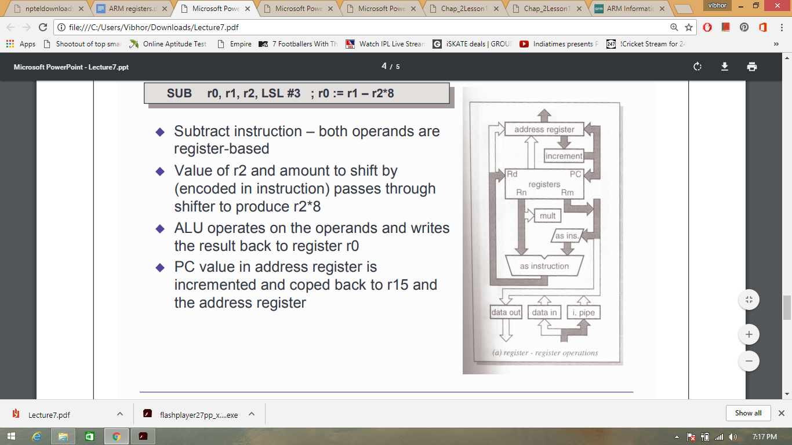

**Fig 2.10 ARM Registers**

ARM processors provide general-purpose and special-purpose registers. Some additional registers are available in privileged execution modes.

In all ARM processors, the following registers are available and accessible in any processor mode:

13 general-purpose registers R0-R12.

One Stack Pointer (SP).

One Link Register (LR).

One Program Counter (PC).

One Application Program Status Register (APSR).

**Note :**The Link Register can also be used as a general-purpose register. The Stack Pointer can be used as a general-purpose register in ARM state only.

Additional registers are available in privileged software execution.

ARM processors, with the exception of ARMv6-M and ARMv7-M based processors, have a total of 37 registers, with 3 additional registers if the Security Extensions are implemented, and in ARMv7-A only, 3 more if the Virtualization Extensions are implemented. The registers are arranged in partially overlapping banks. There is a different register bank for each processor mode. The banked registers give rapid context switching for dealing with processor exceptions and privileged operations.

The additional registers that are available in privileged software execution, with the exception of ARMv6-M and ARMv7-M, are:

Two Supervisor mode registers for banked SP and LR.

Two Abort mode registers for banked SP and LR.

Two Undefined mode registers for banked SP and LR.

Two Interrupt mode registers for banked SP and LR.

Seven FIQ mode registers for banked R8-R12, SP and LR.

Two Monitor mode registers for banked SP and LR. These are only present if the Security Extensions are implemented.

Two Hyp mode registers for banked SP, and to hold the return address from Hyp mode. These are only present if the Virtualization Extensions are implemented.

One Saved Program Status Register (SPSR) for each exception mode.

**Note :**In privileged software execution, CPSR is an alias for APSR and gives access to additional bits.

The following figure shows how the registers are banked in the ARM architecture except ARMv6-M and ARMv7-M:

Figure Organization of general-purpose registers and Program Status Registers

Organization of general-purpose registers and Program Status Registers

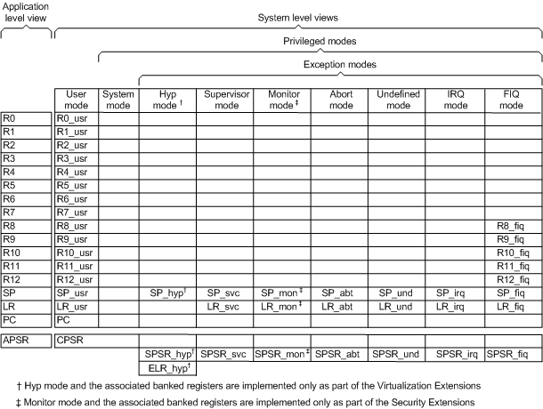

**Fig 2.11 Register Modes**

In ARMv6-M and ARMv7-M based processors, SP is an alias for the two banked stack pointer registers:

Main stack pointer register, which is only available in privileged software execution.

Process stack pointer register.

**General-purpose registers**

There are restrictions on the use of SP and LR as general-purpose registers.

With the exception of ARMv6-M and ARMv7-M based processors, there are 30 (or 32 if Security Extensions are implemented) general-purpose 32-bit registers, that include the banked SP and LR registers. Fifteen general-purpose registers are visible at any one time, depending on the current processor mode. These are R0-R12, SP, LR. The PC (R15) is not considered a general-purpose register.

SP (or R13) is the stack pointer. The C and C++ compilers always use SP as the stack pointer. Use of SP as a general purpose register is discouraged. In Thumb, SP is strictly defined as the stack pointer. The instruction descriptions mention when SP and PC can be used.

In User mode, LR (or R14) is used as a link register to store the return address when a subroutine call is made. It can also be used as a general-purpose register if the return address is stored on the stack.

In the exception handling modes, LR holds the return address for the exception, or a subroutine return address if subroutine calls are executed within an exception. LR can be used as a general-purpose register if the return address is stored on the stack.

**Register accesses**

16-bit Thumb instructions can access only a limited set of registers. There are also some restrictions on the use of special-purpose registers by ARM and 32-bit Thumb instructions.

Most 16-bit Thumb instructions can only access R0 to R7. Only a small number of these instructions can access R8-R12, SP, LR, and PC. Registers R0 to R7 are called Lo registers. Registers R8-R12, SP, LR, and PC are called Hi registers.

All 32-bit Thumb instructions can access R0 to R12, and LR. However, apart from a few designated stack manipulation instructions, most Thumb instructions cannot use SP. Except for a few specific instructions where PC is useful, most Thumb instructions cannot use PC.

In ARM state, all instructions can access R0 to R12, SP, and LR, and most instructions can also access PC (R15). However, the use of the SP in an ARM instruction, in any way that is not possible in the corresponding Thumb instruction, is deprecated. Explicit use of the PC in an ARM instruction is not usually useful, and except for specific instances that are useful, such use is deprecated. Implicit use of the PC, for example in branch instructions or load (literal) instructions, is never deprecated.

The MRS instructions can move the contents of a status register to a general-purpose register, where they can be manipulated by normal data processing operations. You can use the MSR instruction to move the contents of a general-purpose register to a status register.

**Pre declared core register names**

Many of the core register names have synonyms.

The following table shows the predeclared core registers:

|  |  |
| --- | --- |
| **Register names** | **Meaning** |
| r0-r15 and R0-R15 | General purpose registers. |
| a1-a4 | Argument, result or scratch registers. These are synonyms for R0 to R3 |
| v1-v8 | Variable registers. These are synonyms for R4 to R11. |
| sb and SB | Static base register. This is a synonym for R9. |
| ip and IP | Intra procedure call scratch register. This is a synonym for R12. |
| sp and SP | Stack pointer. This is a synonym for R13. |
| lr and LR | Link register. This is a synonym for R14. |
| pc and PC | Program counter. This is a synonym for R15. |

With the exception of a1-a4 and v1-v8, you can write the registers either in all upper case or all lower case.

**Application Program Status Register**

The Application Program Status Register (APSR) holds the program status flags that are accessible in any processor mode.

It holds copies of the N, Z, C, and V condition flags. The processor uses them to determine whether or not to execute conditional instructions.

On ARMv5TE, ARMv6 and later architectures, the APSR also holds the Q (saturation) flag.

On ARMv6 and later, the APSR also holds the GE (Greater than or Equal) flags. The GE flags can be set by the parallel add and subtract instructions. They are used by the SEL instruction to perform byte-based selection from two registers.

These flags are accessible in all modes, using the MSR and MRS instructions.

**Current Program Status Register**

The Current Program Status Register (CPSR) holds the same program status flags as the APSR, and some additional information.

The CPSR holds:

The APSR flags.

The processor mode.

The interrupt disable flags.

The instruction set state (ARM, Thumb, ThumbEE, or Jazelle®).

The endianness state (on ARMv4T and later).

The execution state bits for the IT block (on ARMv6T2 and later).

The execution state bits control conditional execution in the IT block.

Only the APSR flags are accessible in all modes. ARM deprecates using an MSR instruction to change the endianness bit (E) of the CPSR, in any mode. SETEND is the preferred instruction to write to the E bit.

The execution state bits for the IT block (IT[1:0]), Jazelle bit (J), and Thumb bit (T) can be accessed by MRS only in Debug state.

**Saved Program Status Registers**

A Saved Program Status Register (SPSR) stores the current value of the CPSR when an exception is taken so that the CPSR can be restored after handling the exception.

Each exception handling mode can access its own SPSR. User mode and System mode do not have an SPSR because they are not exception handling modes.

The execution state bits, including the endianness state and current instruction set state can be accessed from the SPSR in any exception mode, using the MSR and MRS instruction. You cannot access the SPSR using MSR or MRS in User or System mode.

**2.5 Instruction Set Architecture**

• Describes how processor processes instructions

• Makes available instructions, binary codes, syntax, addressing modes, data formats etc.

• ARM defines two separate instruction sets :-

* ARM state instruction set – 32-bit wide
* Thumb state instruction set – 16-bit wide

**ARM State Instruction Set :-**

Features

* 3-address data processing instructions
* Conditional execution of each instruction
* Shift and ALU operations in single instruction
* Load-Store and Load-Store multiple instructions
* Single cycle execution of all instructions
* Instruction set extension through coprocessor instructions

**Classes of Instructions:-**

* Data processing instructions
* Branch instructions
* Load store instructions
* Software interrupt instructions
* Program status register instructions
* Coprocessor instructions

**Data Processing Instructions**

• Perform move, arithmetic, logical, compare and multiply operations.

• All operations except multiply instructions are carried out in ALU

• Multiply instructions are carried out in multiplier block

• Data processing instructions do not access memory

• Instructions operate on two 32-bit operands, produce 32-bit result.

• Instructions can pre-process one operand using barrel shifter

• No. of basic instructions: 16 (excluding two basic multiply instrs.)

Syntax:

<opcode> {<cond>}{S} Rd, Rn, n

‘cond’- indicates flags to test, ‘S’ – set condition flags in CPSR

‘n’ may be ‘Rm’, ‘#const’ or ‘ Rs, N’

Rd – destination, Rn – 1 st operand, N. MathivananRn/Rm/Rs remains unchanged

• Basic data processing instructions :-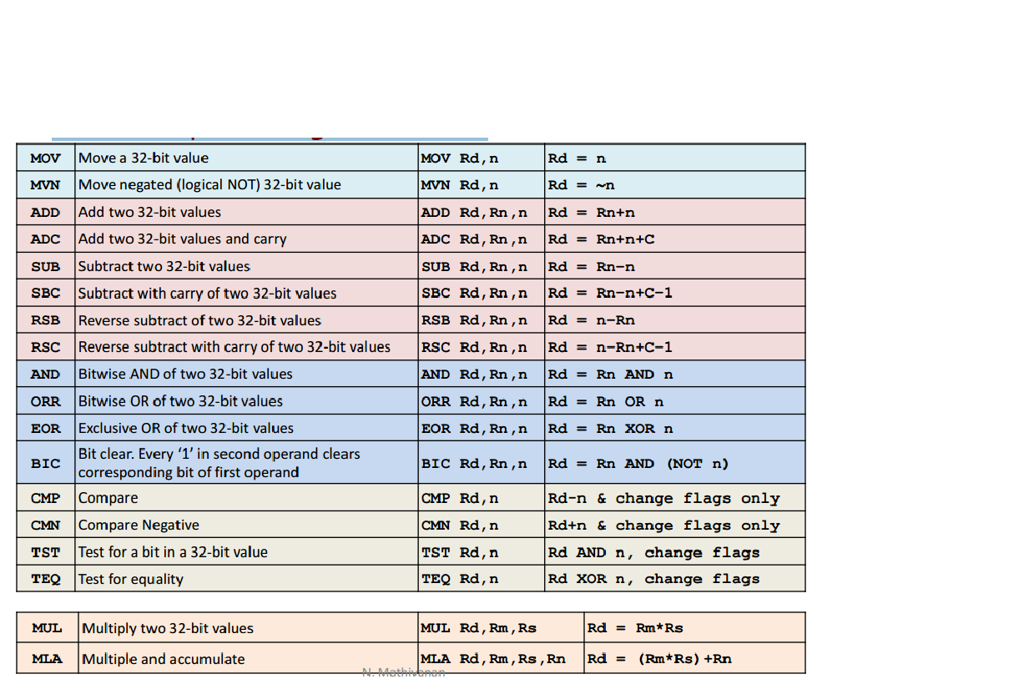

**Branch instructions :-**

• Divert sequential execution / CALL a subroutine,

• Range: +/- 32 MB from current position (i.e. PC-8), PC relative offset

• Instruction has 24 bits allocated for specifying word offset

• With 24-bit offset append ‘00’ at LSB, extend sign bit, place into PC

• PC is set to point to new address

• How is asm instruction ‘here B here’ encoded? – Ans. 0xEAFFFFFE o Hint: [31:28] = 1110, [27:24] = 1010, [23:0] = 24-bit offset

Branch Instructions – Examples

1. Example of using ‘B’ instruction:

CMP r0,#0 ; check if r0 == 0

BNE r2inc ; if r0 !=0 branch to ‘r2inc’

ADD r1,r1,#1 ; r1 += 1

B next ; unconditional branch to ‘next’

r2inc ADD r2,r2,#1 ; r2 += 1

next ---- ; continue

1. Example of using ‘BL’ instruction

BL funct1 ; save return addr. & subroutine

CMP r0,#5 ; next instruction

- func1ADD r0,r0,#1 ; subroutine

--- ; codes

MOV pc,lr ; return to program

**Load-Store Instructions**

• Single Transfer Instruction

* Transfers boundary aligned Word/HW/Byte between mem&reg
* LDR and STR instructions
* Address of mem loc. is given by Base Addr. +/- Offset
* Addressing modes: method of providing offset Register addressing – A register contains offset♣ Immediate addressing – Immediate constant is offset♣ Scaled addressing – Offset in a reg is scaled using shift operation♣
* Syntax: {<opcode>}{<condition>}Rd,[Rn{,}] ♣ - H, HS, B, BS Rd – source/destination register♣Rn – Base address♣♣ - ‘Rm’ or #(0-4095) or ‘Rm,#n’

**Single register transfer instructions addressing modes – Example**

1. LDRB r3,[r8,#3] ; load at bottom byte of r3 from mem8[r8+3]

2. STRB r10,[r7,-r4] ; store bottom byte of r10 at mem8[r7-r4]

3. LDRH r1,[r0] ; load at bottom halfword of r1 from mem16[r0]

4. STRH r10,[r7,-r4] ; store bottom halfword of r10 at mem16[r7-r4] 5. LDR r0,[r1,r2] ; r0=mem32[r1+r2]

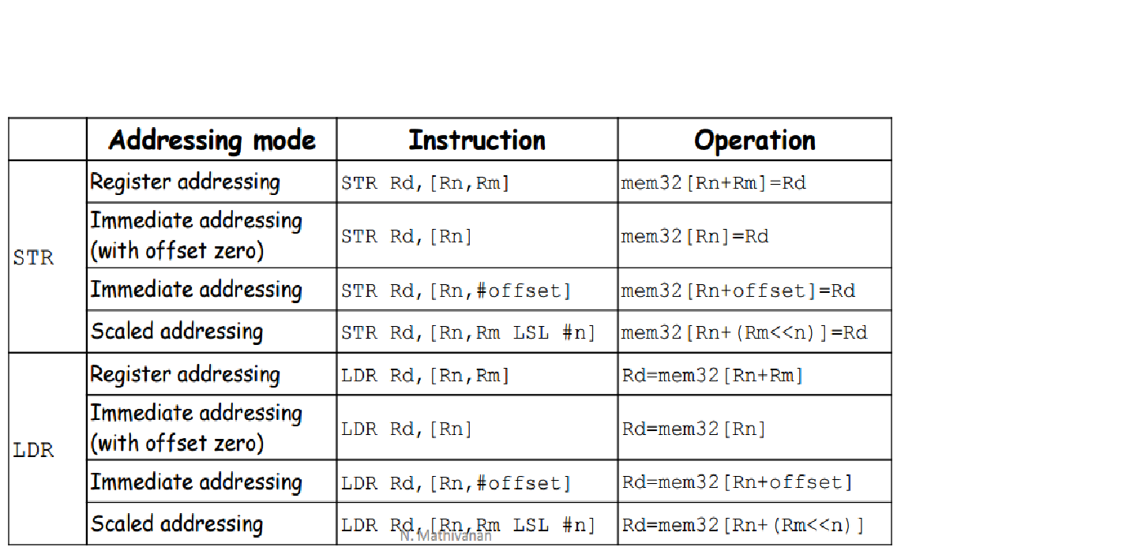

**Multiple Load-Store Instructions**

• Transfers data between multiple regs&mem in single instruction

• Instructions: LDM and STM

• Use: stack, block move, temporary store & restore

• Advantages: small code size, single instruction fetch from memory • Disadvantages: can’t be interrupted, increases interrupt latency

• Syntax:

{}Rn{!}, • Rn – Base register, ‘!’ update base reg. after data transfer (option)

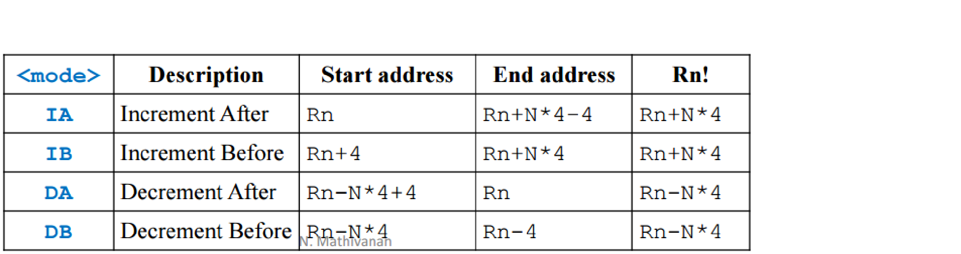

• Examples

STMxx r9, {r0-r2}

LDMxx r9, {r0-r2}

• Used in pairs for temp store/restore

STMIA – LDMDB, STMIB – LDMDA

STMDA – LDMIB, STMDB – LDMIA

• Stack operations

* Alternative suffixes to IA, IB, DA and DB
* Full/Empty, Ascending/Descending (FD, FA, ED, EA) (8085 stack–FD)
* E.g.: STMFD r13, {r2, r0, r3-r8, r1}

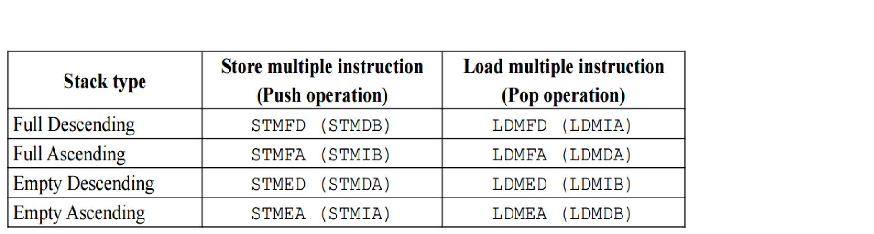

• Swap instructions (also known as semaphore instructions)

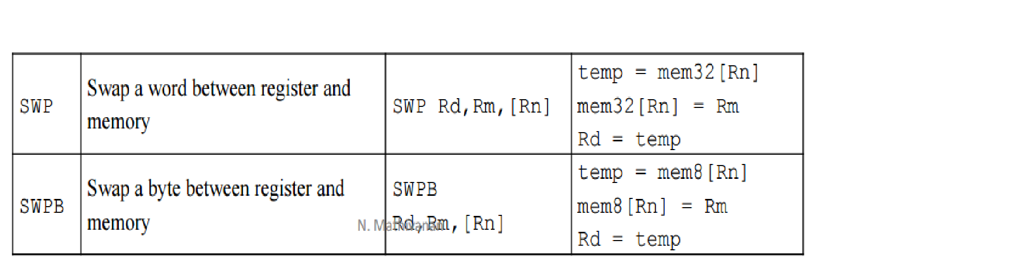

**Software Interrupt Instructions**

• Use: User mode applications to execute OS routines

• When executed, mode changes to supervisor mode

• Syntax: SWI{cond} SWI_number

• Example: SWI 0x123456

• Return instruction from SWI routine: MOVS PC, r14

• Examples – Semihosting

Mechanism to communicate & use I/O facilities on host computer running debugger

MOV r0,#0x18 ; program termination

LDR r1,=0x20026 ; SVC #0x123456 ; semihosting CALL

* Semihosting overview:-

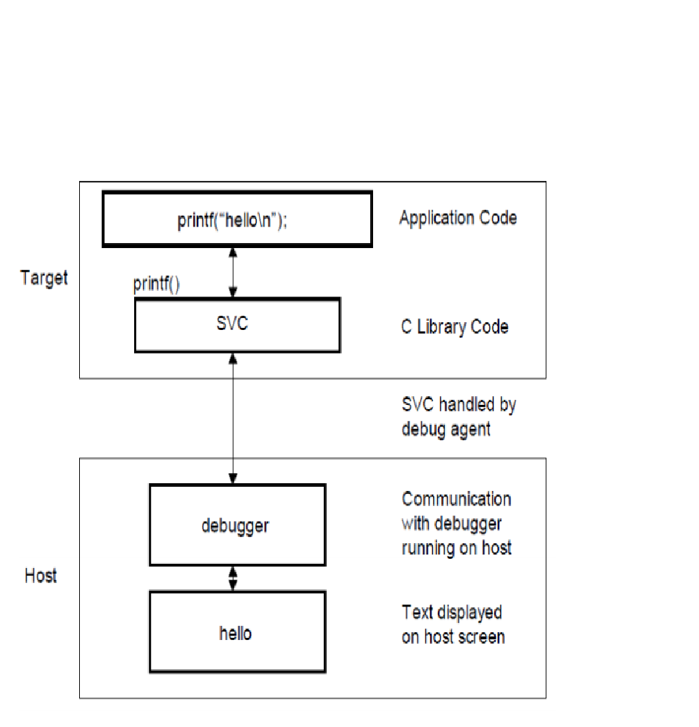

**Program Status Register Instructions**

• Instructions to read/write from/to CPSR or SPSR

• Instructions: MRS, MSR

• Syntaxes: MRS{} Rd, MSR{} ,Rm MSR{} _,Rm MSR{} _,#immediate

• Modifying CPSR, SPSR: Read, Modify and Write back technique o Read CPSR/SPSR using MRS o Modify relevant bits o Transfer to CPSR/SPSR using MSR

• Note:

• In user mode all fields can be read, but flags alone can be modified

• Examples:

* Program to enable FIQ (executed in svc mode)

MRS r1,cpsr ; copies CPSR into r1

BIC r1,#0x40 ; clears B6, i.e. FIQ interrupt mask bit MSR cpsr,r1 ; copies r1 into CPSR

* Program to change mode (from svc mode to fiq mode)

MRS r0,cpsr ; get CPSR into r0

BIC r0,r0,0x1F ; clear the mode bits, i.e. 5 LSB bits - B[4:0] ORR r0,r0,0x11 ; set to FIQ mode

MSR cpsr,r0 ; write r0 into CPSR

**Coprocessor Instructions**

• ARM supports 16 coprocessors

• Coprocessor implemented in hardware, software or both

• Coprocessor contains instruction pipeline, instruction decoding logic, handshake logic, register bank, special processing logic with its own data path.

• It is also connected to data bus like ARM core processor

• Instructions in program memory are available for coprocessors also. • Works in conjunction with ARM core and process same instruction stream as ARM, but executes only instructions meant for coprocessor and ignores ARM and other coprocessor’s instructions

• 3 types of instructions: data processing, register transfer, memory transfer N

**Coprocessor instructions :-**

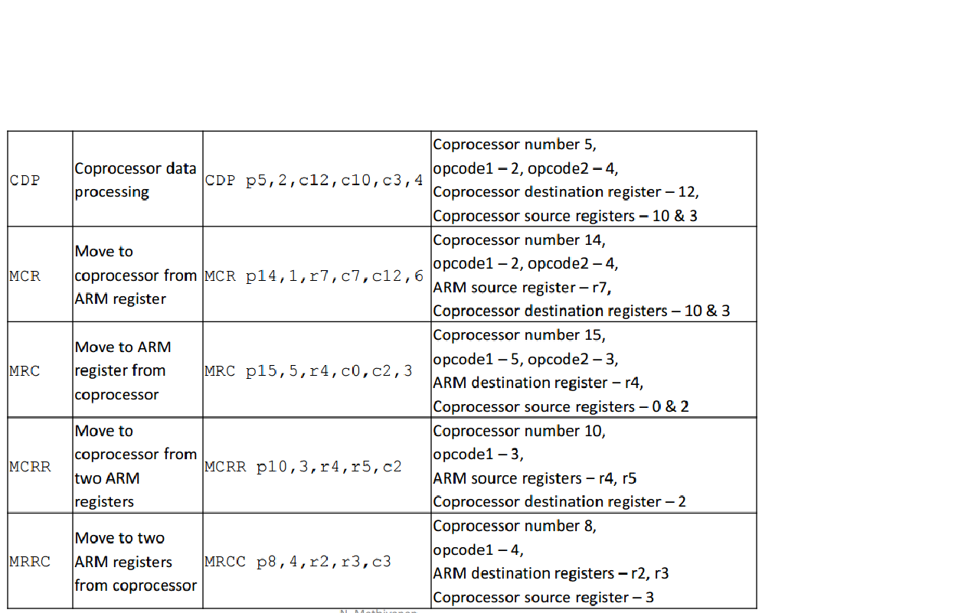

**Thumb State Instruction Set**

• 16-bit instructions (compressed form), executable in Thumb state.

• Instruction decoder decompresses to 32-bit ARM equivalent

• Features:

• Works on 32-bit values, produces 32-bit addr for mem access

• Access to low registers (r0-r7) similar to ARM state

• Restricted access to high registers (r8-r15), MOV, ADD, CMP can access • Thumb state enabled by ‘T’ bit (if set) of CPSR.

• If enabled, fetches 16-bit code from HW aligned addresses, PC is incremented by two bytes

• Instructions removed: MLA, RSB, RSC, MSR, MRS, SWP, SWPB and coprocessor instructions;

• New Instructions: LSL, LSR, ASR, ROR (barrel shifter can’t be combined with any instruction)

• Not conditionally executable (except ‘B’ branch instruction)

**2.6 ARM Assembly Programming Principles**

The previous chapters have covered the ARM instruction set, and using the ARM assembler. Now we are in a position to start programming properly. Since we are assuming you can program in BASIC, most of this chapter can be viewed as a conversion course. It illustrates with examples how the programming techniques that you use when writing in a high-level language translate into assembler.

**Control structures**

A program is made up of instructions which implement the solution to a problem. Any such solution, or algorithm, may be expressed in terms of a few fundamental concepts. Two of the most important are program decomposition and flow of control.

The composition of a program relates to how it is split into smaller units which solve a particular part of the problem. When combined, these units, or sub-programs, form a solution to the problem as a whole. In high-level languages such as BASIC and Pascal, the procedure mechanism allows the practical decomposition of programs into smaller, more manageable units. Down at the assembly language level, subroutines perform the same function.

Flow of control in a program is the order in which the instructions are executed. The three important types of control structure that have been identified are: the sequence, iteration, and decision.

An instruction sequence is simply the act of executing instructions one after another in the order in which they appear in the program. On the ARM, this action is a consequence of the PC being incremented after each instruction, unless it is changed explicitly.

The second type of control flow is decision: the ability to execute a sequence of instructions only if a certain condition holds (e.g. **IF...THEN...**). Extensions of this are the ability to take two separate, mutually exclusive paths (**IF**...**THEN**...**ELSE**...), and a multi-way decision based on some value (**ON...PROC...**). All of these structures are available to the assembly language programmer, but he has to be more explicit about his intentions.

Iteration means looping. Executing the same set of instructions over and over again is one of the computer's fortes. High-level languages provide constructs such as **REPEAT**..**UNTIL** and **FOR**...**NEXT** to implement iteration. Again, in assembler you have to spell out the desired action a little more explicitly, using backward (perhaps conditional) branches.

**Position-independence**

Some of the examples below (for example the **ON**...**PROC** implementation using a branch table) may seem slightly more complex than necessary. In particular, addressing of data and routines is performed not by loading addresses into registers, but by performing a calculation (usually 'hidden' in an **ADR** directive) to obtain the same address. This seemingly needless complexity is due to a desire to make the programs position-independent.

Position-independent code has the property that it will execute correctly no matter where in memory it is loaded. In order to possess this property, the code must contain no references to absolute objects. That is, any internal data or routines accessed must be referenced with respect to some fixed point in the program. As the offset from the required location to the fixed point remains constant, the address of the object may be calculated regardless of where the program was loaded. Usually, addresses are calculated with respect to the current instruction. You would often see instructions of the form:

**.here ADD ptr, pc, #object-(here+8)**

to obtain the address of **object** in the register **ptr**. The +8 part occurs because the PC is always two instructions (8 bytes) further on than the instruction which is executing, due to pipelining.

It is because of the frequency with which this calculation crops up that the **ADR** directive is provided. As we explained in Chapter Four, the line above could be written:

**ADR ptr, object**

Why strive for position-independence? In a typical ARM system, the programs you write will be loaded into RAM, and may have to share that RAM with other programs. The operating system will find a suitable location for the program and load it there. As 'there' might be anywhere in the available memory range, your program can make no assumptions about the location of its internal routines and data. Thus all references must be relative to the PC. It is for this reason that branches use offsets instead of absolute addresses, and that the assembler provides the

**LDR <dest>,<expression>**

form of **LDR** and **STR** to automatically form PC-relative addresses.

Many microprocessors (especially the older, eight-bit ones) make it impossible to write position-independent code because of unsuitable instructions and architectures. The ARM makes it relatively easy, and you should take advantage of this.

**Sequences**

These barely warrant a mention. As we have already implied, ARM instructions execute sequentially unless the processor is instructed to do otherwise. Sequence of high-level assignments:

**LET a = b+c  
LET d = b-c**

would be implemented by a similar sequence of ARM instructions:

**ADD ra, rb, rc  
SUB rd, rb, rc**

**IF-type conditions**

Consider the BASIC statement:

**IF a=b THEN count=count+1**

This maps quite well into the following ARM sequence:

**CMP ra, rb  
ADDEQ count, count, #1**

The ARM's ability to execute any instruction conditionally enables us to make a straightforward conversion from BASIC. Similarly, a simple **IF**..**THEN**...**ELSE** such as this one

**IF val<0 THEN sign=-1 ELSE sign=1**

leads to the ARM equivalent:

**TEQ val, #0  
MVNMI sign, #0  
MOVPL sign, #1**

The opposite conditions (**MI** and **PL**) on the two instructions make them mutually exclusive (i.e. one and only one of them will be executed after the **TEQ**), corresponding to the same property in the **THEN** and **ELSE** parts of the BASIC statement.

Below is an example of a two-word add which executes only if R0=R1:

**CMP R0, R1  
BNE noAdd  
ADDS lo1, lo1, lo2  
ADC hi1, hi1, hi2  
.noAdd ...**

Notice that the condition used in the branch is the opposite to that under which the **ADD** is to be performed. Here is the general translation of the BASIC statements:

**IF cond THEN sequence1 ELSE sequence2 statement  
;'ARM' version  
;Obtain <cond>  
B<NOT cond> seq2 ;If <cond> fails then jump to ELSE  
sequence1 ;Otherwise do the THEN part  
...  
BAL endSeq2 ;Skip over the ELSE part  
.seq2  
sequence2 ;This gets executed if <cond> fails  
...  
.endSeq2  
statement ;The paths re-join here**

At the end of the **THEN** sequence is an unconditional branch to skip the **ELSE** part. The two paths rejoin at **endSeq2**.

It is informative to consider the relative timings of skipped instructions and conditionally executed ones. Suppose the conditional sequence consists of X group one instructions. The table below gives the timings in cycles for the cases when they are executed and not executed, using each method:

|  |  |  |
| --- | --- | --- |
|  | ***Branch*** | ***Conditional*** |
| ***Executed*** | **s + Xs** | **Xs** |
| ***Not executed*** | **2n + s** | **Xs** |

**Multi-way branches**

Often, a program needs to take one of several possible actions, depending on a value or a condition. There are two main ways of implementing such a branch, depending on the tests made.

If the action to be taken depends on one of a few specific conditions, it is best implemented using explicit comparisons and branches. For example, suppose we wanted to take one of three actions depending on whether the character in the lowest byte of R0 was a letter, a digit or some other character. Assuming that the character set being used is ASCII, then this can be achieved thus:

**CMP R0,#ASC"0" ;Less than the lowest digit?  
BCC doOther ;Yes, so must be 'other'  
CMP R0,#ASC"9" ;Is it a digit?  
BLS doDigit ;Yes  
CMP R0,#ASC"A" ; Between digits and upper case?  
BCC doOther ;Yes, so 'other'  
CMP R0,#ASC"Z" ;Is it upper case?  
BLS doLetter ;Yes  
CMP R0,#ASC"a" ; Between upper and lower case?  
BLT doOther ;Yes, so 'other'  
CMP R0,#ASC"z" ; Lower case?  
BHI doOther ; No, so 'other'  
.doLetter  
...  
B nextChar ;Process next character  
.doDigit  
...  
B nextChar ;Process next character  
.doOther  
...  
.nextChar  
...**

Note that by the time the character has been sorted out, the flow of control has been divided into three possible routes. To make the program easier to follow, the three destination labels should be close to each other. It is very possible that after each routine has done its job, the three paths will converge again into a single thread. To make this clear, each routine is terminated by a commented branch to the meeting point.

As we mentioned in the position-independent code section, this may seem a little bit involved just to jump to one of four locations. Remember though that the technique will work for an arbitrary number of entries in the table, and will work at whatever address the program is loaded.

**Loops**

Looping is vital to any non-trivial program. Many problems have solutions that are expressed in an iterative fashion. There are two important classes of looping construct. The first is looping while, or until, a given condition is met (e.g. **REPEAT** and **WHILE** loops in BASIC). The second is looping for a given number of iterations (e.g. **FOR**loops). In fact, the second class is really a special case of the general conditional loop, the condition being that the loop has iterated the correct number of times.

An important characteristic of any looping construct is where the test of the looping condition is made. In BASIC **REPEAT** loops, for example, the test is made at the corresponding **UNTIL**. This means that the instructions in the loop are always executed at least once. Consider this example:

**REPEAT  
IF a>b THEN a=a-b ELSE b=b-a  
UNTIL a=b**

This is a simple way to find the greatest common divisor (GCD) of **a** and **b**. If **a**=**b** (and **a**<>0) when the loop is entered, the result is an infinite loop as on the first iteration **b=b-a** will be executed, setting **b** to 0. From then on, **a=a-0** will be executed, which will never make **a**=**b**.

The **WHILE** loop tests the condition at the 'top', before its statements have been executed at all:

**WHILE a<>b   
IF a>b THEN a=a-b ELSE b=b-a  
ENDWHILE**

This time, if **a**=**b**, the condition at the top will fail, so the loop will never be executed, leaving **a**=**b**=GCD(**a**,**b**).

Below are the two ARM equivalents of the **REPEAT** and **WHILE** loop versions of the GCD routine:

**;Find the GCD of ra,rb.  
;Fallible version using 'repeat' loop  
.repeat  
CMP ra,rb ;REPEAT IF a>b  
SUBGT ra,ra,rb ; THEN a=a-b  
SUBLE rb,rb,ra ; ELSE b=b-a  
CMP ra,rb ;UNTIL  
BNE repeat ;a=b   
;**

**;Find GCD of ra,rb, using 'while' loop  
.while  
CMP ra,rb ;WHILE a<>b  
BNE endwhile  
SUBGT ra,ra,rb ; IF a>b THEN a=a-b   
SUBLE rb,rb,ra ; ELSE b=b-a  
B while ;ENDWHILE  
.endwhile**

Notice that the difference between the two is that the **WHILE** requires a forward branch to skip the instructions in the body of the loop. This is not a problem for an assembler, which has to cope with forward references to be of any use at all. In an interpreted language like BASIC, though, the need to scan through a program looking for a matching **ENDWHILE** is something of a burden, which is why some BASIC's don't have such structures.

A common special case of the **REPEAT** loop is the infinite loop, expressed as:

**REPEAT   
REM do something  
UNTIL FALSE**

or in ARM assembler:

**.loop  
; do something  
BAL loop**

Programs which exhibit this behaviour are often interactive ones which take an arbitrary amount of input from the user. Again the BASIC interpreter is a good example. The exit from such programs is usually through some 'back door' method (e.g. calling another program) rather than some well-defined condition.

Since **FOR** loops are a special case of general loops, they can be expressed in terms of them. The **FOR** loop in BBC BASIC exhibits a **REPEAT**-like behaviour, in that the test for termination is performed at the end, and it executes at least once. Below is a typical **FOR** loop and its **REPEAT** equivalent:

**REM A typical for loop   
FOR ch=32 TO 126   
VDU ch  
NEXT ch  
REM REPEAT loop equivalent  
ch=32  
REPEAT  
VDU ch  
ch=ch+1  
UNTIL ch>126**

The initial assignment is placed just before the **REPEAT**. The body of the **REPEAT** is the same as that for the **FOR**, with the addition of the incrementing of **ch** just before the condition. The condition is that **ch** is greater than the limit given in the **FOR** statement.

**Subroutines and procedures**

We have now covered the main control flow structures. Programs written using just these constructs would be very large and hard to read. The sequence, decision and loop constructs help to produce an ordered solution to a given problem. However, they do not contribute to the division of the problem into smaller, more manageable units. This is where subroutines come in.

Even the most straightforward of problems that one is likely to use computer to solve can be decomposed into a set of simpler, shorter sub-programs. The motivations for performing this decomposition are several. Humans can only take in so much information at once. In terms of programming, a page of listing is a useful limit to how much a programmer can reasonably be expected to digest in one go. Also, by implementing the solution to a small part of a problem, you may be writing the same part of a later program. It is surprising how much may be accomplished using existing 'library' routines, without having to re-invent the wheel every time.

Once the input, processing and output stages have been identified, work can begin on solving these individual parts. Almost invariably this will involve further decomposition, until eventually a set of routines will be obtained which can be written directly in a suitably small number of basic instructions.

**Branch and link**

The ARM **BL** instruction is a subroutine-calling primitive. Primitive in this context means an operation which is implemented at the lowest level, with no more hidden detail.

For comparison, the BASIC program below solves the problem using exactly the same structure as the following ARM version:

**REPEAT ch = FNreadChar  
IF ch<>0 PROCoutput(FNprocess(ch))  
UNTIL ch=0  
END  
REM *******************************************  
DEF FNreadChar=GET  
REM *******************************************  
DEF FNprocess(ch)  
LOCAL count  
count=0  
REPEAT  
count=count + ch MOD 2  
ch=ch DIV 2  
UNTIL ch=0  
=count  
REM *******************************************  
DEF PROCoutput(num)  
PRINT num  
ENDPROC**

There are four entities, separated by the lines of asterisks. At the top is the 'main program'. This is at the highest level and is autonomous: no other routine calls the program. The next three sections are the routines which the main program uses to solve the problem. As this is a fairly trivial example, none of the subroutines calls any other; they are all made from primitive instructions. Usually (and especially in assembly language where primitives are just that), these 'second level' routines would call even simpler ones, and so on.

**Parameter passing**

When values are passed to a routine, they are called the parameters, or arguments, of the routine. A routine performs some general task. When supplied with a particular set of arguments, it performs a more specific action (it has been parameterized, if you like), and the job it performs is usually the same for a particular set of arguments. When a routine returns one or more values to its caller, these values are known as the results of the routine.

The term 'subroutine' is usually applied to a primitive operation such as branch and link, which enables a section of code to be called then returned from. When a well-defined method of passing parameters is combined with the basic subroutine mechanism, we usually call this a procedure. For example, **output** in the example above is a procedure which takes a number between 0 and 9 in R1 and prints the digit corresponding to this. When a procedure is called in order to obtain the results it returns, it is called a function.

Using registers is just one of the ways in which arguments and results can be passed between caller and callee. Other methods include using fixed memory areas and the stack. Each method has its own advantages and drawbacks. These are described in the next few sections.

**Register parameters**

On a machine like the ARM, using the registers for the communication of arguments and results is the obvious choice. Registers are fairly plentiful (13 left after the PC, link and stack pointer have been reserved), and access to them is rapid. Remember that before the ARM can perform any data processing instructions, the operands must be loaded into registers. It makes sense then to ensure that they are already in place when the routine is called.

The operating system routines that we use in the examples use the registers for parameter passing. In general, registers which are not used to pass results back are preserved during the routine, i.e. their values are unaltered when control passes back to the caller. This is a policy you should consider using when writing your own routines. If the procedure itself preserves and restores the registers, there is no need for the caller to do so every time it uses the routine.

**Reference parameters**

To overcome the problem of passing large objects, we resort to a slightly different form of parameter passing. Up until now, we have assumed that the contents of a register contain the value of the character or integer to be passed or returned. For example, when we use the routine called **process** in the earlier example, R0 held the value of the character to be processed, and on exit R1 contained the value of the count of the number one bits. Not surprisingly, this method is called call-by-value.

If instead of storing the object itself in a register, we store the object's address, the size limitations of using registers to pass values disappear. For example, suppose a routine requires the name of a file to process. It is obviously impractical to pass an arbitrarily long string using the registers, so we pass the address of where the string is stored in memory instead.

**2.7 Exception and Interrupt Handling in ARM**

**ARM Exceptions**

An exception is any condition that needs to halt normal execution of the instructions. As an example of exceptions the state of resetting ARM core, the failure of fetching instructions or memory access, when an external interrupt is raised or when a software interrupt instruction is executed. There is always software associated with each exception, this software is called exception handler. Each of the ARM exceptions causes the ARM core to enter a certain mode automatically also we can switch between different modes manually by modifying the CPSR register. The following table summarises different exceptions and the associated mode of operation on ARM processor.

|  |  |
| --- | --- |
| **Exception** | **Mode** |
| Fast Interrupt Request | FIQ |
| Interrupt Request | IRQ |
| SWI and RESET | SVC |
| Instruction fetch or memory access failure | ABT |
| Undefined Instruction | UND |

**Exception priorities**

Since exceptions can occur simultaneously so we may have more than one exception raised at the same time, the processor has to have a priority for each exception so it can decide which of the currently raised exceptions is more important. The following table shows various exceptions that occur on the ARM and their associated priorities.

|  |  |  |  |
| --- | --- | --- | --- |
| Exception | Priority | I bit | F bit |
| Reset | 1 | 1 | 1 |
| Data Abort | 2 | 1 | - |
| FIQ | 3 | 1 | 1 |
| IRQ | 4 | 1 | - |
| Pre-fetch abort | 5 | 1 | - |
| SWI | 6 | 1 | - |
| Undefined instruction | 6 | 1 | - |

**Vector Table**

It is a table of instructions that the ARM core branches to when an exception is raised. These instructions are places in a specific part in memory and its address is related to the exception type. It always contains a branching instruction in one of the following forms:

**B <Add>**

This instruction is used to make branching to the memory location with address “Add” relative to the current location of the pc.

**LDR pc, [pc, #offset]**

This instruction is used to load in the program counter register its old value + an offset value equal to “offset”.

**LDR pc, [pc, #-0xff0]**

This instruction is used only when an interrupt controller is available, to load a specific ISR address from the vector table. The vector interrupt controller (VIC) is placed at memory address 0xfffff000 this is the base address of the VIC. The ISR address is always located at 0xfffff030.

**MOV pc, #immediate**

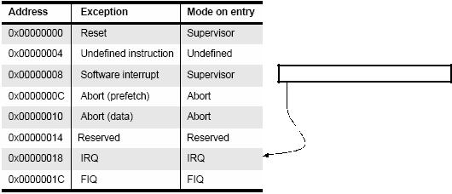

Load in the program counter the value “immediate”.

At these addresses we find a jump instruction

**Figure 2.12An exact vector table with the branching instruction**

We can notice in the vector table that the FIQ exception handler is placed at the end of the vector table, so no need for a branching instruction there; we can place the exception handler directly there so handling begins faster by eliminating the time of branching.

**Entering and exiting an exception handler**

Here are the steps that the ARM processor does to handle an exception :

Preserve the address of the next instruction.

Copy ***CPSR*** to the appropriate ***SPSR***, which is one of the banked registers for each mode of operation.

Force the ***CPSR*** mode bits to a value depending on the raised exception.

Force the ***PC*** to fetch the next instruction from the exception vector table.

Now the handler is running in the mode associated with the raised exception.

When handler is done, the ***CPSR*** is restored from the saved ***SPSR.***

***PC*** is updated with the value of (***LR*** – offset) and the offset value depends on the typeof the exception.

And when deciding to leave the exception handler, the following steps occurs:

Move the Link Register ***LR*** (minus an offset) to the ***PC***.

Copy ***SPSR*** back to ***CPSR,*** this will automatically changes the mode back to the previous one.

Clear the interrupt disable flags (if they were set).

**Interrupts**

There are two types of interrupts available on ARM processor. The first type is the interrupt caused by external events from hardware peripherals and the second type is the SWI instruction.

The ARM core has only one FIQ pin, that is why an external interrupt controller is always used so that the system can have more than one interrupt source which are prioritized with this interrupt controller and then the FIQ interrupt is raised and the handler identifies which of the external interrupts was raised and handle it.

**Interrupt Latency**

It is the interval of time between from an external interrupt signal being raised to the first fetch of an instruction of the ISR of the raised interrupt signal.

System architects must balance between two things, first is to handle multiple interrupts simultaneously, second is to minimize the interrupt latency.

Minimization of the interrupt latency is achieved by software handlers by two main methods, the first one is to allow nested interrupt handling so the system can respond to new interrupts during handling an older interrupt. This is achieved by enabling interrupts immediately after the interrupt source has been serviced but before finishing the interrupt handling. The second one is the possibility to give priorities to different interrupt sources; this is achieved by programming the interrupt controller to ignore interrupts of the same or lower priority than the interrupt being handled if there is one.

**IRQ and FIQ exceptions**

Both exceptions occur when a specific interrupt mask is cleared in the *CPSR*. The ARM processor will continue executing the current instruction in the pipeline before handling the interrupt. The processor hardware go through the following standard procedure:

The processor changes to a specific mode depending on the received interrupt.

The previous mode ***CPSR*** is saved in ***SPSR*** of the new mode.

The ***PC*** is saved in the ***LR*** of the new mode.

Interrupts are disabled, either IRQ or both IRQ and FIQ.

The processor branches to a specific entry in the vector table.

Enabling/Disabling FIQ and IRQ exceptions is done on three steps; at first loading the contents of ***CPSR*** then setting/clearing the mask bit required then copy the updated contents back to the ***CPSR***.

**Interrupt stack**

Exception handling uses stacks extensively because each exception has a specific mode of operation, so switching between modes occurs and saving the previous mode data is required before switching so that the core can switch back to its old state successfully. Each mode has a dedicated register containing a stack pointer. The design of these stacks depends on some factors like operating system requirements for stack design and target hardware physical limits on size and position in memory. Most of ARM based systems has the stack designed such that the top of it is located at high memory address. A good stack design tries to avoid stack overflow because this causes instability in embedded systems.

In the following figure we have two memory layouts which show how the stack is placed in memory:

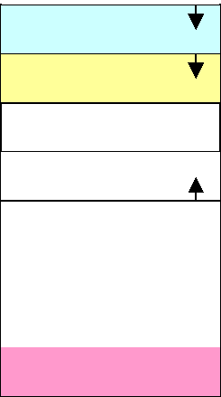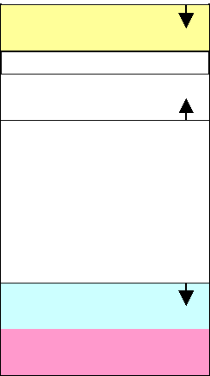

User stack

Heap

Code

Interrupt stack

Vector Table

Interrupt stack

User stack

Heap

Code

Vector Table

**Figure 2.13 Typical Memory Layouts**

**Interrupt handling schemes**

**Non-nested interrupt handling**

This is the simplest interrupt handler. Interrupts are disabled until control is returned back to the interrupted task. So only one interrupt can be served at a time and that is why this scheme is not suitable for complex embedded systems which most probably have more than one interrupt source and require concurrent handling. Figure shows the steps taken to handle an interrupt:

Initially interrupts are disabled, When IRQ exception is raised and the ARM processor disables further IRQ exceptions from occurring. The mode is changed to the new mode depending on the raised exception. The register ***CPSR*** is copied to the ***SPSR*** of the new mode. Then the ***PC*** is set to the correct entry in the vector table and the instruction there will direct the ***PC*** to the appropriate handler. Then the context of the current task is saved a subset of the current mode non banked register. Then the interrupt handler executes some code to identify the interrupt source and decide which ISR will be called. Then the appropriate ISR is called. And finally the context of the interrupted task is restored, interrupts are enabled again and the control is returned to the interrupted task.

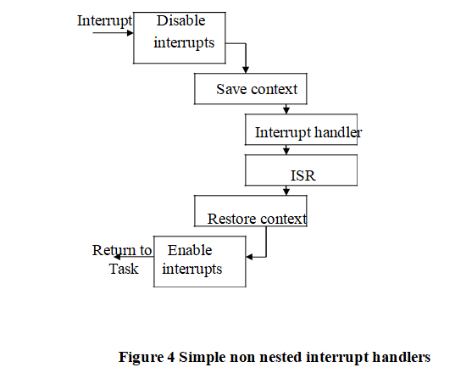

**Fig 2.13: Simple non nested interrupt handlers**

**Non-nested interrupt handling summary:**

Handle and service individual interrupts sequentially.

High interrupt latency.

Relatively easy to implement and debug.

Not suitable for complex embedded systems.

**Nested interrupt handling**

In this handling scheme handling more than one interrupt at a time is possible. This is achieved by re-enabling interrupts before the handler has fully served the current interrupt. This feature increases the complexity of the system but improves the latency. The scheme should be designed carefully to protect the context saving and restoration from being interrupted. The designer should balance between efficiency and safety by using defensive coding style that assumes problems will occur.

Also performing context switch requires emptying the IRQ stack because the handler will not perform switching if there is data on the IRQ stack, so all registers saved on the IRQ stack have to be transferred to task stack. The part of the task stack used in this process is called ***stack frame***.

**Prioritized simple interrupt handling**

In this scheme the handler will associate a priority level with a particular interrupt source. A higher priority interrupt will take precedence over a lower priority interrupt. Handling prioritization can be done by means of software or hardware. In case of hardware prioritization the handler is simpler to design because the interrupt controller will give the interrupt signal of the highest priority interrupt requiring service. But on the other side the system needs more initialization code at start-up since priority level tables have to be constructed before the system being switched on.

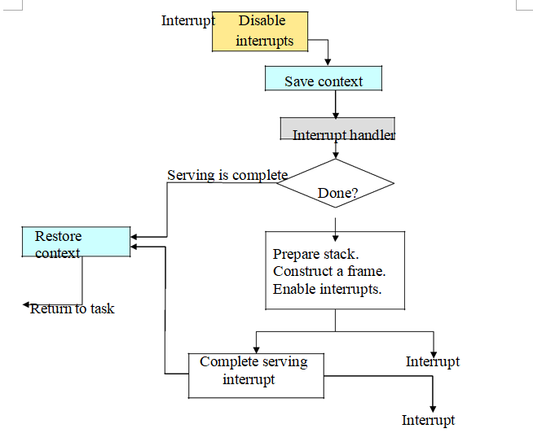

**Fig 2.14Nested Interrupt Handling**

**2.8 Thumb mode Architecture**

Thumb encodes a subset of the 32-bit ARM instructions into a 16-bit instruction set space. Since Thumb has higher performance than ARM on a processor with a 16-bit data bus, but lower performance than ARM on a 32-bit data bus, use Thumb for memory-constrained systems.  
Thumb has higher code density—the space taken up in memory by an executable  
program—than ARM. For memory-constrained embedded systems, for example, mobile  
phones and PDAs, code density is very important. Cost pressures also limit memory size, width, and speed.

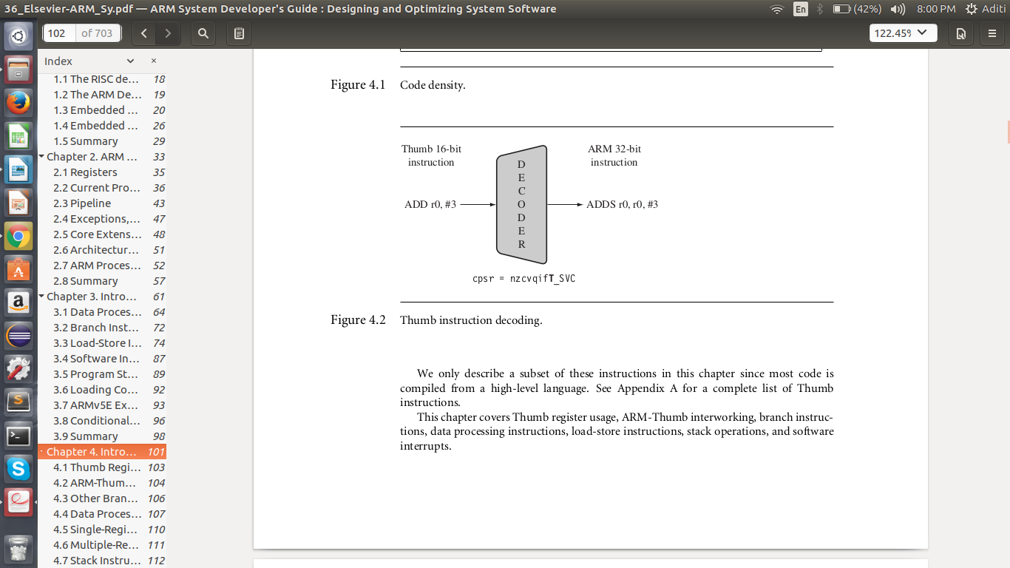  
**Fig 2.15: Thumb Instruction Decoding**

Table 2.8: Thumb Set Instructions  
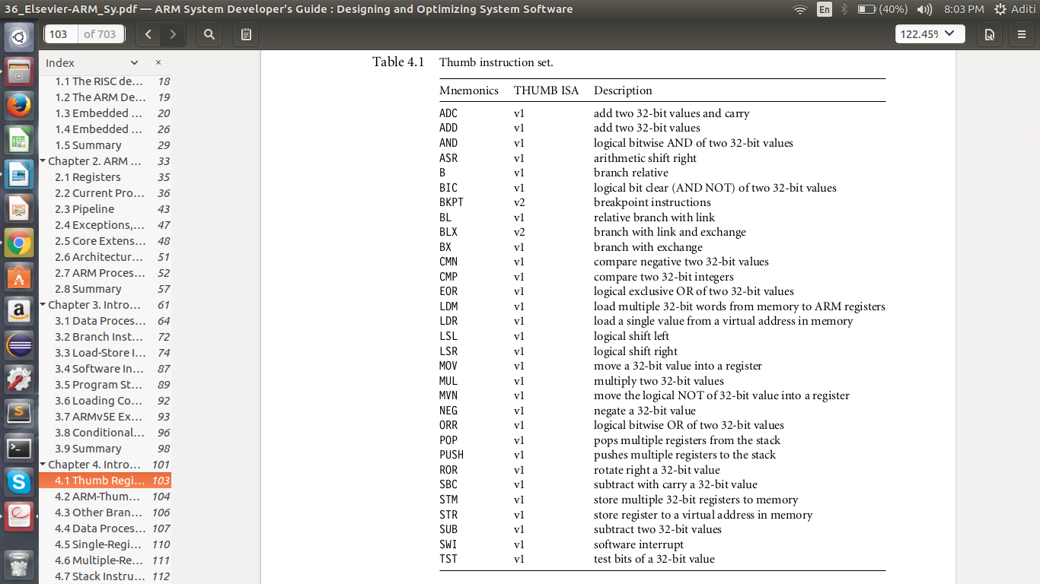  
  
  
**Thumb Register Usage**   
  
In Thumb state, you do not have direct access to all registers. Only the low registers r0 to r7 are fully accessible, as shown in Table 4.2. The higher registers r8 to r12 are only accessible with MOV, ADD, or CMP instructions. CMP and all the data processing instructions that operate on low registers update the condition flags in the cpsr.

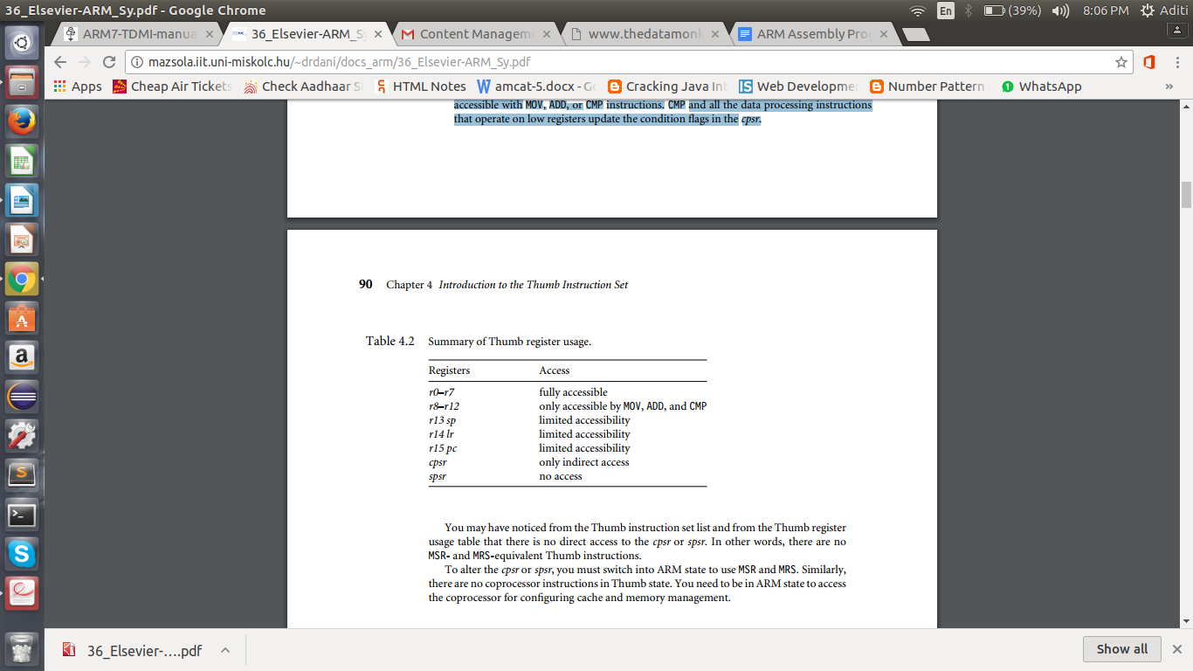

**ARM-Thumb Interworking**

ARM-Thumb interworking is the name given to the method of linking ARM and Thumb code together for both assembly and C/C++. It handles the transition between the two states. Extra code, called a veneer, is sometimes needed to carry out the transition. ATPCS defines the ARM and Thumb procedure call standards.  
To call a Thumb routine from an ARM routine, the core has to change state. This state change is shown in the T bit of the cpsr. The BX and BLX branch instructions cause a switch between ARM and Thumb state while branching to a routine. The BX lr instruction returns from a routine, also with a state switch if necessary.  
The BLX instruction was introduced in ARMv5T. On ARMv4T cores the linker uses  
a veneer to switch state on a subroutine call. Instead of calling the routine directly, the linker calls the veneer, which switches to Thumb state using the BX instruction.  
There are two versions of the BX or BLX instructions: an ARM instruction and a Thumb equivalent. The ARM BX instruction enters Thumb state only if bit 0 of the address in Rn is set to binary 1; otherwise it enters ARM state. The Thumb BX instruction does the same.

**Syntax:** BX  
BLX  
Rm  
Rm | label

**Other Branch Instructions**

There are two variations of the standard branch instruction, or B. The first is similar to the ARM version and is conditionally executed; the branch range is limited to a signed 8-bit immediate, or −256 to +254 bytes. The second version removes the conditional part of the instruction and expands the effective branch range to a signed 11-bit immediate, or −2048 to

+2046 bytes.

The conditional branch instruction is the only conditionally executed instruction in Thumb state.   
**Syntax:** B<cond> label  
B label  
BL label

**Data Processing Instructions**

The data processing instructions manipulate data within registers. They include move instructions, arithmetic instructions, shifts, logical instructions, comparison instructions, and multiply instructions. The Thumb data processing instructions are a subset of the ARM data processing instructions.

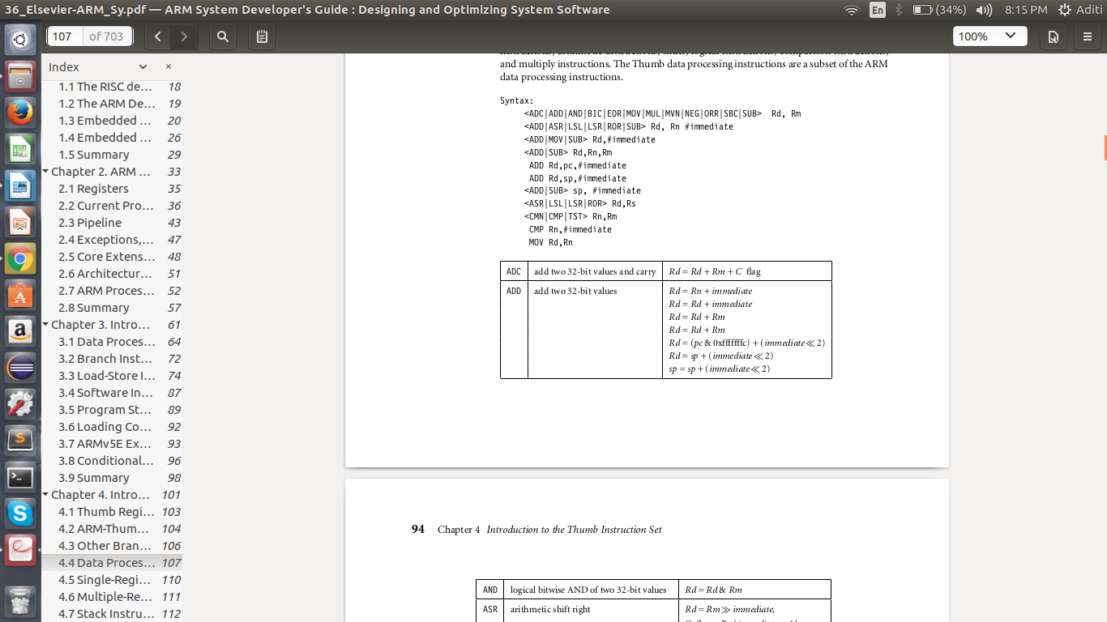  
  
  
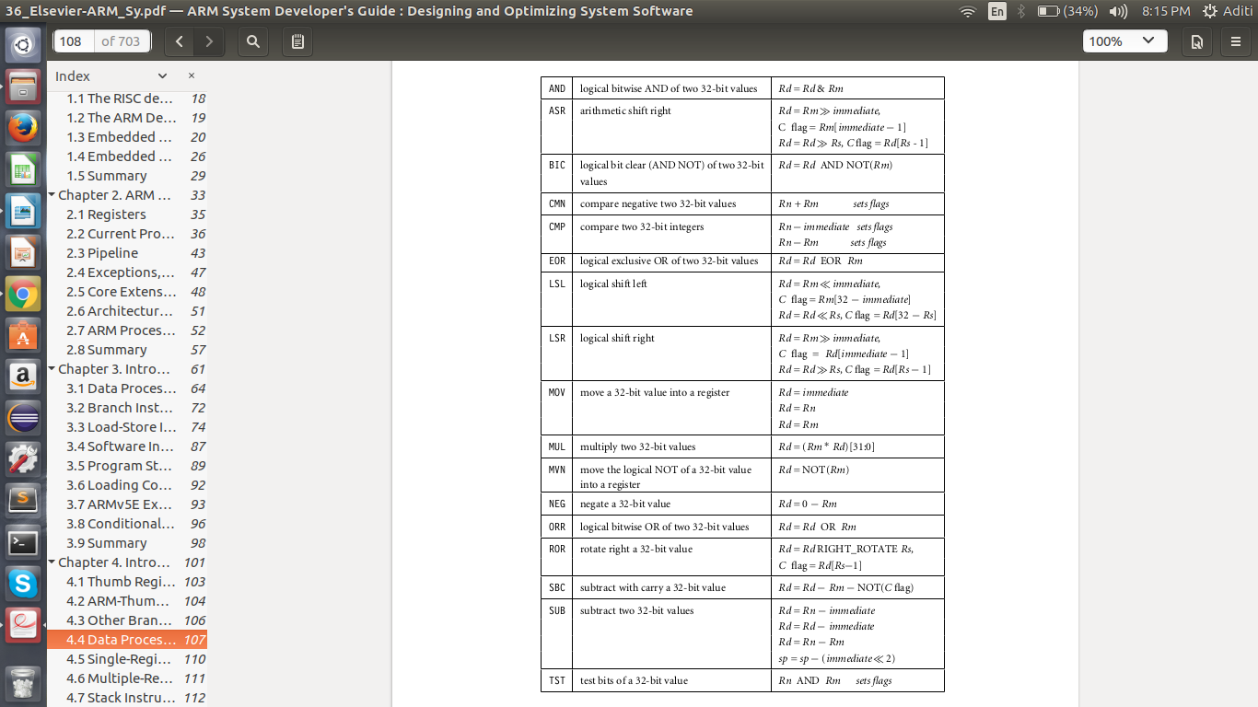

**Single-Register Load-Store Instructions**

The Thumb instruction set supports load and storing registers, or LDR and STR. These instructions use two pre-indexed addressing modes: offset by register and offset by immediate.

**Syntax:**<LDR|STR>{<B|H>} Rd, [Rn,#immediate]  
LDR{<H|SB|SH>} Rd,[Rn,Rm]  
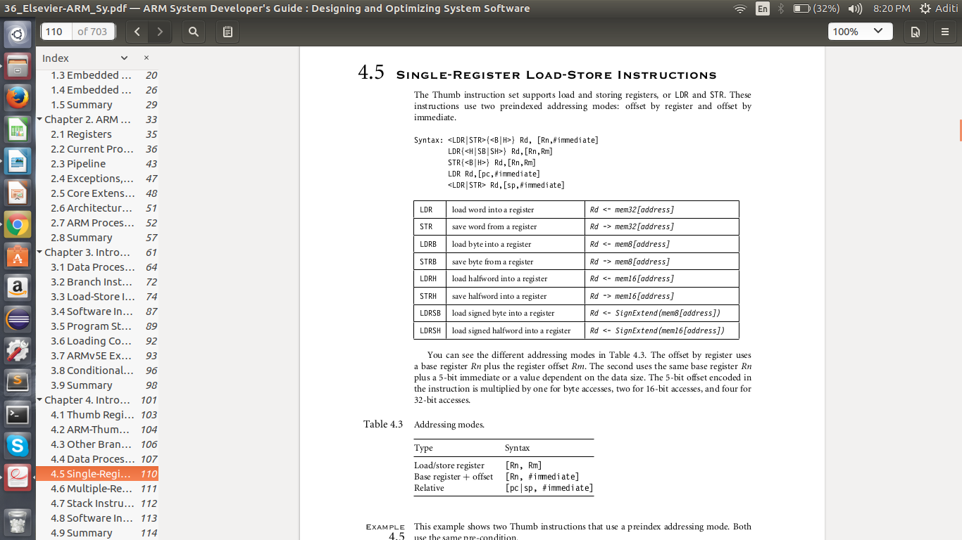**Multiple-Register Load-Store Instructions**

The Thumb versions of the load-store multiple instructions are reduced forms of the ARM load-store multiple instructions. They only support the increment after (IA) addressing mode.  
  
**Syntax :**<LDM|STM>IA Rn!, {low Register list}

|  |  |  |
| --- | --- | --- |
| LDMIA | load multiple registers | {Rd}*N <- mem32[Rn + 4 ∗ N],  Rn = Rn + 4 ∗ N |
| STMIA | save multiple registers | {Rd}*N -> mem32[Rn + 4 ∗ N],  Rn = Rn + 4 ∗ N |

**Stack Instructions**  
  
The Thumb stack operations are different from the equivalent ARM instructions because they use the more traditional POP and PUSH concept.  
  
**Syntax**: POP {low_register_list{, pc}}  
PUSH {low_register_list{, lr}}

|  |  |  |
| --- | --- | --- |
| POP | pop registers from the stacks | Rd ∗N <- mem32[sp + 4 ∗ N],  sp = sp + 4 ∗ N |
| PUSH | push registers from the stacks | Rd ∗N -> mem32[sp + 4 ∗ N],  sp = sp − 4 ∗N |

**Software Interrupt Instruction**

Similar to the ARM equivalent, the Thumb software interrupt (SWI) instruction causes a software interrupt exception. If any interrupt or exception flag is raised in Thumb state, the processor automatically reverts back to ARM state to handle the exception.

**2.9 BUS STRUCTURE**

**TIME MULTIPLEXING**

A time-multiplexed multi-speed bus that comprises a combination of a low-speed communications bus and a high-speed communications bus into a single communications bus that supports both low-speed and high-speed operations. The time-multiplexed multi-speed bus contains a low-speed state machine and a high-speed state machine. The time-multiplexed multi-speed bus is controlled by the low-speed state machine and operated at low speed in order to conduct transactions between two low-speed peripheral devices, and is controlled by the high-speed state machine and operated at high speed in order to conduct transactions between and two high-speed peripheral devices. For transactions between peripheral devices having different speeds, either a buffer is used to store data between data transmission and data reception by the two devices, or the low-speed and high-speed state machines are synchronized and operationally interleaved.

A time-multiplexed multi-speed communications bus comprising:

* a number of high-speed signal lines that are operated only at high speed;
* a number of low-speed signal lines that are operated only at low speed
* a number of multi-speed signal lines that are operated at low speed together with the low-speed signal lines and at high speed together with the high-speed signal lines
* at least one low-speed device connected to the multi-speed signal lines and to the low-speed signal lines, the time-multiplexed multi-speed bus operating at low speed to carry out a bus operation when one of the low-speed devices initiates the bus operation with another one of the low-speed devices
* at least one high-speed device connected to the multi-speed signal lines and to the high-speed signal lines, the time-multiplexed multi-speed bus operating at high speed to carry out a bus operation when one of the high-speed devices initiates the bus operation with another one of the high-speed devices; and when a bus operation between one of the low-speed devices and one of the high-speed devices is initiated, during the portion of the bus operation in which data is transmitted by a device, the time-multiplexed multi-speed bus operates at the speed required by the device that transmits data for the operation, and during the portion of the bus operation in which data is received by a device, the time-multiplexed multi-speed bus operates at the speed required by the device that receives the data.

The time-multiplexed multi-speed communications bus of claim 1 further comprising:

1. an arbiter that detects a speed of a device that initiates a bus operation;
2. a low-speed state machine that, when the detected device speed is low, is activated by the arbiter to control the sequencing of signal propagation over the signal times during an initial portion of the execution of the bus operation; and
3. a high-speed state machine that, when the detected device speed is high, is activated by the arbiter to control the sequencing of signal propagation over the signal lines during an initial portion of the execution of the bus operation.

**2.10 Serial and Parallel Communication Bus Structure**

**Serial Communication**

S**erial communication** is the process of sending [data](https://en.wikipedia.org/wiki/Data) one [bit](https://en.wikipedia.org/wiki/Bit) at a time, sequentially, over a [communication channel](https://en.wikipedia.org/wiki/Communication_channel) or [computer bus](https://en.wikipedia.org/wiki/Computer_bus). This is in contrast to [parallel communication](https://en.wikipedia.org/wiki/Parallel_communication), where several bits are sent as a whole, on a link with several parallel channels.

Serial communication is used for all long-haul communication and most [computer networks](https://en.wikipedia.org/wiki/Computer_network), where the cost of [cable](https://en.wikipedia.org/wiki/Electrical_cable) and [synchronization](https://en.wikipedia.org/wiki/Synchronization) difficulties make parallel communication impractical. Serial computer buses are becoming more common even at shorter distances, as improved [signal integrity](https://en.wikipedia.org/wiki/Signal_integrity) and transmission speeds in newer serial technologies have begun to outweigh the parallel bus's advantage of simplicity (no need for serializer and deserializer, or [SerDes](https://en.wikipedia.org/wiki/SerDes)) and to outstrip its disadvantages ([clock skew](https://en.wikipedia.org/wiki/Clock_skew), interconnect density). The migration from [PCI](https://en.wikipedia.org/wiki/Peripheral_Component_Interconnect) to [PCI Express](https://en.wikipedia.org/wiki/PCI_Express) is an example.

Many serial communication systems were originally designed to transfer data over relatively large distances through some sort of [data cable](https://en.wikipedia.org/wiki/Data_cable).

The term "serial" most often refers to the RS232 port on the back of the original [IBM PC](https://en.wikipedia.org/wiki/IBM_PC), often called "the" [serial port](https://en.wikipedia.org/wiki/Serial_port), and "the" [serial cable](https://en.wikipedia.org/wiki/Serial_cable) designed to plug into it, and the many devices designed to be compatible with it.

Practically all long-distance communication transmits data one bit at a time, rather than in parallel, because it reduces the cost of the cable. The cables that carry this data (other than "the" serial cable) and the [computer ports](https://en.wikipedia.org/wiki/Computer_port_(hardware)) they plug into are usually referred to with a more specific name, to reduce confusion.

Keyboard and mouse cables and ports are almost invariably serial—such as [PS/2 port](https://en.wikipedia.org/wiki/PS/2_port) and [Apple Desktop Bus](https://en.wikipedia.org/wiki/Apple_Desktop_Bus) and [USB](https://en.wikipedia.org/wiki/USB).

The cables that carry digital video are almost invariably serial—such as [coax cable](https://en.wikipedia.org/wiki/Coax_cable) plugged into a [HD-SDI](https://en.wikipedia.org/wiki/HD-SDI) port, a [webcam](https://en.wikipedia.org/wiki/Webcam) plugged into a USB port or [Firewire port](https://en.wikipedia.org/wiki/Firewire_port), [Ethernet cable](https://en.wikipedia.org/wiki/Ethernet_cable) connecting an [IP camera](https://en.wikipedia.org/wiki/IP_camera) to a [Power over Ethernet](https://en.wikipedia.org/wiki/Power_over_Ethernet) port, [FPD-Link](https://en.wikipedia.org/wiki/FPD-Link), etc.

Other such cables and ports, transmitting data one bit at a time, include [Serial ATA](https://en.wikipedia.org/wiki/Serial_ATA), [Serial SCSI](https://en.wikipedia.org/wiki/SCSI_connector#Serial_SCSI), Ethernet cable plugged into [Ethernet ports](https://en.wikipedia.org/wiki/Ethernet_port), the [Display Data Channel](https://en.wikipedia.org/wiki/Display_Data_Channel) using previously reserved pins of the [VGA connector](https://en.wikipedia.org/wiki/VGA_connector) or the [DVI port](https://en.wikipedia.org/wiki/DVI_port) or the [HDMI](https://en.wikipedia.org/wiki/HDMI) port.

Many communication systems were generally designed to connect two integrated circuits on the same [printed circuit board](https://en.wikipedia.org/wiki/Printed_circuit_board), connected by [signal traces](https://en.wikipedia.org/wiki/Signal_trace) on that board (rather than external cables).

[Integrated circuits](https://en.wikipedia.org/wiki/Integrated_circuit) are more expensive when they have more pins. To reduce the number of pins in a package, many ICs use a serial bus to transfer data .

**Parallel Communication**

**Parallel communication** is a method of conveying multiple binary digits ([bits](https://en.wikipedia.org/wiki/Bit)) simultaneously. It contrasts with [serial communication](https://en.wikipedia.org/wiki/Serial_communication), which conveys only a single bit at a time; this distinction is one way of characterizing a communications link.

The basic difference between a parallel and a serial [communication channel](https://en.wikipedia.org/wiki/Communication_channel) is the number of electrical conductors used at the [physical layer](https://en.wikipedia.org/wiki/Physical_layer) to convey bits. Parallel communication implies more than one such conductor. For example, an 8-bit parallel channel will convey eight bits (or a [byte](https://en.wikipedia.org/wiki/Byte)) simultaneously, whereas a serial channel would convey those same bits sequentially, one at a time. If both channels operated at the same [clock speed](https://en.wikipedia.org/wiki/Clock_speed), the parallel channel would be eight times faster. A parallel channel may have additional conductors for other signals, such as a clock signal to pace the flow of data, a signal to control the direction of data flow, and [handshaking](https://en.wikipedia.org/wiki/Handshaking) signals.

Parallel communication is and always has been widely used within [integrated circuits](https://en.wikipedia.org/wiki/Integrated_circuit), in [peripheral](https://en.wikipedia.org/wiki/Peripheral) buses, and in memory devices such as [RAM](https://en.wikipedia.org/wiki/Random-access_memory). Computer system buses, on the other hand, have evolved over time: parallel communication was commonly used in earlier system buses, whereas serial communications are prevalent in modern computers.

Before the development of high-speed serial technologies, the choice of parallel links over serial links was driven by these factors:

* Speed: Superficially, the speed of a parallel data link is equal to the number of bits sent at one time times the [bit rate](https://en.wikipedia.org/wiki/Bit_rate) of each individual path; doubling the number of bits sent at once doubles the data rate. In practice, [clock skew](https://en.wikipedia.org/wiki/Clock_skew) reduces the speed of every link to the slowest of all of the links.
* Cable length: [Crosstalk](https://en.wikipedia.org/wiki/Crosstalk_(electronics)) creates interference between the parallel lines, and the effect worsens with the length of the communication link. This places an upper limit on the length of a parallel data connection that is usually shorter than a serial connection.
* Complexity: Parallel data links are easily implemented in hardware, making them a logical choice. Creating a [parallel port](https://en.wikipedia.org/wiki/Parallel_port) in a computer system is relatively simple, requiring only a [latch](https://en.wikipedia.org/wiki/Latch_(electronic)) to copy data onto a [data bus](https://en.wikipedia.org/wiki/Bus_(computing)).

2.11 **Bus Arbitration**

* Bus arbitration is the process by which the next device to become the bus master is selected and bus mastership is transferred to it. The selection of bus master is usually done on the priority basis.
* There are two approaches to bus arbitration: Centralized and distributed.

**1. Centralized Arbitration**

* + In centralized bus arbitration, a single bus arbiter performs the required arbitration. The bus arbiter may be the processor or a separate controller connected to the bus.
  + There are three different arbitration schemes that use the centralized bus arbitration approach. There schemes are:

a. Daisy chaining

b. Polling method

c. Independent request

**a) Daisy chaining**

* + The system connections for Daisy chaining method are shown in fig below.

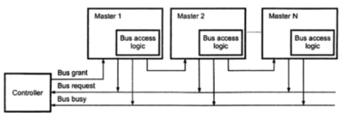

* It is simple and cheaper method. All masters make use of the same line for bus request.
* In response to the bus request the controller sends a bus grant if the bus is free.
* The bus grant signal serially propagates through each master until it encounters the first one that is requesting access to the bus. This master blocks the propagation of the bus grant signal, activities the busy line and gains control of the bus.
* Therefore any other requesting module will not receive the grant signal and hence cannot get the bus access.

**b) Polling method**

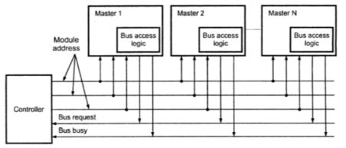

* The system connections for polling method are shown in figure above.
* In this the controller is used to generate the addresses for the master. Number of address line required depends on the number of master connected in the system.
* For example, if there are 8 masters connected in the system, at least three address lines are required.
* In response to the bus request controller generates a sequence of master address. When the requesting master recognizes its address, it activated the busy line ad begins to use the bus.

**c) Independent request**

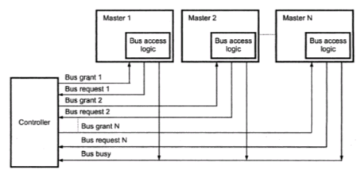

* The figure below shows the system connections for the independent request scheme.
* In this scheme each master has a separate pair of bus request and bus grant lines and each pair has a priority assigned to it.
* The built in priority decoder within the controller selects the highest priority request and asserts the corresponding bus grant signal.

**2. Distributed Arbitration**

* In distributed arbitration, all devices participate in the selection of the next bus master.
* In this scheme each device on the bus is assigned a4-bit identification number.
* The number of devices connected on the bus when one or more devices request for the control of bus, they assert the start-arbitration signal and place their 4-bit ID numbers on arbitration lines, ARB0 through ARB3.
* These four arbitration lines are all open-collector. Therefore, more than one device can place their 4-bit ID number to indicate that they need to control of bus. If one device puts 1 on the bus line and another device puts 0 on the same bus line, the bus line status will be 0. Device reads the status of all lines through inverters buffers so device reads bus status 0as logic 1. Scheme the device having highest ID number has highest priority.
* When two or more devices place their ID number on bus lines then it is necessary to identify the highest ID number on bus lines then it is necessary to identify the highest ID number from the status of bus line. Consider that two devices A and B, having ID number 1 and 6, respectively are requesting the use of the bus.
* Device A puts the bit pattern 0001, and device B puts the bit pattern 0110. With this combination the status of bus-line will be 1000; however because of inverter buffers code seen by both devices is 0111.
* Each device compares the code formed on the arbitration line to its own ID, starting from the most significant bit. If it finds the difference at any bit position, it disables its drives at that bit position and for all lower-order bits.
* It does so by placing a 0 at the input of their drive. In our example, device detects a different on line ARB2 and hence it disables its drives on line ARB2, ARB1 and ARB0. This causes the code on the arbitration lines to change to 0110. This means that device B has won the race.
* The decentralized arbitration offers high reliability because operation of the bus is not dependent on any single device.

**2.12 DMA(Direct Memory Access)**

**Introduction**

Direct Memory Access (DMA) allows devices to transfer data without subjecting the processor a heavy overhead. Otherwise, the processor would have to copy each piece of data from the source to the destination. This is typically slower than copying normal blocks of memory since access to I/O devices over a peripheral bus is generally slower than normal system RAM. During this time the processor would be unavailable for any other tasks involving processor bus access. But it can continue to work on any work which does not require bus access. DMA transfers are essential for high performance embedded systems where large chunks of data need to be transferred from the input/output devices to or from the primary memory.

**DMA Controller**

A DMA controller is a device, usually peripheral to a CPU that is programmed to perform a sequence of data transfers on behalf of the CPU. A DMA controller can directly access memory and is used to transfer data from one memory location to another, or from an I/O device to memory and vice versa. A DMA controller manages several DMA channels, each of which can be programmed to perform a sequence of these DMA transfers. Devices, usually I/O peripherals, that acquire data that must be read (or devices that must output data and be written to) signal the DMA controller to perform a DMA transfer by asserting a hardware DMA request (DRQ) signal. A DMA request signal for each channel is routed to the DMA controller. This signal is monitored and responded to in much the same way that a processor handles interrupts. When the DMA controller sees a DMA request, it responds by performing one or many data transfers from that I/O device into system memory or vice versa. Channels must be enabled by the processor for the DMA controller to respond to DMA requests. The number of transfers performed, transfer modes used,and memory locations accessed depends on how the DMA channel is programmed. A DMA controller typically shares the system memory and I/O bus with the CPU and has both bus master and slave capability. Fig.16.1 shows the DMA controller architecture and how the DMA controller interacts with the CPU. In bus master mode, the DMA controller acquires the system bus (address, data, and control lines) from the CPU to perform the DMA transfers. Because the CPU releases the system bus for the duration of the transfer, the process is sometimes referred to as cycle stealing.

In bus slave mode, the DMA controller is accessed by the CPU, which programs the DMA controller's internal registers to set up DMA transfers. The internal registers consist of source and destination address registers and transfer count registers for each DMA channel, as well as control and status registers for initiating, monitoring, and sustaining the operation of the DMA controller. **DMA Controller Status Register Mask Register DMA Channel X Base Count Current Count Base Address Current Address DMA Arbitration Logic Base Request**

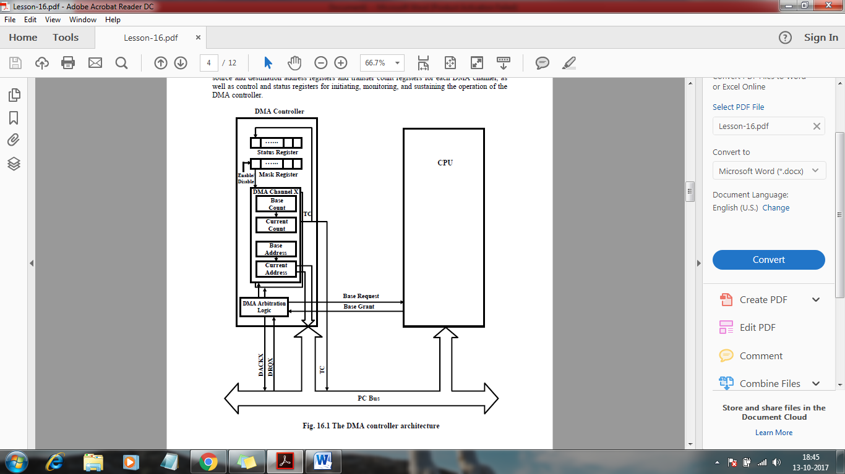

DMA Controller Architecture

**DMA Transfer Types and Modes**

DMA controllers vary as to the type of DMA transfers and the number of DMA channels they support. The two types of DMA transfers are flyby DMA transfers and fetch-and-deposit DMA transfers. The three common transfer modes are single, block, and demand transfer modes. These DMA transfer types and modes are described in the following paragraphs. The fastest DMA transfer type is referred to as a single-cycle, single-address, or flyby transfer. In a flyby DMA transfer, a single bus operation is used to accomplish the transfer, with data read from the source and written to the destination simultaneously. In flyby operation, the device requesting service asserts a DMA request on the appropriate channel request line of the DMA controller. The DMA controller responds by gaining control of the system bus from the CPU and then issuing the pre-programmed memory address. Simultaneously, the DMA controller sends a DMA acknowledge signal to the requesting device. This signal alerts the requesting device to drive the data onto the system data bus or to latch the data from the system bus, depending on the direction of the transfer. In other words, a flyby DMA transfer looks like a memory read or write cycle with the DMA controller supplying the address and the I/O device reading or writing the data. Because flyby DMA transfers involve a single memory cycle per data transfer, these transfers are very efficient. Fig.16.2 shows the flyby DMA transfer signal protocol.

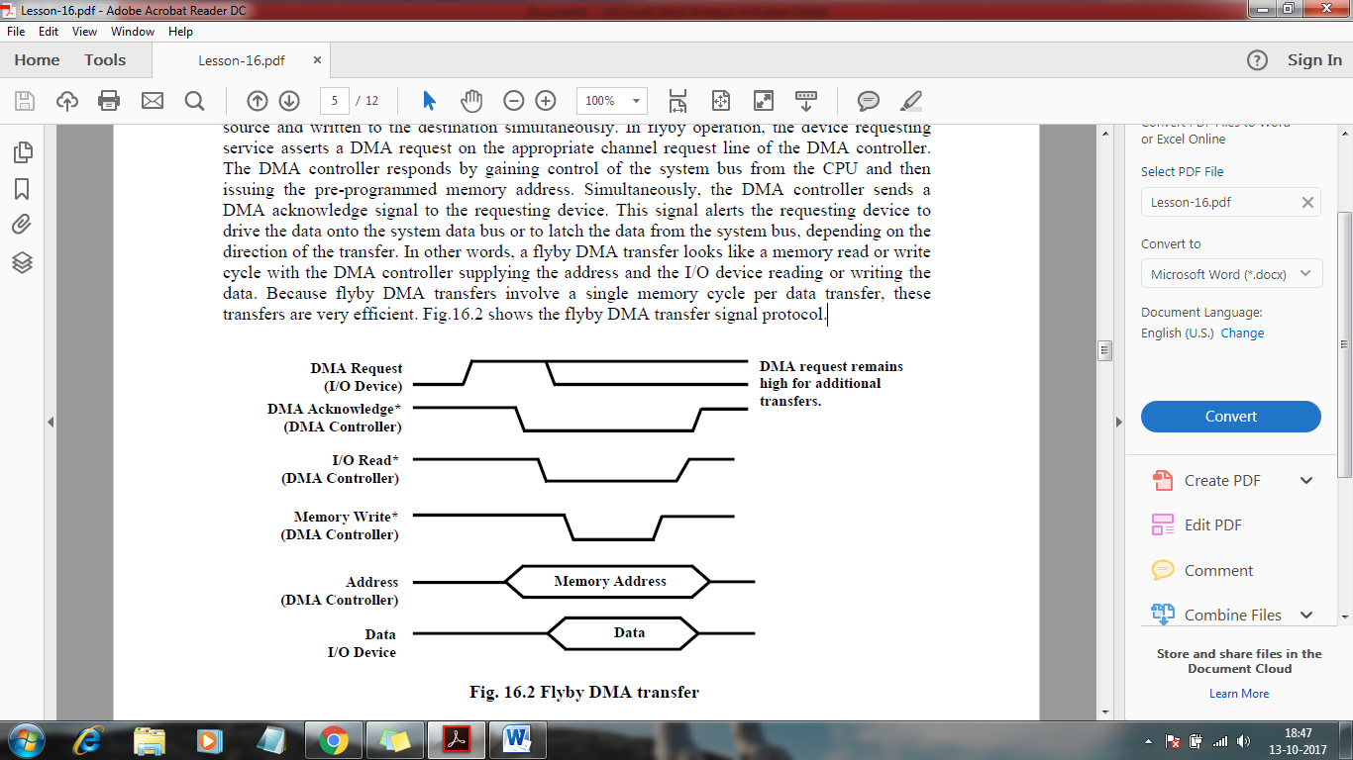

Flyby DMA transfer

The second type of DMA transfer is referred to as a dual-cycle, dual-address, flow-through, or fetch-and-deposit DMA transfer. As these names imply, this type of transfer involves two memory or I/O cycles. The data being transferred is first read from the I/O device or memory into a temporary data register internal to the DMA controller. The data is then written to the memory or I/O device in the next cycle. Fig.16.3 shows the fetch-and-deposit DMA transfer signal protocol. Although inefficient because the DMA controller performs two cycles and thus retains the system bus longer, this type of transfer is useful for interfacing devices with different data bus sizes. For example, a DMA controller can perform two 16-bit read operations from one location followed by a 32-bit write operation to another location. A DMA controller supporting this type of transfer has two address registers per channel (source address and destination address) and bus-size registers, in addition to the usual transfer count and control registers.

Unlike the flyby operation, this type of DMA transfer is suitable for both memory-to-memory and I/O transfers.

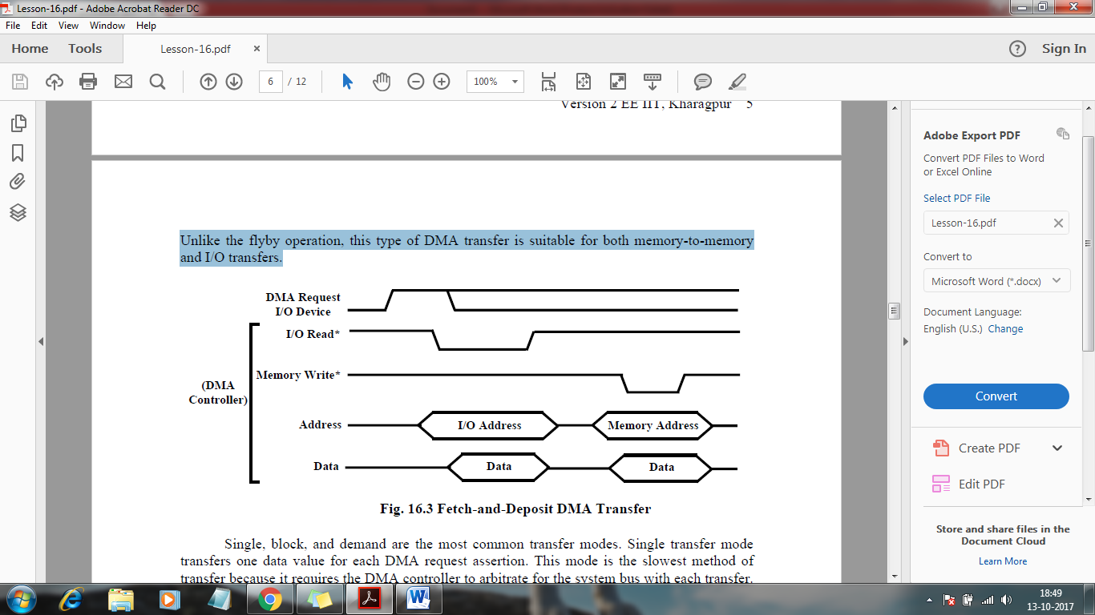

Fetch-and-Deposit DMA Transfer

Single, block, and demand are the most common transfer modes. Single transfer mode transfers one data value for each DMA request assertion. This mode is the slowest method of transfer because it requires the DMA controller to arbitrate for the system bus with each transfer. This arbitration is not a major problem on a lightly loaded bus, but it can lead to latency problems when multiple devices are using the bus. Block and demand transfer modes increase system throughput by allowing the DMA controller to perform multiple DMA transfers when the DMA controller has gained the bus. For block mode transfers, the DMA controller performs the entire DMA sequence as specified by the transfer count register at the fastest possible rate in response to a single DMA request from the I/O device. For demand mode transfers, the DMA controller performs DMA transfers at the fastest possible rate as long as the I/O device asserts its DMA request. When the I/O device unasserts this DMA request, transfers are held off.

**DMA Controller Operation**

For each channel, the DMA controller saves the programmed address and count in the base registers and maintains copies of the information in the current address and current count registers, as shown in Fig.16.1. Each DMA channel is enabled and disabled via a DMA mask register. When DMA is started by writing to the base registers and enabling the DMA channel, the current registers are loaded from the base registers. With each DMA transfer, the value in the current address register is driven onto the address bus, and the current address register is automatically incremented or decremented. The current count register determines the number of transfers remaining and is automatically decremented after each transfer. When the value in the current count register goes from 0 to -1, a terminal count (TC) signal is generated, which signifies the completion of the DMA transfer sequence. This termination event is referred to as reaching terminal count. DMA controllers often generate a hardware TC pulse during the last cycle of a DMA transfer sequence. This signal can be monitored by the I/O devices participating in the DMA transfers. DMA controllers require reprogramming when a DMA channel reaches TC. Thus, DMA controllers require some CPU time, but far less than is required for the CPU to service device I/O interrupts. When a DMA channel reaches TC, the processor may need to reprogram the controller for additional DMA transfers. Some DMA controllers interrupt theprocessor whenever a channel terminates. DMA controllers also have mechanisms for automatically reprogramming a DMA channel when the DMA transfer sequence completes. These mechanisms include auto initialization and buffer chaining. The auto initialization feature repeats the DMA transfer sequence by reloading the DMA channel's current registers from the base registers at the end of a DMA sequence and re-enabling the channel. Buffer chaining is useful for transferring blocks of data into noncontiguous buffer areas or for handling double-buffered data acquisition. With buffer chaining, a channel interrupts the CPU and is programmed with the next address and count parameters while DMA transfers are being performed on the current buffer. Some DMA controllers minimize CPU intervention further by having a chain address register that points to a chain control table in memory. The DMA controller then loads its own channel parameters from memory. Generally, the more sophisticated the DMA controller, the less servicing the CPU has to perform.

A DMA controller has one or more status registers that are read by the CPU to determine the state of each DMA channel. The status register typically indicates whether a DMA request is asserted on a channel and whether a channel has reached TC. Reading the status register often clears the terminal count information in the register, which leads to problems when multiple programs are trying to use different DMA channels.

Steps in a Typical DMA cycle

Device wishing to perform DMA asserts the processors bus request signal.

1. Processor completes the current bus cycle and then asserts the bus grant signal to the device.

2. The device then asserts the bus grant ack signal.

3. The processor senses in the change in the state of bus grant ack signal and starts listening to the data and address bus for DMA activity.

4. The DMA device performs the transfer from the source to destination address.

5. During these transfers, the processor monitors the addresses on the bus and checks if any location modified during DMA operations is cached in the processor. If the processor detects a cached address on the bus, it can take one of the two actions:

o Processor invalidates the internal cache entry for the address involved in DMA write operation

o Processor updates the internal cache when a DMA write is detected

6. Once the DMA operations have been completed, the device releases the bus by asserting the bus release signal.

7. Processor acknowledges the bus release and resumes its bus cycles from the point it left off.

**2.13 PCI Bus Architecture**

A computer bus is used to transfer data from one location or device on the motherboard to the central processing unit where all calculations take place.

Two different parts of a Bus

* Address bus-transfers information about where the data should go
* Data bus-transfers the actual data

**PCI System Bus Interference**

Three features make this possible:

Burst Mode: allows multiple sets of data to be sent (Kozierok, 2001a).

Full Bus Mastering: the ability of devices on the PCI bus to perform transfers directly (Kozierok, 2001c).

High Bandwidth Options: allows increased speed of the PCI (Kozierok, 2001a).

**PLUG AND PLAY**

Requirements for full implementation:

1}Plug and Play BIOS

2}Extended System Configuration Data (ESCD)

3}Plug and Play operating system

Tasks it automates:

1}Interrupt Requests (IRQ)

2}Direct Memory Access (DMA)

3}Memory Addresses

4}Input/Output (I/O) Configuration

**How PCI Works: Installing A New Device**

Once a new device has been inserted into a PCI slot on the motherboard

1. Operating System Basic Input/Output System (BIOS) initiates Plug and Play (PnP) BIOS.

2. PnP BIOS scans the PCI bus for any new hardware connected to the bus. If new hardware is found, it will ask for identification.

The device will respond with its identification and send its device ID to the BIOS through the bus. PnP checks the Extended System Configuration Data (ESCD) to make sure the configuration data already exists for the card. (If the card is new, then there will be no data for it.)

5. PnP will assign an Interrupt Request Line, Direct Memory Access, memory address and Input/Output settings to the card, then stores the information in the ESCD.

6.When the Windows software loads, it will check the PCI bus and the ESCD to see if there is new hardware. Windows will alert the user that new hardware has been found if there is new hardware installed and will also identify the hardware.

1. Windows will determine the device and attempt to install its driver. The operating system may ask the user to insert a disk containing the driver or direct it to where the driver is located. In the event that Windows is unable to determine what the device is, it will provide a dialog window so the user can identify the hardware and load its driver.

**How a Device Works**

Example: PCI-based sound card

The sound card will convert the analog signal to a digital signal.The digital audio data carried across the PCI bus to the bus controller, which determines which device on the PCI device has the priority to send data to the central processing unit (CPU) and whether the data will go directly to the CPU or to the system memory.

If the sound card is in recording mode, the bus controller will assign a high priority to the data coming from the sound card. It will send the sound cards data over the bus bridge to the system bus.

The system bus will save the data in system memory. When the recording is complete, then it will be up to the user to save the data from the sound card on either the hard drive, or will remain in memory for additional processing.

**2.14 AMBA**

AMBA, first introduced in 1996, describes a number of buses and interfaces for on-chip communications. The first version of AMBA contained only two buses—

a system bus and a peripheral bus. The current version, AMBA 4, contains a wide collection of high performance buses and interfaces. In this section, we look at some key AMBA buses, based mostly on the AMBA 3 standard [ARM].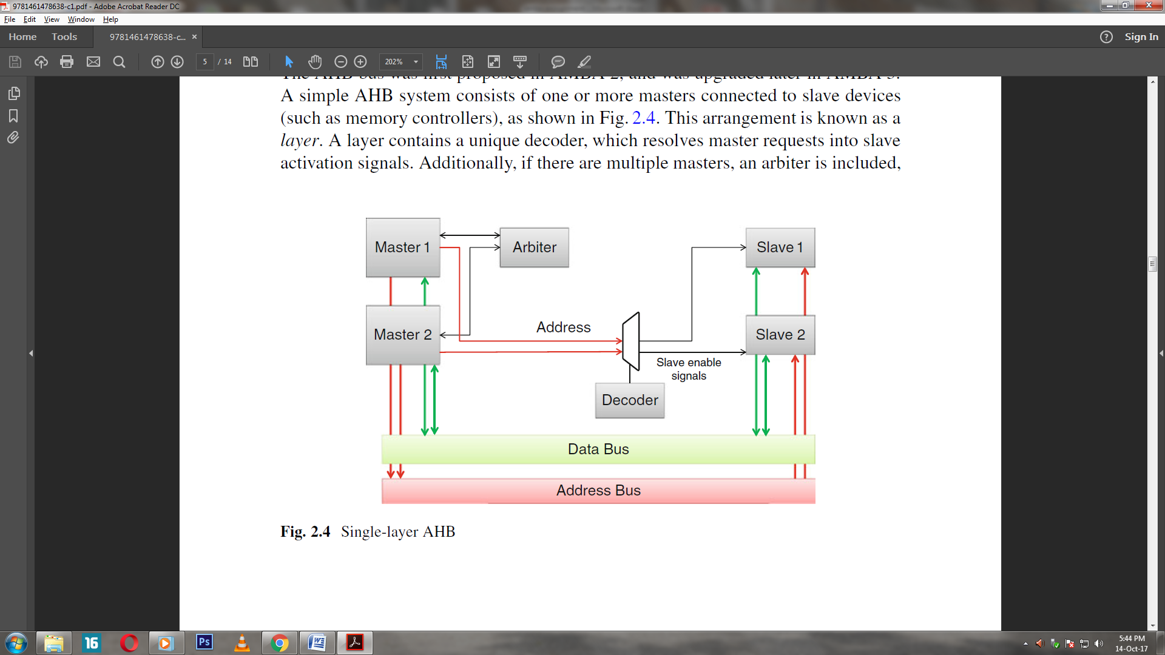

**Overview of the AMBA specification**

The *Advanced Microcontroller Bus Architecture* (AMBA) specification defines an onchip

communications standard for designing high-performance embedded

microcontrollers.

Three distinct buses are defined within the AMBA specification:

• the*Advanced High-performance Bus* (AHB)

• the*Advanced System Bus* (ASB)

• the*Advanced Peripheral Bus* (APB).

A test methodology is included with the AMBA specification which provides an

infrastructure for modular macrocell test and diagnostic access.

**Advanced High-performance Bus (AHB)**

The AMBA AHB is for high-performance, high clock frequency system modules.

The AHB acts as the high-performance system *backbone* bus. AHB supports the

efficient connection of processors, on-chip memories and off-chip external memory

interfaces with low-power peripheral macrocell functions. AHB is also specified to

ensure ease of use in an efficient design flow using synthesis and automated test

techniques.

**Advanced System Bus (ASB)**

The AMBA ASB is for high-performance system modules.

AMBA ASB is an alternative system bus suitable for use where the high-performance

features of AHB are not required. ASB also supports the efficient connection of

processors, on-chip memories and off-chip external memory interfaces with low-power

peripheralmacrocell functions.

**Advanced Peripheral Bus (APB)**

The AMBA APB is for low-power peripherals.

AMBA APB is optimized for minimal power consumption and reduced interface

complexity to support peripheral functions. APB can be used in conjunction with either

version of the system bus.

**A typical AMBA-based microcontroller**

An AMBA-based microcontroller typically consists of a high-performance system

*backbone*bus (AMBA AHB or AMBA ASB), able to sustain the external memory

bandwidth, on which the CPU, on-chip memory and other *Direct Memory Access*

(DMA) devices reside. This bus provides a high-bandwidth interface between the

elements that are involved in the majority of transfers. Also located on the highperformance

bus is a bridge to the lower bandwidth APB, where most of the peripheral

devices in the system are located 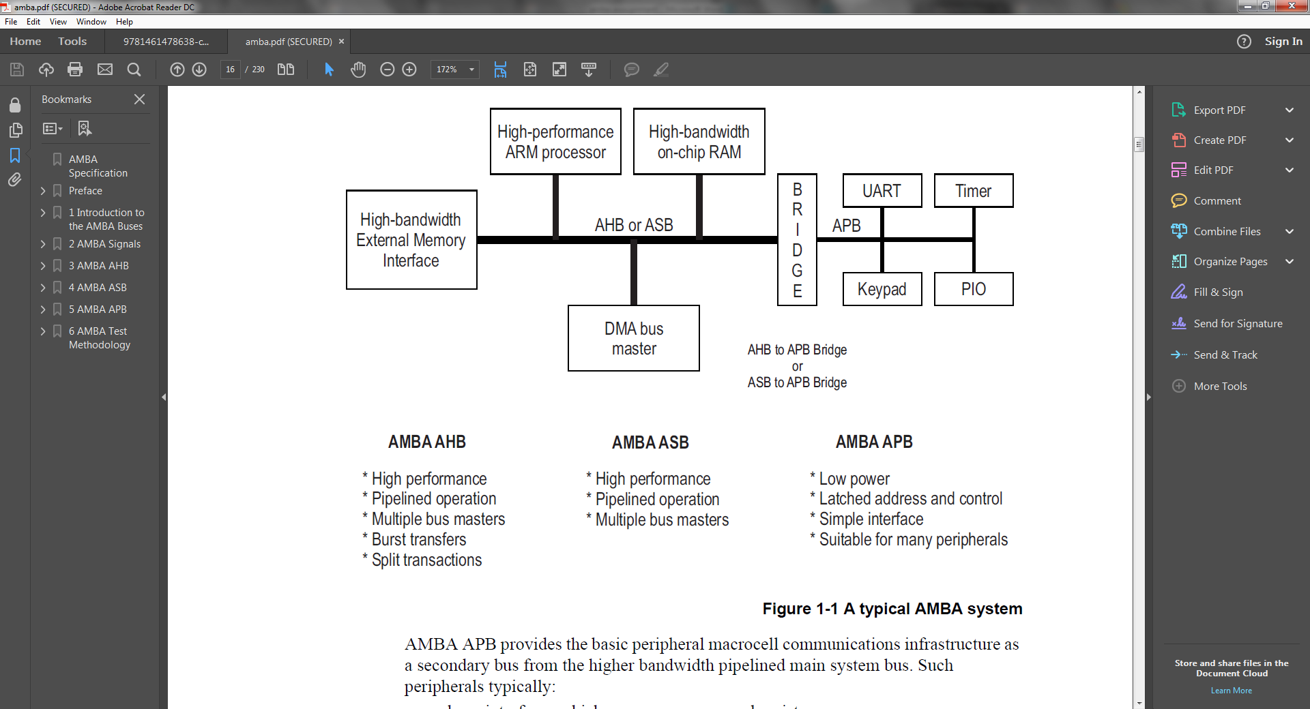

AMBA APB provides the basic peripheral macrocell communications infrastructure as

a secondary bus from the higher bandwidth pipelined main system bus. Such

peripherals typically:

• have interfaces which are memory-mapped registers

• have no high-bandwidth interfaces

• are accessed under programmed control.

The external memory interface is application-specific and may only have a narrow data

path, but may also support a test access mode which allows the internal AMBA AHB,

ASB and APB modules to be tested in isolation with system-independent test sets.

**2.15 12C BUSES**

12C is a serial protocol for two-wire interface to connect low-speed devices like microcontrollers, EEPROMs, A/D and D/A converters, I/O interfaces and other similar peripherals in embedded systems. It was invented by Philips and now it is used by almost all major IC manufacturers. Each I2C slave device needs an address – they must still be obtained from [NXP](http://www.nxp.com/campaigns/i2c-bus/) (formerly Philips semiconductors).

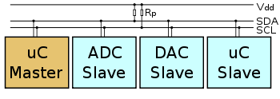

I2C bus is popular because it is simple to use, there can be more than one master, only upper bus speed is defined and only two wires with pull-up resistors are needed to connect almost unlimited number of I2C devices. I2C can use even slower microcontrollers with general-purpose I/O pins since they only need to generate correct [Start and Stop conditions](http://i2c.info/i2c-bus-specification#start-stop) in addition to functions for reading and writing a byte.

Each slave device has a unique address. Transfer from and to master device is serial and it is split into 8-bit packets. All these simple requirements make it very simple to implement I2C interface even with cheap microcontrollers that have no special I2C hardware controller. You only need 2 free I/O pins and few simple i2C routines to send and receive commands.

The initial I2C specifications defined maximum clock frequency of 100 kHz. This was later increased to 400 kHz as [Fast mode](http://i2c.info/i2c-bus-specification#fast-mode). There is also a High speed mode which can go up to 3.4 MHz and there is also a 5 MHz ultra-fast mode.

**I2C Interface**

I2C uses only two wires: SCL (serial clock) and SDA (serial data). Both need to be pulled up with a resistor to +Vdd. There are also I2C level shifters which can be used to connect to two I2C buses with different voltages.

**I2C Addresses**

Basic [I2C communication](http://i2c.info/i2c-bus-specification#data-transfer) is using transfers of 8 bits or bytes. Each I2C slave device has a [7-bit address](http://i2c.info/i2c-bus-specification#7-bit-addressing) that needs to be unique on the bus. Some devices have fixed I2C address while others have few address lines which determine lower bits of the I2C address. This makes it very easy to have all I2C devices on the bus with unique I2C address. There are also devices which have [10-bit address](http://i2c.info/i2c-bus-specification#10-bit-addressing) as allowed by the specification.

7-bit address represents bits 7 to 1 while bit 0 is used to signal reading from or writing to the device. If bit 0 (in the address byte) is set to 1 then the master device will read from the slave I2C device.

Master device needs no address since it generates the clock (via SCL) and addresses individual I2C slave devices.

**I2C Bus Protocol**

The I2C bus physically consists of 2 active wires and a ground connection. The active wires, called SDA and SCL, are both bi-directional. SDA is the Serial DAta line, and SCL is the Serial Clock line.  
Every device hooked up to the bus has its own unique address, no matter whether it is an MCU, LCD driver, memory, or ASIC. Each of these chips can act as a receiver and/or transmitter, depending on the functionality. Obviously, an LCD driver is only a receiver, while a memory or I/O chip can be both transmitter and receiver.  
The I2C bus is a multi-master bus. This means that more than one IC capable of initiating a data transfer can be connected to it. The I2C protocol specification states that the IC that initiates a data transfer on the bus is considered the Bus Master. Consequently, at that time, all the other ICs are regarded to be Bus Slaves.  
  
**2.16 Serial Peripheral Interface (SPI)**

Serial Peripheral Interface (SPI) is an interface bus commonly used to send data between microcontrollers and small peripherals such as shift registers, sensors, and SD cards. It uses separate clock and data lines, along with a select line to choose the device you wish to talk to.

SPI devices communicate in [full duplex](https://en.wikipedia.org/wiki/Full_duplex) mode using a [master-slave](https://en.wikipedia.org/wiki/Master-slave_(technology)) architecture with a single master. The master device originates the [frame](https://en.wikipedia.org/wiki/Frame_(networking))for reading and writing. Multiple slave devices are supported through selection with individual [slave select](https://en.wikipedia.org/wiki/Slave_select) (SS) lines.

Sometimes SPI is called a *four-wire* serial bus, contrasting with [three-](https://en.wikipedia.org/wiki/Serial_Peripheral_Interface_Bus#Three-wire_serial_buses), [two-](https://en.wikipedia.org/wiki/I%C2%B2C), and [one-wire](https://en.wikipedia.org/wiki/1-Wire) serial buses. The SPI may be accurately described as a synchronous serial interface, but it is different from the [Synchronous Serial Interface](https://en.wikipedia.org/wiki/Synchronous_Serial_Interface) (SSI) protocol, which is also a four-wire synchronous serial communication protocol. SSI Protocol employs [differential signaling](https://en.wikipedia.org/wiki/Differential_signaling) and provides only a single [simplex communication](https://en.wikipedia.org/wiki/Simplex_communication) channel.

**2.17 Interview Questions based on ARM Processors:**

1. What are the types of CORTEX-M series ?
2. How do you select a specific CORTEX-M processor ?
3. What is Trustzone System IP block ?
4. What is the use of T604 ? Have you used it ?
5. Have you come across LINARO? Have you been involved in LINARO ?
6. What is pipeline shutdown ?
7. What are the kinds of protection available for SRAMS ?
8. How to use the single bit or double bit fault correction ?
9. What is interrupt pipelining ?
10. Explain the architecture of the CORTEX series ARM that you have used .
11. What is the use of the AMBA interface and where is it present in the architecture ?
12. What is branch prediction ?
13. What is out of order execution ? Have you considered it in selection of processor ?
14. If the pipeline is wider , the instruction throughput is high – True/False ?
15. What is the use of Neon Floating point engine ?
16. In what scenarios can neon do better than normal core ?
17. Is power dissipation more in neon compared to normal core ?
18. Incase of multimedia applications, what is the approximate number of times by which the throughput is increased compared to normal core ?
19. Is Neon available with Cortex M or Cortex A series ?
20. Have you used RVDS ? Have you used gcc arm toolchain ? Which of these two tools is better ?
21. What is the use of –vectorize option ?
22. Have you used Palladium emulator ? Is it JTAG based ?
23. Have you used XDS510 emulator ?
24. What is Coresight System Trace Macrocell(STM) ?
25. What is the difference between ‘intrusive trace’ and ‘non-intrusive trace’ mechanisms ?
26. Which of the following is intrusive – printf, lttng, strace, ftrace, ltrace ?
27. Can you explain the flow from User application and the role of STM driver ?
28. What are the advantages and disadvantages of LTTng ?
29. What is hardware assisted instrumentation ?
30. What is the advantage of hardware assisted instrumentation over software instrumentation ?
31. What is PTM ?
32. What is TPIU ?
33. What is ITM ?
34. What is ETM ?
35. Low latency instrumentation is required for ISR tracing, Bootcode tracing . How is low latency tracing achieved ?
36. STM cannot trace instructions. It traces only system level calls – True / False.
37. ETM is for data/program instructions & for cache/DMA level instructions – True / False.
38. In Kinetis, can SRAM be configured to act as either NVRAM or EEPROM ? Have you configured or tried it ?
39. How many power modes are there in Kinetis ? Can you tell the wakeup/recovery time for every mode ?Which mode has the fastest recovery time ? Which mode has the lowest current consumption ?
40. Cortex M4 has Run , Sleep and Deep sleep modes – True / False ?
41. Is 32-pin Cortex M4 compatible with 256 pin Cortex M4 processor ?
42. What is I2S interface ?
43. What are the features of Cortex M4 ?
44. Tell about the Exception Handling in ARM processor. What does the ARM Core do automatically for every exception ?
45. Can you tell about DSP in ARM7TDMI or DSP in STRONGARM or DSP in ARM9E ?
46. Why should you design the DSP algorithm in general ARM architecture so that saturation is not required ?
47. Tell about AIF(Arm Image Format) and AOF(Arm Object Format) ?
48. What are the Memory initialization directives ?
49. What is the use of ‘SWI’ in ARM assembly ?
50. How to Represent a Digital Signal in ARM ?
51. Give Example of STMFD w.r.t Stack Operation push/pop ?
52. Tell about Extended Multiply Instructions in ARM
53. Tell about the NORMAL Multiply Instructions in ARM
54. Tell about ADR’s relation with LDR and the Advantage of using LDR together with ‘=’ ?
55. When does the Processor Stall in ARM and what is the pipeline hazard in ARM?
56. What is called ‘pipeline bubble’ in ARM ?
57. What is Saturating Arithmetic ? Explain
58. Tell the 2 software methods available to remove interlocks following load instructions
59. Tell about ‘Load Scheduling By Preloading’ and ‘Load Scheduling by unrolling’ ?
60. How will you flush the instuction Cache in ARM processor ?
61. List the issues when porting C code to the ARM processor ?
62. What are the advantages of writing in Assembly in ARM processor?
63. Explain this -> “AREA |.text|, CODE, READONLY”
64. What is the use of the ‘EXPORT’ directive ?
65. What is the use of various directives ?
66. How to build using command line tools w.r.t ARM ?
67. Write a simple square.s program in ARM assembly called from a C file ?
68. What will you change that program when calling ARM code from C compiled as Thumb ?
69. How will you allow Thumb C code to call the ARM assembly Code ?
70. What is the use of ‘RN’ directive in ARM assembly ?
71. What imports the libraries like printf automatically in the assembly side of ARM ?
72. What is the DCB directive and its relation with strings ?
73. What is ARMulator ? Where and How have you used it ?
74. How will you handle the Register Shortage problem in ARM ?
75. Relation between CPSR flags, S Suffix Instructions and Comparison Instructions ?
76. What is Conditional Execution in ARM ?
77. What is single issue multiple data (SIMD) processing ?
78. What is a Coprorcessor / CP15 in ARM ?
79. What does the ‘B’ mean in LDRB or What is the difference between LDR and LDRB in ARM ?
80. What is the use of Write-Back ?
81. When should i use ‘!’ in ARM programming and where is it Not Allowed to be used in ARM programming ?
82. Tell about ‘Single Data Transfer’ and ‘Multiple Data Transfer’ in ARM
83. How will you manually Enable / Disable an interrupt in ARM Processor?
84. Tell about MRS and MSR instructions?
85. Can you tell a 32-bit branch instruction and the way you used it?
86. When have you used Thumb instructions in ARM processor?
87. Write a program to mask bytes in ARM assembly?
88. ARM7 family of processors does not use any branch prediction scheme. Neither ARM9 nor ARM9E family implements branch prediction – True / False
89. The ARM11 micro-architecture uses two techniques to predict branches – True / False
90. What is Translation Lookaside Buffer (TLB)?
91. What are the types of addressing modes in ARM?
92. Can you brief up the evolution of ARM architecture?
93. Why ARM7TDMI alone highlights the features that it supports in its naming and why not other ARM architectures ?
94. When will you choose to use ARM and when will you choose to use Thumb instructions ?
95. Can you explain the operation of ARM7 pipeline for simple instructions?
96. Can you tell about function performed by this instruction – ADD r3, r5, r12?

**2.18 Objective Questions**

1. ARM stands for _____________.

A. Advanced RISC Microprocessors  
B. Advanced RISC Management  
C. Advanced RISC Machines  
D. Advanced RISC Main frame

2. Instruction in ARM machines is encoded into __________ Word.

A. Two byte  
B. Four Byte  
C. Eight Byte  
D. Six Byte

3. The address space in ARM is ___________

A. 2^8  
B. 2^16  
C. 2^32  
D. 2^64

4. Which of the following is False?

A. The ability to store data in the form of consecutive bytes.  
B. These ARM processors are designed for handheld devices.  
C. ARM is a type of system architecture.  
D. Both A and B

5. __________ is the address that the computer acquires from the current instruction being executed.

A. Simple Address  
B. Complex Address  
C. Non-Effective address  
D. Effective address

6. The duplicate registers are used in situations of _________.

A. Banked switching  
B. Extential switching  
C. context switching  
D. Internal switching

7. Which instruction is used to list the registers used for execution?

A. ASSIGN  
B. RN  
C. PSLOAD  
D. ADR

8. Which instruction is basically used to check the branch enable bit?

A. BEQ  
B. ASSIGN  
C. PSLOAD  
D. ADR

9. Which of the following is true?

A. instructions are generally used to perform memory transfer operations.  
B. The LDM instruction is used to load data into multiple locations.  
C. The MLA instruction is used perform addition and multiplication together.  
D. All of the above

10. The offset used in the conditional branching is __________ bit.

A. 8  
B. 16  
C. 24  
D. 32

11. RISC stands for ________

1. Reduced Instruction Set Computer
2. Reduced Instruction Set Compiler
3. Reduced Instruction Set Component
4. None of the above

12. Thumb has ______ bit instruction set.

* 1. 32
  2. 8
  3. 16
  4. 4

13. Does ARM has an in-built hardware debug technology?

a) No

b) Yes

14. AMBA stands for__________

* 1. Advanced Microcontroller Bit Achitecture
  2. Advanced Mobile Bus Achitecture
  3. Advanced Microcontroller Bus Achitecture
  4. None of the above

15. There are ____ registers in the register file of ARM processor.

* 1. 35
  2. 36
  3. 38
  4. 37

16. CPSR register is divided into _______ fields.

* 1. 5
  2. 6
  3. 3
  4. 4

17. What is the instruction set used by ARM7?

1. 4-bit
2. 32-bit
3. 64-bit
4. 8-bit

18. Register R13 is used as___________

* 1. Link register
  2. Stack pointer
  3. Program counter
  4. Status register

19. Processor modes are divided into ___________ modes

1. 5
2. 6
3. 7
4. 8

20. Register R14 is used as___________

1. Link register
2. Stack pointer
3. Program counter
4. Status register

**2.19 END TERM QUESTIONS**

Q1. What is recursive and reentrant functions?

Q2. Discuss the architecture of ARM microcontroller.

Q3. Write short note on RS232 and I2C bus?

Q4.Discuss the interrupts in ARM microcontroller?

Q5. Explain the bus architecture of ARM Microcontroller?

#### Q6.  Difference between RISC and CISC processor?

#### Q7. What is interrupt latency?

#### Q8. What is a nested interrupt?

#### Q9. What is NVIC in ARM Cortex?

#### Q10.Can we change the interrupt priority level of the Cortex-M processor family?

Q11. What is DMA in an embedded system?

Q12.What is the difference between the I2c and SPI communication Protocols?

References:

1. Muhammad Ali Mazidi, “Microprocessors and Microcontrollers”, Pearson, 2006
2. Design with ARM Microcontrollers, John B. Peatman, Pearson Education Asia, 2002
3. ARM System Developer’s Guide: Designing and Optimizing System Software, Andrew N. Sloss,

**UNIT-III**

**EMBEDDED SYSTEMS**

* 1. **EMBEDDED SOFTWARE**

**What is embedded software?**

Embedded software is a piece of software that is embedded in hardware or non-PC devices. It is written specifically for the particular hardware that it runs on and usually has processing and memory constraints because of the device’s limited computing capabilities. Examples of embedded software include those found in dedicated GPS devices, factory robots, some calculators and even modern smart watches.

Embedded software varies in complexity as much the devices it is used to control. Although the term is often used interchangeably with firmware, embedded software is often the only computer code running on a piece of hardware, while firmware, in contrast, hands over control to an operating system that in turn launches and controls programs.

Embedded software can be very simple, such as that used for controlling lighting in homes, and can run on an 8-bit microcontroller with just a few kilobytes of memory, or it can be quite complex such as the software running all of the electronic components of a modern smart car, complete with climate controls, automatic cruising and collision sensing, as well as control navigations.

**Difference between embedded software and application software**

The main difference between embedded software and application software is that the former is usually tied to a specific device, serving as the OS itself, with restrictions tied to that device’s specifications, so updates and additions are strictly controlled, whereas application software provides the functionality in a computer and runs on top of an actual full OS, so it has fewer restrictions in terms of resources.

**The need for embedded tools**

A significant factor in getting any kind of job done properly is having the right tools. This is true whether you are remodelling a kitchen, fixing your car, or developing embedded software. Of course, it is the last of these that is of interest here. I have been evangelizing on this topic for years (decades!). The problem is that there is a similarity - arguably superficial - between programming an embedded system and programming a desktop computer. The same kinds of languages are used and software design techniques are fairly universal. However, there are some major differences.

There are three key areas of difference between desktop and embedded programming:

* The degree of control required by the embedded developer is much greater, in order to utilize resources (time, memory and power) effectively.
* The approaches to verification and debugging are quite different for an embedded system, as an external connection and/or a selection of instruments need to be employed. Also, further tools may be needed to optimize the performance of the application.
* Every embedded system is different, whereas every desktop computer is basically the same. So, desktop programming tools can make numerous assumptions about the execution environment and user requirements and expectations. Embedded development tools make few such assumptions. This means that the tools (like the programmers) need to be much more flexible and adaptable.

Because there are so many desktop programmers, all working in the same environment, there is a huge demand for tools. The result is that very good tools are effectively (or literally) free. The apparent similarity of embedded to desktop programming means that developers have a misguided expectation that their tools should be free too - regardless of their specialized needs and much lower demand level. In the electronic design (EDA) world, there is no such expectation. They can purchase commercial tools that are dedicated to the needs of the embedded developer. This is undoubtedly the best approach, but their costs are substantial. There is a reasonable expectation that the tools will work "out of the box" and that good quality technical support is available.

* They can choose free open source tools that have been adapted for embedded use, or do the adaptation themselves. The direct costs are lower, but the extratime needed to get the tools into shape and to obtain support from the open source community cannot be ignored.

The challenges associated with utilizing open source toolsshould not be under-estimated.

**Open source tools deployment**

There are a number of key issues to be addressed and decisions to be made when deploying open source tools. This process starts with consideration of exactly which tools are needed for the project; each one needs to be considered in turn:  
**C/C++ compilers** – Do you need C++? GNU C++ runtime library can be difficult to build. Some C++ features, like EHS, require additional configuration and validation.  
  
**EDITOR**

* The first tool you need for Embedded Systems Software Development Tools is text editor.
* This is where you write the code for your embedded system.
* The code is written in some programming language. Most commonly used language is C or C++.
* The code written in editor is also referred to source code.

**COMPILER**

* The second among Embedded Systems Software Development Tools is a compiler.
* A compiler is used when you are done with the editing part and made a source code.
* The function of compiler is to convert the source code in to object code.
* Object code is understandable by computer as it in low level programming language.
* So we can say that a compiler is used to convert a high level language code in to low level programming language.

**ASSEMBLER**

The third and an important one among Embedded Systems Software Development Tools is an assembler.

* The function of an assembler is to convert a code written in assembly language into machine language.
* All the mnemonics and data is converted in to op codes and bits by an assembler.
* We all know that our computer understands binary and it works on 0 or 1, so it is important to convert the code into machine language.
* That was the basic function of an assembler, now I am going to tell you about a debugger.

**DEBUGGER**

* As the name suggests, a debugger is a tool used to debug your code.
* It is important to test whether the code you have written is free from errors or not. So, a debugger is used for this testing.
* Debugger goes through the whole code and tests it for errors and bugs.
* It tests your code for different types of errors for example a run time error or a syntax error and notifies you wherever it occurs.
* The line number or location of error is shown by debugger so you can go ahead and rectify it.
* So from the function, you can see how important tool a debugger is in the list of Embedded Systems Software Development Tools.

**LINKER**

* The next one in basic Embedded Systems Software Development Tools is a linker.
* A linker is a computer program that combines one or more object code files and library files together in to executable program.
* It is very common practice to write larger programs in to small parts and modules to make job easy and to use libraries in your program.
* All these parts must be combined into a single file for execution, so this function requires a linker.
* Now let’s talk about libraries.

**LIBRARY**

* A library is a pre written program that is ready to use and provides specific functionality.
* For Embedded Systems Software Development Tools, libraries are very important and convenient.
* Library is a file written in C or C++ and can be used by different programs and users.
* For example, arduino microcontroller comes with a number of different libraries that you can download and use while developing your software.
* For instance, controlling LED or reading sensor like an encoder can be done with a library.

**SIMULATOR**

* Among all embedded software tools, simulating software is also needed.
* A simulator helps you to see how your code will work in real time.
* You can see how sensors are interacting, you can change the input values from sensors, and you can see how the components are working and how changing certain values can change parameters.
* These were the basic software tools required for embedded software development.

**INTEGRATED DEVELOPMENT ENVIRONMENT-EMBEDDED SYSTEM SOFTWARE DEVELOPMENT TOOLS**

* An Integrated Development Environment is software that contains all the necessary tools required for embedded software development.
* For creating software for you embedded system, you need all of the above mentioned tools.
* So it is very helpful to have software that can provide all of the necessary tools from writing to testing of your code, in one package.
* An IDE normally consists of a code editor, compiler and a debugger.
* An Integrated Development Environment also provides a user interface.
* An example of integrated development environment is Microsoft visual studio. It is used for developing computer programs and supports different programming languages.
* Other examples of IDE that are common are given below:
* Android Studio
* Eclipse
* Code Blocks
* BlueJ
* Xcode
* Adobe Flash Builder etc.

Depending on what kind of microcontroller you are using, you can choose from many different software applications. I am going to share a few of these Embedded Systems Software Development Tools here in my article.

* 1. **Concepts of Real-Time System**

**Definition of Real-time Systems(RTS)**

* A real-time system is any information processing system which has to respond to externally generated input stimuli within a finite and specified period.
* The correctness depends not only on the logical result but also the time it was delivered.
* Failure to respond is as bad as the wrong response!
* Real-time system has four types of pattern
* Hard real-time systems
* Soft real-time systems
* Firm real-time systems
* Weakly hard real-time

A deadline is a given time after triggering event, by which a response has to be completed.

* What’s needed of a RTOS?
* Should be fast context switches
* Should be small in size
* Not necessarily quick to response external triggers but predictable
* Often used multitasking, but not necessarily
* “LOW LEVEL” programming interfaces might be needed as with other embedded systems
* High processor utilization is desirable in any system (avoid oversized system)
* Hard real-time systems
* An overrun in response time leads to potential loss of life and/or big financial damage
* Many of these systems are considered to be safety critical
* Sometimes they are only mission critical, with the mission being very expensive
* In general there is a cost function associated with the system
* Soft real-time
* Deadline overrun are tolerable, but not desired
* There are no catastrophic consequences of missing one or more deadline
* There is a cost associated to overrunning, but this cost may be abstract
* Often connected to quality-of-service(Qos)
* Firm real-time system
* The computation is obsolete if the job is not finished on time
* Cost may be interpreted as loss of revenue
* Typical example is forecast systems
* Weakly hard real-time systems
* Systems where *m* out of *k* deadlines have to be met
* In most cases feedback control systems, in which control becomes unstable with too many missed control cycles
* Best suited if system has to deal with other failures as

well (eg. Electro magnetic interference EMI )

* Likely probabilistic guarantees sufficient.

**BASIC CONCEPTS OF REAL TIME OPERATING SYSTEMS**

Most embedded systems are bound to real-time constraints. In production control the various machines have to receive their orders at the right time to ensure smooth operation of a plant and to fulfill customer orders in time. Rail- way switching systems obviously have to act in a timely manner. In flight control systems the situation is even more restrictive. Inside technical artifacts many operations depend on timing, e.g. the control of turbines or combustion engines. This is just a small fraction of such applications. Even augmented reality systems are real-time applications as augmenting a moving reality with outdated information is useless or even dangerous.

“Real-time” means that the IT system is no longer controlling its own time domain. Now it is the progress of time of the environment which dictates how time has to progress inside the system. This environmental time may be the real one of our physical world or it may be artificially generated by some surrounding environment as well. For the embedded system there is no difference between these options. Kopetz defines real-time systems as “A real-time computer system is a computer system in which the correctness of the system behaviour depends not only on the logical results of the computation, **but also on the physical instant at which these results are produced**”. This means that in strict real-time systems a late result is not just late but wrong. The meaning of “late” of course has to be defined dependent on the specific application. In case of an air-bag controller it is intuitively clear what real- time means and it is easy to understand that a late firing of the air-bag is not only late but definitely wrong.

It can be concluded that in real-time systems the program logic of application tasks has to be augmented by information about timing. Such timing information contains the earliest point of time the task may be started as well as the latest allowed finishing time. This, together with the program logic may be seen as a specification for the computing system what to do and when to do it.

Many such tasks may have to be executed concurrently on an embedded computing system. Such situations usually are handled by some kind of operating system. The same is true in case of real-time systems. But now an additional objective function is introduced, an objective function which dominates most other ones: Formulated real-time constraints have to be respected. An operating system which is capable of taking care of this is called a “Real- time Operating System (RTOS)”. Of course some additional information is needed by an RTOS to manage real-time tasks. Especially the worst-case execution time (WCET) on the specific target architecture of any real-time task has to be available. Determining the WCET of a task is a demanding goal on its own. It must never be underestimated. On the other hand the potential over-estimation has to be reduced as far as possible to allow efficient system implementations.

The above discussion indicates that we first have to discuss fundamental properties of real-time tasks. On this basis we can then introduce basic techniques used in RTOS to handle such tasks. We will concentrate on real-time scheduling and on schedulability analysis.

**Characteristics of Real-Time Tasks**

First of all a real-time task is a task like any other. However, there is an essential difference to other computation: the notion of *time*. *Time* means that the correctness of the system depends not only on logical results but also on the time the results are produced. In contrary to other classes of systems in a real- time system the system time (*internal time*) has to be measured with same time scale as the controlled environment (*external time*). One parameter constitutes the main difference between *real time* and *non-real-time*: the ***deadline***. Any postulated deadline has to be met under all (even the worst) circumstances. This has the consequence that real-time means predictability. It is a wide- spread myth that real-time systems have to be fast. Of course they have to be fast enough to enable guaranteeing the required deadlines. Most of all, however, a real-time system has to be predictable. Ensuring this predictability even may slow down a system.

Real-time systems can be characterized by the strictness of real-time restrictions. A real-time task is called *hard* if missing its deadline may cause catastrophic consequences on the environment under control. Typical application areas can be found in the automotive domain when looking at e.g. power-train control, air-bag control, steer by wire, and brake by wire. In the aeronautics domain engine control or aerodynamic control may serve as examples.

A RT task is called *firm* if missing its deadline makes the result useless, but missing does not cause serious damage. Typical application areas are weather forecast or decisions on stock exchange orders.

A RT task is called *soft* if meeting its deadline is desirable (e.g. for performance reasons) but missing does not cause serious damage. Here typical application areas are communication systems (voice over IP), any kind of user interaction, or comfort electronics (most body electronics in cars).

**Real-Time Scheduling**

Given is a set of *n* generic tasks *Ŵ* = {*τ*1*,..., τn*}, a set of *m* processors *P* = {*P*1*,..., Pm*}, and a set of *s* resources *R* = {*R*1*,..., Rs* }. There may exist precedencies, specified using a precedence graph (DAG) and, as we areconsidering real-time systems, timing constraints are associated to each task. The goal of *real-time scheduling* is to assign processors from *P* and resources from *R* to tasks from *Ŵ* in such a way that all task instances are completed un- der the imposed constraints. This problem in its general form is NP-complete! Therefore relaxed situations have to be enforced and/or proper heuristics have to be applied. In principle scheduling is an on-line algorithm. Under certain assumptions large parts of scheduling can be done off-line. Generating static cyclic schedules may serve as an example. In any case all exact or heuristic algorithms should have very low complexity.

In principle scheduling algorithms may be *preemptive* or *non preemptive*. In preemptive approaches a running task instance may be stopped (preempted) at any time and restarted (resumed) at any time later. Any preemption means some delay in executing the task instance, a delay which the RTOS has to take care of as it has to guarantee respecting the deadline. In case of non preemptive scheduling a task instance once started will execute undisturbed until it finishes or is blocked due to an attempt to access an unavailable exclusive resource. Non preemptive approaches result in less context switches (replacement of one task by another one, usually a very costly operation as many processor locations have to be saved and restored). This may lead to the conclusion that non preemptive approaches should be preferable in real-time scheduling. However, not allowing preemption imposes such hard restrictions on the scheduler’s free- dom that for most non-static cases predictable real-time scheduling solutions with an acceptable processor utilization rate are known only if preemption is allowed. In the sequel basic preemptive real-time scheduling algorithms for periodic and aperiodic tasks will be discussed shortly.

**Operating System Designs**

The most common Operating Systems are based on kernel designs. The kernel design has been around for almost 40 years and offers a clear separation between the operating system and the application running on top of it, as they are allocated in different memory locations. The processes can use the kernel functionality by performing system calls. System calls are software interrupts which allow switching from the application to the operating system. Therefore the kernel needs to install an interrupt handler for different modes of operation that can be enabled in the program status word (PSW): User mode and Supervisor mode. For this reason, protection is done in modern SoCs at peripheral side. Some registers can be changed only if the CPU signals a specific execution mode (e.g. master mode) via a set of additional HW-signals in the bus infrastructure [1].

  Processes outside the OS are executed within user mode and are not al- lowed to execute     instructions which are only available in supervisor mode. This means that the user mode instructions constitute a non-critical subset of the supervisor mode instructions. During runtime of a process the supervisor mode bit within the PSW is disabled and can only be enabled if an interrupt such as a system call or an external interrupt occurs. The operating system is responsible for enabling the user mode at the time a user process is activated. Typically a user process has its own virtual memory address space which separates it completely from the kernel. However this is not possible on all embedded microcontrollers as they may lack a memory management unit (MMU) enabling the use of virtual memory. The use of virtual memory, if there is a MMU available, has to be realized without any unbound memory accesses like swapping on an external disk or re- placing translation look aside buffer (TLB) entries by searching a dynamically sized page table. To use the functionality provided by the OS kernel it is necessary to define an interface that allows applications to use it. This interface is called the application binary interface (ABI). The ABI defines a set of **system calls**, a **register usage convention**, a **stack layout** and enables binary compatibility whereas an application programming interface (API) enables source code compatibility through the definition of a set of function signatures providing a fixed interface to call these functions. Figure 2.5 shows the location of the ABI within an architectural schemata

**Real-Time Requirements of Multimedia Application**

The timing constraints for multimedia traffic originate from the requirement to maintain the same temporal relationship in the sequence of information on transmission from service provider to service requester from the necessity of preferably low offset delays between information departure and arrival the requisite to keep multiple types of media in sync Consequently, each piece of information needs to be transmitted within a bound time frame and the traffic becomes real-time. Any failure to meet the timing constraints impairs the user-perceived Quality of Service (QoS) of net- worked multimedia applications. Different types of applications, however, have different QoS requirements. Common multimedia applications can be classified as *multimedia playback applications*, *streaming applications*, and *real-time interactive*.

* 1. **SOFTWARE QUALITY MANAGEMENT**

Software quality measurement quantifies to what extent a software program or system rates along each of these five dimensions. An aggregated measure of software quality can be computed through a qualitative or a quantitative scoring scheme or a mix of both and then a weighting system reflecting the priorities. This view of software quality being positioned on a linear continuum is supplemented by the analysis of "critical programming errors" that under specific circumstances can lead to catastrophic outages or performance degradations that make a given system unsuitable for use regardless of rating based on aggregated measurements. Such programming errors found at the system level represent up to 90% of production issues, whilst at the unit-level, even if far more numerous, programming errors account for less than 10% of production issues.

**WHY SOFTWARE QUALITY MANAGEMENT IS REQUIRED:**

 Measuring software quality is motivated by at least two reasons:

* Risk Management: Software failure has caused more than inconvenience. Software errors have caused human fatalities. The causes have ranged from poorly designed user interfaces to direct [programming errors](https://en.wikipedia.org/wiki/Programming_error). An example of a programming error that led to multiple deaths is discussed in Dr. Leveson's paper. This resulted in requirements for the development of some types of software, particularly and historically for [software embedded](https://en.wikipedia.org/wiki/Embedded_software) in medical and other devices that regulate critical infrastructures: "[Engineers who write embedded software] see Java programs stalling for one third of a second to perform garbage collection and update the user interface, and they envision airplanes falling out of the sky". In the United States, within the [Federal Aviation Administration](https://en.wikipedia.org/wiki/Federal_Aviation_Administration) (FAA), the FAA Aircraft Certification Service provides software programs, policy, guidance and training, focus on software and Complex Electronic Hardware that has an effect on the airborne product (a "product" is an aircraft, an engine, or a propeller).
* Cost Management: As in any other fields of engineering, an application with good structural software quality costs less to maintain and is easier to understand and change in response to pressing business needs. Industry data demonstrate that poor application structural quality in core [business applications](https://en.wikipedia.org/wiki/Business_application) (such as [enterprise resource planning](https://en.wikipedia.org/wiki/Enterprise_resource_planning)(ERP), [customer relationship management](https://en.wikipedia.org/wiki/Customer_relationship_management) (CRM) or large [transaction processing](https://en.wikipedia.org/wiki/Transaction_processing) systems in financial services) results in cost and schedule overruns and creates waste in the form of rework (up to 45% of development time in some organizations). Moreover, poor structural quality is strongly correlated with high-impact business disruptions due to corrupted data, application outages, security breaches, and performance problems.

However, the distinction between measuring and improving software quality in an embedded system (with emphasis on risk management) and software quality in business software (with emphasis on cost and maintainability management) is becoming somewhat irrelevant. Embedded systems now often include a user interface and their designers are as much concerned with issues affecting usability and user productivity as their counterparts who focus on business applications. The latter are in turn looking at ERP or CRM system as a corporate nervous system whose uptime and performance are vital to the well-being of the enterprise. This convergence is most visible in mobile computing: a user who accesses an ERP application on their [smart phone](https://en.wikipedia.org/wiki/Smartphone) is depending on the quality of software across all types of software layers.

Both types of software now use multi-layered technology stacks and complex architecture so software quality analysis and measurement have to be managed in a comprehensive and consistent manner, decoupled from the software's ultimate purpose or use. In both cases, engineers and management need to be able to make rational decisions based on measurement and fact-based analysis in adherence to the precept ["In God (we) trust. All others bring data"](https://en.wikipedia.org/wiki/W._Edwards_Deming#Quotations_and_concepts). ((mis-)attributed to [W. Edwards Deming](https://en.wikipedia.org/wiki/W._Edwards_Deming) and others).

**QUALITY:**

There are many different definitions of quality. For some it is the "capability of a software product to conform to requirements." while for others it can be synonymous with "customer value" or even defect level.

The first definition of quality History remembers is from Shewhart in the beginning of 20th century: There are two common aspects of quality: one of them has to do with the consideration of the quality of a thing as an objective reality independent of the existence of man. The other has to do with what we think, feel or sense as a result of the objective reality. In other words, there is a subjective side of quality.

**CISQ'S QUALITY MODEL:**

Even though "quality is a perceptual, conditional and somewhat subjective attribute and may be understood differently by different people" (as noted in the article on [quality in business](https://en.wikipedia.org/wiki/Quality_(business))), software structural quality characteristics have been clearly defined by the Consortium for IT Software Quality (CISQ). Under the guidance of [Bill Curtis](https://en.wikipedia.org/wiki/Dr_Bill_Curtis), co-author of the [Capability Maturity Model](https://en.wikipedia.org/wiki/Capability_Maturity_Model) framework and CISQ's first Director; and [Capers Jones](https://en.wikipedia.org/wiki/Capers_Jones), CISQ's Distinguished Advisor, CISQ has defined five major desirable characteristics of a piece of software needed to provide [business value](https://en.wikipedia.org/wiki/Business_value). In the [House of Quality](https://en.wikipedia.org/wiki/House_of_Quality) model, these are "What’s" that need to be achieved:

[**Reliability**](https://en.wikipedia.org/wiki/Reliability_(engineering))**:**

An attribute of resiliency and structural solidity. Reliability measures the level of risk and the likelihood of potential application failures. It also measures the defects injected due to modifications made to the software (its "stability" as termed by ISO). The goal for checking and monitoring Reliability is to reduce and prevent application downtime, application outages and errors that directly affect users, and enhance the image of IT and its impact on a company's business performance.

[**Efficiency**](https://en.wikipedia.org/wiki/Efficiency)**:**

The source code and software architecture attributes are the elements that ensure high performance once the application is in run-time mode. Efficiency is especially important for applications in high execution speed environments such as algorithmic or transactional processing where performance and scalability are paramount. An analysis of source code efficiency and scalability provides a clear picture of the latent business risks and the harm they can cause to customer satisfaction due to response-time degradation.

[**Security**](https://en.wikipedia.org/wiki/Security)**:**

A measure of the likelihood of potential security breaches due to poor coding practices and architecture. This quantifies the risk of encountering critical vulnerabilities that damage the business.

[**Maintainability**](https://en.wikipedia.org/wiki/Maintainability)**:**

Maintainability includes the notion of adaptability, portability and transferability (from one development team to another). Measuring and monitoring maintainability is a must for mission-critical applications where change is driven by tight time-to-market schedules and where it is important for IT to remain responsive to business-driven changes. It is also essential to keep maintenance costs under control.

**Size:**

While not a quality attribute, the sizing of source code is a software characteristic that obviously impacts maintainability. Combined with the above quality characteristics, software size can be used to assess the amount of work produced and to be done by teams, as well as their productivity through correlation with time-sheet data, and other [SDLC](https://en.wikipedia.org/wiki/Software_development_process)-related metrics.

Software functional quality is defined as conformance to explicitly stated functional requirements, identified for example using [Voice of the Customer](https://en.wikipedia.org/wiki/Voice_of_the_Customer) analysis (part of the [Design for Six Sigma](https://en.wikipedia.org/wiki/Design_for_Six_Sigma) toolkit and/or documented through [use cases](https://en.wikipedia.org/wiki/Use_cases)) and the level of satisfaction experienced by end-users. The latter is referred as to as [usability](https://en.wikipedia.org/wiki/Usability) and is concerned with how intuitive and responsive the [user interface](https://en.wikipedia.org/wiki/User_interface) is, how easily simple and complex operations can be performed, and how useful [error messages](https://en.wikipedia.org/wiki/Error_messages) are. Typically, software testing practices and tools ensure that a piece of software behaves in compliance with the original design, planned user experience and desired [testability](https://en.wikipedia.org/wiki/Software_testability), i.e. a piece of software's disposition to support acceptance criteria.

The dual structural/functional dimension of software quality is consistent with the model proposed in [Steve McConnell](https://en.wikipedia.org/wiki/Steve_McConnell)'s [Code Complete](https://en.wikipedia.org/wiki/Code_Complete) which divides software characteristics into two pieces: internal and external quality characteristics. External quality characteristics are those parts of a product that face its users, where internal quality characteristics are those that do not.

**MEASUREMENT:**

Software quality measurement is about quantifying to what extent a system or software possesses desirable characteristics. This can be performed through qualitative or quantitative means or a mix of both. In both cases, for each desirable characteristic, there are a set of measurable attributes the existence of which in a piece of software or system tend to be correlated and associated with this characteristic. For example, an attribute associated with portability is the number of target-dependent statements in a program. More precisely, using the [Quality Function Deployment](https://en.wikipedia.org/wiki/Quality_Function_Deployment) approach, these measurable attributes are the "hows" that needs to be enforced to enable the "whats" in the Software Quality definition above.

The structure, classification and terminology of attributes and metrics applicable to software quality management have been derived or extracted from the [ISO](https://en.wikipedia.org/wiki/ISO_9126) and the subsequent ISO/IEC quality model. The main focus is on internal structural quality. Subcategories have been created to handle specific areas like business application architecture and technical characteristics such as data access and manipulation or the notion of transactions.

The dependence tree between software quality characteristics and their measurable attributes is represented in the diagram on the right, where each of the 5 characteristics that matter for the user (right) or owner of the business system depends on measurable attributes (left):

* Application Architecture Practices
* Coding Practices
* Application Complexity
* Documentation
* Portability
* Technical and Functional Volume

Correlations between programming errors and production defects unveil that basic code errors account for 92% of the total errors in the source code. These numerous code-level issues eventually count for only 10% of the defects in production. Bad software engineering practices at the architecture levels account for only 8% of total defects, but consume over half the effort spent on fixing problems, and lead to 90% of the serious reliability, security, and efficiency issues in production.

**COMPILERS FOR EMBEDDED SYSTEMS**

Compilers translate high level programming language instructions into machine language. They perform the same task for high level languages that an assembler performs for assembly language, translating program instructions from a language such as C to an equivalent set of instructions in machine language. This translation does not happen in a single step – three different components are responsible for changing C instructions into their machine language equivalents. These three components are [2]:

1) Pre-processor

2) Compiler

3) Linker

**1. The Pre-processor**

A program first passes through the C pre-processor. The pre-processor goes through a program and prepares it to be read by the compiler. The pre-processor includes the contents of other programmer specified files, manipulates the program text, and passes on instructions about the particular computer for which the compiler will be translating.

**2. The Compiler**

The compiler translates a program into an intermediate form containing both machine code and information about the program’s contents. The compiler is the second component to handle your program. The compiler has the most important job: digesting and translating the program into a language readable by the destination computer. Many compilers operate in different passes through the code. There are often passes specifically to handle optimizations of code which will reduce the size of the machine code generated.

**3. The Linker**

When programs were written in the past often the development computer was not powerful enough to hold the entire program being developed in memory at one time. Historically, programs had to be divided into separate modules where each module would be compiled into object code and a linker would link the object modules together. Our development machines today are very powerful and the use of a linker is no longer absolutely necessary. Many implementations of C provide function libraries which have been precompiled for a particular computer. These functions serve common program needs such as serial port support, input/output, and description of the destination computer. Functions within libraries are usually either linked with modules which use them or included directly by the compiler if the compiler supports library function inclusion. When your program has been pre-processed, compiled and linked, the destination computer will be able to read and execute your program.

**Cross Development**

A cross compiler runs on one type of computer and produces machine code for a different type of computer. While many 8 bit embedded microcontrollers can support sophisticated and extremely useful programs, they are not powerful enough to support the resource needs of a C development environment. How does a developer create and compile programs for an 8 bit microcontroller? By using a cross compiler.

1. **Cross compiler**

An embedded systems developer writes and compiles programs on a larger computer which can support a C development environment. The compiler used does not translate to the machine language of the development computer, it produces a version of the program in the machine language of the 8 bit microcontroller. A compiler that runs on one type of computer and provides a translation for a different type of computer is called a cross-platform compiler or cross-compiler. The object code formats generated by a cross-compiler are based on the target device. For example, a compiler for the Motorola MC68HC705C8 could generate an S-record file for its object code.

1. **Cross development tools**

After a program is compiled it must be tested using a simulator or an emulator. After testing the developer uses a special machine called a programmer to imprint the translated program into the memory of the 8 bit microcontroller.

**Simulator**

A simulator is a software program which allows a developer to run a program designed for one type of machine (the target machine) on another (the development machine). The simulator simulates the running conditions of the target machine on the development machine. Using a simulator you can step through your code while the program is running. You can change parts of your code in order to experiment with different solutions to a programming problem. Simulators do not support real interrupts or devices. An in-circuit simulator includes a hardware device which can be connected to your development system to behave like the target microcontroller. The in-circuit simulator has all the functionality of the software simulator while also supporting the emulation of the microcontroller’s I/O capabilities.

**Emulator**

An emulator or in-circuit emulator is a hardware device which behaves like a target machine. It is often called a real time tool because it can react to events as the target microcontroller would. Emulators are often packaged with monitor programs which allow developers to examine registers and memory locations and set breakpoints.

**SOME EXAMPLES OF COMPILERS**

**1.WinAVR**

WinAVR is a set of development tools for the Atmel AVR series of RISC microprocessors. It includes avr-gcc (the GNU gcc compiler for the AVR), avr-gdb (the GNU debugger), simulator, IDE, a tool to download/upload the ROM and EEPROM contents of AVR microcontrollers, a tool for editing EPROM load files, etc. The host platform for the tools is Windows.

**2.OnBoard Suite**

The OnBoard Suite creates executables (or, if you wish, a Hackmaster hack) for the Palm PDA. It includes a C compiler, assembler, programmer's editor and a Palm-to-host porting tool. The Suite runs directly on PalmOS, on the Palm handheld.

**3.**[**Reads51 Small C Cross-Compiler**](http://rigelcorp.com/reads51.htm)

Version 2.0 of Reads51 comes with an assembler that runs under Windows 3.1 to generate 8051 code. It comes with an IDE, editor, debugger, and monitor. Version 4.10 includes a Small C compatible 8051 compiler, a relative assembler, a linking locator (loader), an editor, a chip simulator, an assembly language debugger and a monitor. This version runs under Windows 95, 98 and NT. With these tools, you can write, compile, assemble, debug, download and run application software (including embedded control software) in the MCS-51 language. It comes with an online help system. If you do not buy their board, you may only use the software for non-commercial home and educational purposes.

**4.**[**ANYC C Compiler**](http://anyc.sourceforge.net/)

AnyC is a re-targetable C compiler released under the GNU GPL. It is intended for use with 8 bit microprocessors, particularly 8 bit RISC microcontrollers. The original target is the Microchip PIC 16C5X family of 8 bit RISC microcontrollers.

**5.**[**z88dk - The z88 Development Kit**](https://github.com/z88dk/z88dk)

z88dk is a z80 C cross compiler based on the Small C compiler, supporting many features of ANSI C. It comes with an assembler and linker as well as a standard C library. Supported host systems include Amiga, BeOS, HP-UX 9, Linux, BSD systems, MacOS X, Solaris, Win32, Win16 and MSDOS. The compiler generates code for the following target systems: Cambridge Computers z88, Sinclair ZX Spectrum, Sinclair ZX81, CP/M based machines, Amstrad NC100, VZ200/300, Sharp MZ series, TI calculators (TI82, TI83, TI83+, TI85, TI86), ABC80, Jupiter Ace, Xircom REX 6000, Sam Coupe, MSX1,Spectravideo, Mattel Aquarius, Peters Sprinter, and C128 (in z80 mode).

**3.4 MULTIPLE CHOICE QUESTIONS**

Q1. Which of the following provides a buffer between the user and the low-level interfaces to the hardware?  
a)operating system  
b) kernel  
c) software  
d) hardware

Q2. Which of the following enables the user to utilise the system efficiently?  
a) kernel  
b) operating system  
c) software  
d) hardware

Q3. Which of the following speed up the testing process?  
a) kernel  
b) software  
c) application manager  
d) program debugging tools

Q4. Which of the following includes its own I/O routine?  
a) hardware  
b) kernel  
c) operating system  
d) application manager

Q5. Which forms the heart of the operating system?  
a) kernel  
b) applications  
c) hardware  
d) operating system

Q6. Which of the following are not dependent on the actual hardware performing the physical task?  
a) applications  
b) hardware  
c) registers  
d) parameter block

Q7. Which of the following bus can easily upgrade the system hardware?  
a) control bus  
b) data bus  
c) VMEbus  
d) bus interface unit

**3.5 END TERM QUESTIONS**

Q1 Define the following terms: a. Loader b. Assembler c. Assembler

Q2. What is the differentiation in working of RTOS with normal embedded system?

Q3. Differentiate between RTOS and normal operating System.

Q4. What are the characteristics of embedded system that differentiate it from normal operating system?

Q5. Difference between process, tasks, and threads.

**3.6INTERVIEW QUESTIONS**

**Q1) Explain what is embedded system in a computer system?**

**Q2) Mention what are the essential components of embedded system?**

**Q3) Explain what are real-time embedded systems?**

**Q4) Explain what is a Watchdog Timer?**

**Q5) List out some of the commonly found errors in Embedded Systems?**

Q6) What are the components of an embedded system?

Q7) What is the boot-loader?

**References**

1. Computers as components: Principles of Embedded Computing System Design, Wayne Wolf, Morgan Kaufman Publication, 2000**.**
2. The Design of Small-Scale embedded systems, Tim Wilmshurst, Palgrave2003.

**Unit - 4**

**Real Time Operating System**

**4.1 Embedded Operating Systems**

Embedded Computing Applications exist in a spectacular range of size and complexity for areas such as home automation to cell phones, automobiles and industrial controllers. Most of these applications demand such functionality, performance and reliability from the software that simple and direct assembly language programming of the processors is clearly ruled out. Moreover, as a distinguishing feature from general purpose computing, a large part of the computation is real-time or time constrained and also reactive or external event driven since such systems generally interface strongly with the external environment through a variety of devices. Thus, an operating system is generally used. An operating system facilitates development of application program by making available a number of services, which, otherwise would have to be coded by the application program. The application programs interface with the hardware through a operating system services and functions. It is therefore important understand the basic features of such operating systems. In this chapter we present the fundamental concepts of a real-time operating system in a generic context. Most large industrial controllers employ such operating systems. Before we undertake the discussion, we briefly review the nature of computation in industrial automation systems.

An embedded operating system is an [operating system](https://en.wikipedia.org/wiki/Operating_system) for [embedded computer systems](https://en.wikipedia.org/wiki/Embedded_system). This type of operating system is typically designed to be resource-efficient and reliable. Resource efficiency comes at the cost of losing some functionality or granularity that larger computer operating systems provide, including functions which may not be used by the specialized applications they run. Depending on the method used for multitasking, this type of OS is frequently considered to be a [real-time operating system](https://en.wikipedia.org/wiki/Real-time_operating_system), or *RTOS*.

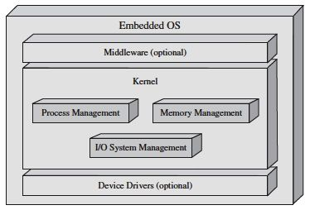

Figure: Organization of an Embedded System

The hardware running an embedded operating system can be very limited in resources such as [RAM](https://en.wikipedia.org/wiki/RAM) and [ROM](https://en.wikipedia.org/wiki/Read-only_memory), therefore embedded design of these operating systems may have a narrow scope tailored to a specific application in order to achieve desired operation under these constraints. In order to take better advantage of the processing power of the [CPU](https://en.wikipedia.org/wiki/Central_processing_unit), software developers may write critical code directly in [assembly](https://en.wikipedia.org/wiki/Assembly_language). This machine efficient language can potentially result in gains in speed and [determinism](https://en.wikipedia.org/wiki/Deterministic_system) at the cost of portability and maintainability. Often times, embedded operating systems are written entirely in more portable languages, like C, however.

An important difference between most embedded operating systems and desktop operating systems is that the application, including the operating system, is usually statically linked together into a single executable image. Unlike a desktop operating system, the embedded operating system does not load and execute applications. This means that the system is only able to run a single application.

**Computation for industrial automation is typified by the following characteristics:**

• The computation is reactive in nature, that is, the computation is carried out with respect to real-world physical signals and events. Therefore industrial computers must have extensive input-output subsystems that interface it with physical signals.

• In general speed of computation is not very high. This is because dynamics for variables such as temperature are very slow. For electromechanical systems speed requirement is higher. However, there processing is often done by dedicated coprocessors.

• The algorithmic complexity of computation is generally not very high, although it is increasing due to the deployment of sophisticated control and signal processing algorithms. Therefore general-purpose processors are sufficient, almost in all cases.

• A large part of the computational tasks are repetitive or cyclic, that is their executions are invoked periodically in time. Many of these tasks are also real-time, in the sense that there are deadlines associated with their execution. When there are a large number of such tasks to be executed on a single processor, appropriate scheduling strategies are required. Since the number of tasks is mostly fixed, simple static scheduling policies are generally adequate.

• Although computational demands are not very high, the computation is critical in nature. Indeed, the cost ratios of industrial controllers and the plant equipment they control can well be in excess of one thousand. This requirement is coupled with the fact that such controllers are often destined to work in harsher industrial environments. Thus, reliability requirement of industrial control computers are very high. In fact, this is one of the main reasons that decide the high price of such systems compared to commercial computers of comparable or even higher data processing capability. In this lesson the basic features of a Real-Time Operating System (RTOS) are introduced and motivated from the demands of typical real-time applications. Before the RTOS is discussed the typical functionalities of a general Operating System (OS) reviewed briefly. While the RTOS has some distinguishing features, it is also largely similar to general purpose operating systems. The discussion here is necessarily brief and user oriented, rather than designer oriented. For a detailed exposition on OS any standard textbook on the subject may be referred to.

**Embedded System**

* Refers to the use of electronics and software within a product that is designed to perform a dedicated function.
* In many cases, embedded systems are part of a larger system or product .
* Antilock braking system in a car would be an example.

**Characteristics of Embedded OS**

* Real-time operation
* Reactive operation
* Configurability
* I/O device flexibility
* Streamlined protection mechanisms
* Direct use of interrupts

**Developing an Embedded OS**

Two general approaches:

* Take an existing OS and adapt it for the embedded application.
* Design and implement an OS intended solely for embedded use

**Adapting an Existing OS**

An existing commercial OS can be used for an embedded system by adding:

* real time capability
* streamlining operation
* adding necessary functionality

**Advantage**:

• Familiar interface

**Disadvantage**:

• Not optimized for real-time and embedded applications.

**Purpose-Built Embedded OS**

Typical characteristics include:

* fast and lightweight process or thread switch
* scheduling policy is real time and dispatcher module is part of scheduler
* small size ν responds to external interrupts quickly
* minimizes intervals during which interrupts are disabled
* provides fixed or variable-sized partitions for memory management
* provides special sequential files that can accumulate data at a fast rate

**Embedded Linux**

* A version of Linux running in an embedded system.
* Embedded devices typically require support for a specific set of devices, peripherals, and protocols, depending on the hardware that is present in a given device and the intended purpose of that device.
* An embedded Linux distribution is a version of Linux to be customized for the size and hardware constraints of embedded devices.
* Includes software packages that support a variety of services and applications on those devices.
* An embedded Linux kernel will be far smaller than an ordinary Linux kernel.

**Cross Compiler**

* A key differentiator between desktop/server and embedded Linux distributions is that desktop and server software is typically compiled on the platform where it will execute.
* Embedded Linux distributions are usually compiled on one platform but are intended to be executed on another.
* the software used for this purpose is referred to as a cross-compiler.

**Advantages of Embedded Linux**

* Vendor independence -
* The platform provider is not dependent on a particular vendor to provide needed features and meet deadlines for deployment
* Varied hardware support -
* Linux support for a wide range of processor architectures and peripheral devices makes it suitable for virtually any embedded system
* low cost -
* The use of Linux minimizes cost for development and training
* Open source -
* The use of Linux provides all of the advantages of open source software

**4.2 Mutitasking**

* Multitasking is a method by which multiple tasks, also known as processes, share common processing resources such as a CPU. With a multitasking OS, such as Windows XP, you can simultaneously run multiple applications. Multitasking refers to the ability of the OS to quickly switch between each computing task to give the impression the different applications are executing multiple actions simultaneously.
* As CPU clock speeds have increased steadily over time, not only do applications run faster, but OSs can switch between applications more quickly. This provides better overall performance. Many actions can happen at once on a computer, and individual applications can run faster.

**Single Core**

* With a single CPU core, only one task runs at any point in time, meaning that the CPU is actively executing instructions for that task. Multitasking solves this problem by scheduling which task may run at any given time and when another waiting taskgets a turn.

[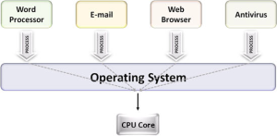](https://2ec414sg.files.wordpress.com/2014/09/1.png)

Fig: Single-core systems schedule tasks on 1 CPU to multitask

**Multicore**

* When running on a multi core system, multitasking OSs can truly execute multiple tasks concurrently. The multiple computing engines work independently on different tasks.
* For example, on a dual-core system, four applications – such as word processing, e-mail, Web browsing, and antivirus software – can each access a separate processor core at the same time. You can multitask by checking e-mail and typing a letter simultaneously, thus improving overall performance for applications.
* The OS executes multiple applications more efficiently by splitting the different applications, or processes, between the separate CPU cores. The computer can spread the work – each core is managing and switching through half as many applications as before – and deliver better overall throughput and performance. In effect, the applications are running in parallel.

[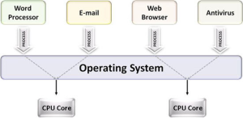](https://2ec414sg.files.wordpress.com/2014/09/2.png)

Fig: Dual-core systems enable multitasking operating systems to execute two tasks simultaneously

**4.3 MutiThreading**

* Multithreading extends the idea of multitasking into applications, so you can subdivide specific operations within a single application into individual threads. Each of the threads can run in parallel. The OS divides processing time not only among different applications, but also among each thread within an application.
* Multithreaded applications, multiple tasks can progress in parallel with other applications that are running on the system.

[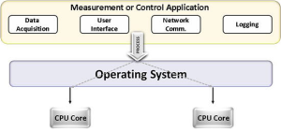](https://2ec414sg.files.wordpress.com/2014/09/3.png)

Fig: Dual-core system enables multithreading

**Applications** that take advantage of multithreading have numerous benefits, including the following:

Better system reliability.

* Improved performance on multiprocessor computers.
* In many applications, you make synchronous calls to resources, such as instruments. These instrument calls often take a long time to complete. In a single-threaded application, a synchronous call effectively blocks, or prevents, any other task within the application from executing until the operation completes.
* Multithreading prevents this blocking.
* While the synchronous call runs on one thread, other parts of the program that do not depend on this call run on different threads. Execution of the application progresses instead of stalling until the synchronous call completes. In this way, a multithreaded application maximizes the efficiency of the CPU because it does not idle if any thread of the application is ready to run.

**4.4 Real Time Operating System**

**Real time**[**Operating Systems**](http://ecomputernotes.com/fundamental/disk-operating-system/what-is-operating-system) are very fast and quick respondent systems. These systems are used in an environment where a large number of events (generally external) must be accepted and processed in a short time. Real time processing requires quick transaction and characterized by supplying immediate response. For example, a measurement from a petroleum refinery indicating that temperature is getting too high and might demand for immediate attention to avoid an explosion.

In real time [operating system](http://ecomputernotes.com/fundamental/disk-operating-system/what-is-operating-system) there is a little swapping of programs between primary and secondary [memory](http://ecomputernotes.com/fundamental/input-output-and-memory/what-are-the-different-types-of-ram-explain-in-detail). Most of the time, processes remain in primary memory in order to provide quick response, therefore, memory management in real time system is less demanding compared to other systems.

The primary functions of the real-time operating system are to:

 1. Manage the processor and other system resources to meet the requirements of an application.

2. Synchronize with and respond to the system events.

3. Move the data efficiently among processes and to perform coordination among these processes.

 The Real Time systems are used in the environments where a large number of events (generally external to the [computer](http://ecomputernotes.com/fundamental/introduction-to-computer/what-is-computer) system) is required to be accepted and is to be processed in the form of quick response. Such systems have to be the multitasking. So the primary function of the real time operating system is to manage certain system resources, such as the [CPU](http://ecomputernotes.com/fundamental/introduction-to-computer/what-is-cpu), memory, and time. Each resource must be shared among the competing processes to accomplish the overall function of the system Apart from these primary functions of the real-time operating system there are certain secondary functions that are not mandatory but are included to enhance the performance:

 1. To provide an efficient management of [RAM](http://ecomputernotes.com/fundamental/input-output-and-memory/what-are-the-different-types-of-ram-explain-in-detail).

2. To provide an exclusive access to the computer resources.

 The term real time refers to the technique of updating files with the transaction data immediately just after the event that it relates with.

 Few more examples of real time processing are:

 1. Airlines reservation system.

2. Air traffic control system.

3. Systems that provide immediate updating.

4. Systems that provide up to the minute [information](http://ecomputernotes.com/fundamental/information-technology/what-do-you-mean-by-data-and-information) on stock prices.

5. Defense application systems like as RADAR.

 Real time operating systems mostly use the preemptive priority scheduling. These support more than one scheduling policy and often allow the user to set parameters associated with such policies, such as the time-slice in Round Robin scheduling where each task in the task queue is scheduled up to a maximum time, set by the time-slice parameter, in a round robin manner. Hundreds of the priority levels are commonly available for scheduling. Some specific tasks can also be indicated to be non-preemptive.

**Characteristics of real-time systems**

The operating system achieves the desired extent of regulation as follows:

1. Sense an event: The system monitors its operative environment using some sensors. These sensors keep a tab on some measurable entity. Depending upon the context of use this entity may be a measure of temperature, or a stock price fluctuation or fluid level in a reservoir. These measurements may be periodic. In that case the system would accept an input periodically. In case the measurement of inputs is taken at specified times of operation then the OS may schedule its input at these specified times or it may be interrupted to accept the input. The input may even be measured only when an unusual deviation in the value of the monitored entity occurs. In these cases, the input would certainly result in an interrupt. Regardless of the input mode, the system would have an input following a sensor reading (which is an event).
2. Process the data: The next important task is to process the data which has beenmost recently acquired. The data processing may be aimed at checking the healthof the system. Usually it is to determine if some action is needed.
3. Decide on an action: Usually, the processing steps involving arriving at somedecisions on control settings. For instance, if the stock prices cross somethreshold, then one has to decide to buy or sell or do nothing. As another example,the action may be to open a valve a little more to increase inflow in case reservoirlevel drops.
4. Take a corrective action: In case, the settings need to be altered, the new settingsare determined and control actuators are initiated. Note that the actions in turnaffect the environment. It is quite possible that as a consequence, a new set ofevents get triggered. Also, it is possible that the corrective step requires a drasticand an immediate step. For instance, if an alarm is to be raised, then all the othertasks have to be suspended or pre-empted and an alarm raised immediately. Realtimesystems quite often resort to pre-emption to prevent a catastrophe from happening.

**Classification of Real-time Systems**

The classification of real-time systems is usually based on the severity of theconsequences of failing to meet time constraints. This can be understood as follows.Suppose a system requires a response to an event in time period T. Now we ask: whathappens if the response is not received within the stipulated time period? The failure tomeet the time constraint may result in different degrees of severity of consequences. In alife-critical or safety critical application, the failure may result in a disaster such as loss oflife. A case in point is the shuttle Columbia's accident in early February 2 2003. RecallKalpana Chawla, an aeronautics engineering Ph. D. was on board. During its descent,about 16 minutes from landing, the spacecraft temperature rose to dangerous levelsresulting in a catastrophic end of the mission.

Clearly, the rise in temperature as a spacedraft enters earth's atmosphere is anticipated. Spacecrafts have RTOS regulating thecontrollers to respond to such situations from developing. And yet the cooling system(s)in this case did not offer timely mitigation. Both in terms of loss of human life and thecost of mission such a failure has the highest severity of consequences. Whereas in thecase of an online stock trading, or a game show, it may mean a financial loss or a missedopportunity. In the case of a dropped packet in a video streaming application it wouldsimply mean a glitch and a perhaps a temporary drop in the picture quality. The threeexamples of real-time system we have given here have different levels of severity interms of timely response. The first one has life-threatening implication; the second caserefers to a missed opportunity and finally, degraded picture quality in viewing.Associated with these are the broadly accepted categories hard, firm and soft real-timesystems.

**Architecture of Real-time Systems:**

The basic architecture of such systems is simple.

As shown in Figure 8.1, some sensors provide input from the operative environment anda computation determines the required control. Finally, an appropriate actuator isactivated. However, since the consequence of failure to respond to events can becatastrophic, it is important to build in the following two features in the system.

(a) It should be a fault tolerant design.

(b) The scheduling policy must provide for pre-emptive action.

For a fault tolerant design, the strategies may include majority voting out of the faultysensors. Systems like satellite guidance system, usually have back-up (or a hot-stand-by)system to fall back upon. This is because the cost of failure of a mission is simply toohigh. Designers of Airbus A-320 had pegged the figure of failure probability at lowerthan 10-10 for one-hour period in flight.



**Fig: priority structure for RTOS tasks**

As for design of scheduling policy, one first identifies the critical functions and not socritical functions within an operation. The scheduling algorithm ensures that the criticalfunctions obtain high priority interrupts to elicit immediate responses. In Figure , wedepict the priority structure for such a design.. Yet, it is worth mentioning here that RTOS designers have two basic designorientations to consider. One is to think in terms of event-triggered operations and theother is to think of time-triggered operations. These considerations also determine itsscheduling policy. architectures based on these two considerations. The observation is that time-triggered architectures obtain greater predictability but end up wasting more resource cycles ofoperation due to more frequent pre-emptions. On the other hand, event-triggered systemarchitectures seem to score in terms of their ability to adapt to a variety of operatingscenarios. Event-triggered systems are generally better suited for asynchronous inputevents. The time-triggered systems are better suited for systems with periodic inputs. Fornow, let us examine micro-kernels which are at the heart of RTOS, event-triggered or time-triggered.

**Advantages of Real Time Operating System:-**

There are some of the features of using RTOS that is described below

* **Maximum Consumption: –** RTOS give maximum consumption of the system and gives us more output while using all the resources and keeping all devices active. There is little or no down time in these systems. So it can be also using by the servers that are hosted to give maximum output of hosting companies.
* **Task Shifting: –** There is very little time assignedto shifting tasks in these systems. For example in older systems it takes about 10 micro seconds in shifting one task to another and in latest systems it takes 3 micro seconds.
* **Focus on Application: –** These type of operating system focus on applications which are running and usually give less importance to other application residing in waiting stage of life cycle. So less applications or tasks are managed and give exact result on current execution work.
* **Real time operating system in embedded system: –** Due to small size of programs RTOS can also be used in embedded systems like in transport and others.
* **Error Free: –** RTOS is error free that mean it has no chances of error in performing tasks.
* **24-7 systems:** – RTOS can be best used for any applications which run 24 hours and 7 days because it do less task shifting and give maximum output.

**Disadvantages of Real Time Operating System:-**

* **Limited Tasks: –** There are only limited tasks run at the same time and the concentration of these system are on few application to avoid errors and other task have to wait. Sometime there is no time limit of how much the waiting tasks have to wait**.**
* **Use heavy system resources: –** RTOS used lot of system resources which is not as good and is also expensive.
* **Low multi-tasking: –** Multi tasking is done few of times and this is the main disadvantage of RTOS because these system runs few tasks and stay focused on them. So it is not best for systems which use lot of multi-threading because of poor thread priority.

**4.4 Real-Time Linux Introduction**

If you wanted to control a camera or a robot or a scientific instrument from a PC, it would be natural to think of using Linux so you could take advantage of the development environment, the X Window System, and all the networking support. However, Linux cannot reliably run these kinds of hard real-time applications. A simple experiment can illustrate the problem. Take a speaker and hook it up to one of the pins from the parallel port; then run a program that toggles the pin. If your program is the only one running, the speaker will produce a nice, somewhat steady tone—not completely steady, but not bad. When Linux updates the file system every couple of seconds, you might notice a small change in tone. If you move the mouse over a couple of windows the tone becomes irregular. If you start Netscape, you hear intervals of silence as your program waits for higher priority processes to run.

The problem is that Linux, like most general purpose operating systems, is designed to optimize *average* performance and to try to give every process a fair share of compute time.

This is great for general purpose computing, but for real-time programming, precise timing and predictable performance are more important than average performance. For example, if a camera fills a buffer every millisecond, a momentary delay in the process reading that buffer can cause data loss.

If a stepper motor in a lithography machine must be turned on and off at precise intervals in order to minimize vibration and to move a wafer into position at the correct time, a momentary delay may cause an unrecoverable failure.

Consider what might happen if the task that causes an emergency shutdown of a chemistry experiment must wait to run until Netscape redraws the window.

It turns out redesigning Linux to provide guaranteed performance would take an enormous amount of work. And taking on such a job would defeat our original purpose. Instead of having an off the shelf general purpose OS, we would have a custom-made special purpose OS that would not be riding the wave of the main Linux development effort.

So we slipped a small, simple, real-time operating system *underneath* Linux. Linux becomes a task run only when there is no real-time task to run, and we pre-empt Linux whenever a real-time task needs the processor. The changes needed in Linux itself are minimal. Linux is mostly unaware of the real-time operating system as it goes about its business of running processes, catching interrupts, and controlling devices. Real-time tasks can run at quite a high level of precision.

In our test P120 system, we can schedule tasks to run within a precision of about 20 microseconds.

Real-time Linux is a research project with two goals.

* First, we want a practical, non-proprietary tool we can use to control scientific instruments and robots.
* Our other goal is to use RT-Linux for research in real and non-real-time OS design. We'd like to be able to learn something about how to make operating systems efficient and reliable. For example, even a non-real-time operating system should be able to determine whether it can guarantee timing needed for its I/O devices.

We're also interested in what types of scheduling disciplines actually turn out to be the most useful for real-time applications. Following this dual purpose, in this paper we discuss both how to use RT-Linux and how it works.

**Using RT-Linux 2.0.RT.1**

Let us consider an example. Suppose we want to write an application that polls a device for data in real-time and stores this data in a file. The main design philosophy behind RT-Linux is the following:

* Real-time programs should be split into small, simple parts, with hard real-time constraints, and larger parts that do more sophisticated processing.
* Following this principle, we split our application into two parts. The hard-real-time part will execute as a real-time task and copy data from the device into a special I/O interface called *real-time fifo*.
* The main part of the program will execute as an ordinary Linux process. This part will read data from the other end of the real-time fifo and display and store the data in a file.
* The real-time task structure will contain pointers to code, data, and scheduling information for this task. The task structure is defined in the first include file. Currently, RT-Linux has only one fairly simple scheduler.
* In the future, the schedulers will also be loadable modules. Currently, the only way for real-time tasks to communicate with Linux processes is through special queues called real-time fifos.
* Real-time fifos have been designed so that the real-time task will never be blocked when it reads or writes data. Figure 1 illustrates real-time fifos.

**How RT-Linux Works**

The basic idea is to make Linux run under the control of a real-time kernel. When there is real-time work to be done, the RT operating system runs one of its tasks. When there is no real-time work to be done, the real-time kernel schedules Linux to run. So Linux is the lowest priority task of the RT-kernel.

The problem with Linux disabling interrupts is solved by simulating the Linux interrupt-related routines in the real-time kernel. For example, whenever the Linux kernel invokes the **cli() -** routine that is supposed to disable interrupts, a *software* interrupt flag is reset instead.

All interrupts get caught by the RT-kernel and passed to the Linux kernel according to the state of this flag and the interrupt mask.

Therefore, the interrupts are always available for the RT-kernel, while still allowing Linux to “disable” them. In the example above, the Linux kernel routine would call **cli()** to clear the soft interrupt flag.

If an interrupt occurred, the real-time executive would catch it and decide what to do. If the interrupt caused a real-time task to be run, the executive would save the state of Linux and start the real-time task immediately. If the interrupt just needed to be passed along to Linux, the real-time executive would set a flag showing a pending interrupt, then resume Linux execution without running the Linux interrupt handler. When Linux re-enables interrupts, the real-time executive will process all pending interrupts and cause the corresponding Linux handlers to execute.

The real-time kernel is itself non-preempt able, but since its routines are very small and fast, this does not cause big delays. Testing on a Pentium 120 shows the maximum scheduling delay to be less than 20ms.

Real-time tasks run at the kernel privilege level in order to provide direct access to the computer hardware. They have fixed allocations of memory for code and data—otherwise, we would have to allow for unpredictable delays when a task requests new memory or pages in a code page.

Real-time tasks cannot use Linux system calls or directly call routines or access ordinary data structures in the Linux kernel, as this would introduce the possibility of inconsistencies. In our example above, the kernel routine changing the queue would invoke **cli**, but this would not prevent a real-time task from starting.

So we cannot allow the real-time task to directly access the queue. We do, however, need a way for real-time tasks to exchange data with the kernel and with user tasks. In a data collection application, for example, we might need to send the data collected by an RT-task over the network, or write it locally to a file, while displaying it on the screen.

Real-time fifos are used to pass information between real-time processes and ordinary Linux processes. RT-fifos, like real-time tasks, are never paged out. This eliminates the problem of unpredictable delays due to paging. And real-time fifos are designed to never block the real-time task.

**4.5 RTOS Kernel**

RTOS Kernel provides an Abstraction layer that hides from application software the hardware details of the processor / set of processors upon which the application software shall run.

1. The central component of most Operating systems is called Kernel.

2. The kernel manages system's resources and the communication

3. The kernel provides the most basic interface between the computer itself and the rest of the operating system.

4. The kernel is responsible for the management of the central processor.

5. The kernel includes the dispatcher to allocate the central processor, to determine the cause of an interrupt and initiate its processing, and some provision for communication among the various system and user tasks currently active in the system.

6. Kernel is the core of an operating system.

**Basic functions of RTOS kernel**

1.Task management

2. Task synchronization

• Avoid priority inversion

3. Task scheduling

4. Interrupt handling

5. Memory management

• no virtual memory for hard RT tasks

**Exception handling**

1. A task (also called a thread) is a program on a computer which can be executed and run.

2. A task is an independent thread of execution that can compete with other concurrent tasks for processor execution time.

3. A task is schedulable.

4. The design process for a real-time application involves splitting the work to be done into tasks which are responsible for a portion of the problem.

5. Each task is assigned a priority, its own set of CPU registers, and its own stack area.

**Task Management**

1. Set of services used to allow application software developers to design their software as a number of separate chunks of software each handling a distinct topic, a distinct goal, and sometimes its own real-time deadline.

2. Main service offered is Task Scheduling

1. controls the execution of application software tasks

2. can make them run in a very timely and responsive fashion.

Priority-Based Kernels

• There are two types

– **Non-preemptive**

• Perform “cooperative multitasking” – Each task must explicitly give up control of the CPU – This must be done frequently to maintain the illusion of concurrency

• Asynchronous events are still handled by ISRs – ISRs can make a higher-priority task ready to run – But ISRs always return to the interrupted task

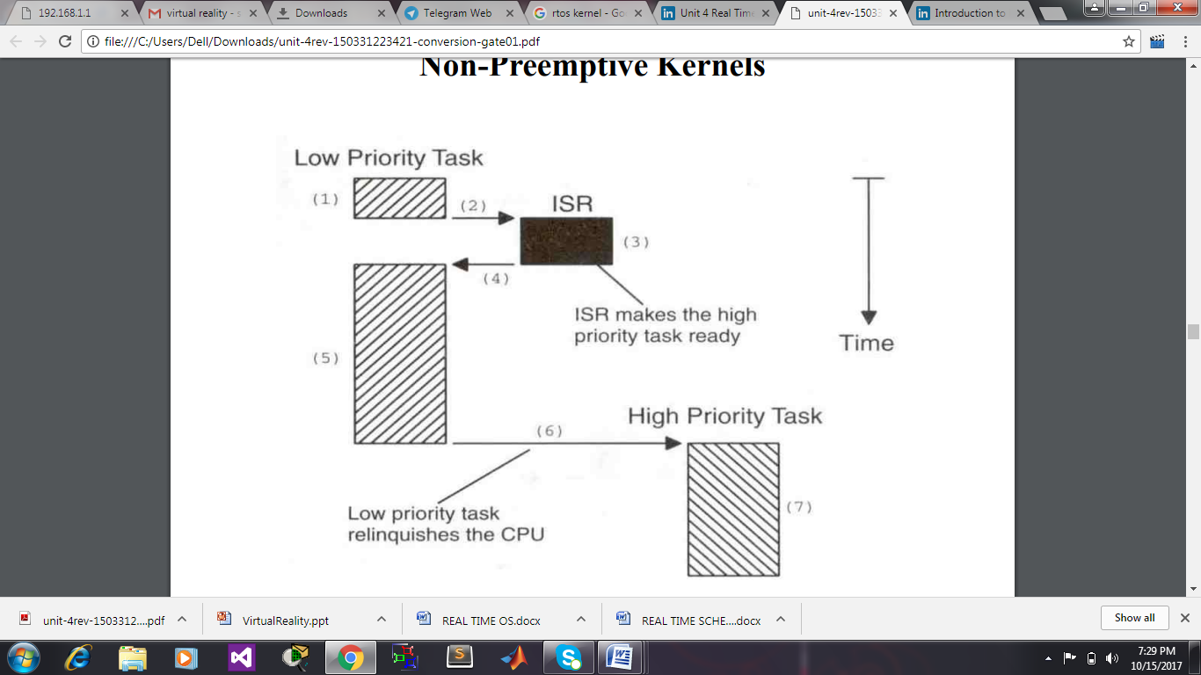

**Fig: Non-Preemptive**

**Advantages of Non-Preemptive Kernels**

• Interrupt latency is typically low

• Can use non-reentrant functions without fear of corruption by another task – Because each task can run to completion before it relinquishes the CPU – However, non-reentrant functions should not be allowed to give up control of the CPU

• Task-response is now given by the time of the longest task – much lower than with F/B systems

• Less need to guard shared data through the use of semaphores

– However, this rule is not absolute.

– Shared I/O devices can still require the use of mutual exclusion semaphores

– A task might still need exclusive access to a printer

**Disadvantages of Non-Preemptive Kernels**

• Responsiveness

– A higher priority task might have to wait for a long time

– Response time is nondeterministic

• Very few commercial kernels are non-preemptive

**Preemptive Kernels**

• The highest-priority task ready to run is always given control of the CPU – If an ISR makes a higher-priority task ready, the higher-priority task is resumed (instead of the interrupted task).

• Most commercial real-time kernels are preemptive.

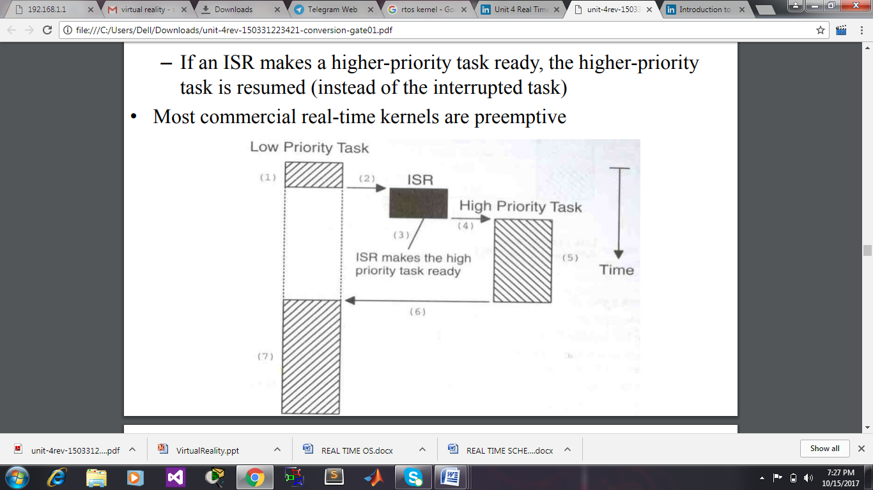

Fig: preemptive kernel

**Advantages of Preemptive Kernels**

• Execution of the highest-priority task is deterministic

• Task-level response time is minimized

**Disadvantages of Preemptive Kernels**

• Should not use non-reentrant functions unless exclusive access to these functionsis ensured.

**4.6 Real time scheduling**

The term **scheduling analysis** in real-time computingincludes the analysis and testing of the scheduler system and the algorithms used in real-time applications. In computer science, real-time scheduling Analysis is the evaluation, testing and verification of the scheduling system and the algorithms used in real-time operations. For critical operations, a real-time system must be tested and verified for performance. In computer science, testing and verification is also known as model checking.

A real-time scheduling System is composed of the scheduler, clock and the processing hardware elements. In a real-time system, a process or task has schedulability; tasks are accepted by a real-time system and completed as specified by the task deadline depending on the characteristic of the scheduling algorithm.[[1]](https://en.wikipedia.org/wiki/Scheduling_analysis_real-time_systems#cite_note-leung2005-1) Modeling and evaluation of a real-time scheduling system concern is on the analysis of the algorithm capability to meet a process deadline. A deadline is defined as the time required for a task to be processed.

For example, in a real-time scheduling algorithm a deadline could be set to five nano-seconds. In a critical operation the task must be processed in the time specified by the deadline (i.e. five nano-seconds). A task in a real-time system must be completed “neither too early nor too late;..”.A system is said to be unschedulable when tasks cannot meet the specified deadlines.A task can be classified as either a periodic or aperiodic process.

Real-time systems will usually have the following characteristics:

* Priority-based scheduler
* Guaranteed maximum time to service interrupts
* Ability to ensure that processes are fully loaded into memory and stay in memory
* Consistent and efficient memory allocation
  1. **Interview Questions**

**Q1. What Is A Non Re­entrant Code?**

**Q2.** **How Is Rtos Different From Other Os?**

**Q3. Is Unix A Multitasking Or Multiprocessing Operating System? Whats The Difference Between The Two?**

**Q4. What Is Stack Overflow And Heap Overflow?**

**Q5. Windows Also Has Multiple Processes Has Process Priorities Switches Between Multiple Process, How Rtos Is Different From That?**

**Q6.** **What Is Paging, Segmentation , Do We Need It?**

**Q7. Write A Code To Check Whether A Stack Grows Upwards Or Downwards?**

**Q8.** **Why Do We Require Semaphore?**

**Q9.  Write A Small Piece Of Code Protecting A Shared Memory Variable With A Semaphore?**

**Q10.** **What Are The Different Inter Process Communications?**

**Q11. What Are The Different Segments Of A Program?**

**Q12.** **What Is An Elf?**

**Q13.** **What Is Priority Inversion?**

**Q14.** What is the main purpose of an operating system?

**4.8 Multiple Choice Questions**

1. In real time operating system ____________  
a) all processes have the same priority  
b) a task must be serviced by its deadline period  
c) process scheduling can be done only once  
d) kernel is not required

2. Hard real time operating system has ______________ jitter than a soft real time operating system.  
a) less  
b) more  
c) equal  
d) none of the mentioned

1. For real time operating systems, interrupt latency should be ____________  
   a) minimal  
   b) maximum  
   c) zero  
   d) dependent on the scheduling
2. In rate monotonic scheduling ____________  
   a) shorter duration job has higher priority  
   b) longer duration job has higher priority  
   c) priority does not depend on the duration of the job  
   d) none of the mentioned
3. In which scheduling certain amount of CPU time is allocated to each process?  
   a) earliest deadline first scheduling  
   b) proportional share scheduling  
   c) equal share scheduling  
   d) none of the mentioned
4. The problem of priority inversion can be solved by ____________  
   a) priority inheritance protocol  
   b) priority inversion protocol  
   c) both priority inheritance and inversion protocol  
   d) none of the mentioned
5. Time duration required for scheduling dispatcher to stop one process and start another is known as ____________  
   a) process latency  
   b) dispatch latency  
   c) execution latency  
   d) interrupt latency
6. Time required to synchronous switch from the context of one thread to the context of another thread is called?  
   a) threads fly-back time  
   b) jitter  
   c) context switch time  
   d) none of the mentioned
7. Which one of the following is a real time operating system?  
   a) RTLinux  
   b) VxWorks  
   c) Windows CE  
   d) All of the mentioned
8. VxWorks is centered around ____________  
   a) wind microkernel  
   b) linux kernel  
   c) unix kernel  
   d) none of the mentioned

**References;**

1. Design with PIC Microcontrollers, John B. Peatman, Pearson Education Asia, 2002

2. Dominic Symes, Chris Wright, Morgan Kaufman Publication, 2004.

3. Computers as components: Principles of Embedded Computing System Design, Wayne Wolf, Morgan Kaufman Publication, 2000

**References Books:**

1. The Design of Small-Scale embedded systems, Tim Wilmshurst, Palgrave2003

2. Embedded System Design , Marwedel ,Peter , Kluwer Publishers , 2004.